Internship Training

At

**SURBHI HOSPITAL PVT. LTD.**

**NOIDA**

**PATIENT SATISFACTION SURVEY**

By

**DR. NITESH KHARE**

**PG/16/031**

Under the guidance of

**DR. PANKAJ TALREJA**

Post Graduate Diploma in Hospital and Health Management

2016-18



**Post Graduate Diploma in Hospital and Health Management**

**2016-18**

**International Institute of Health Management Research, New Delhi**

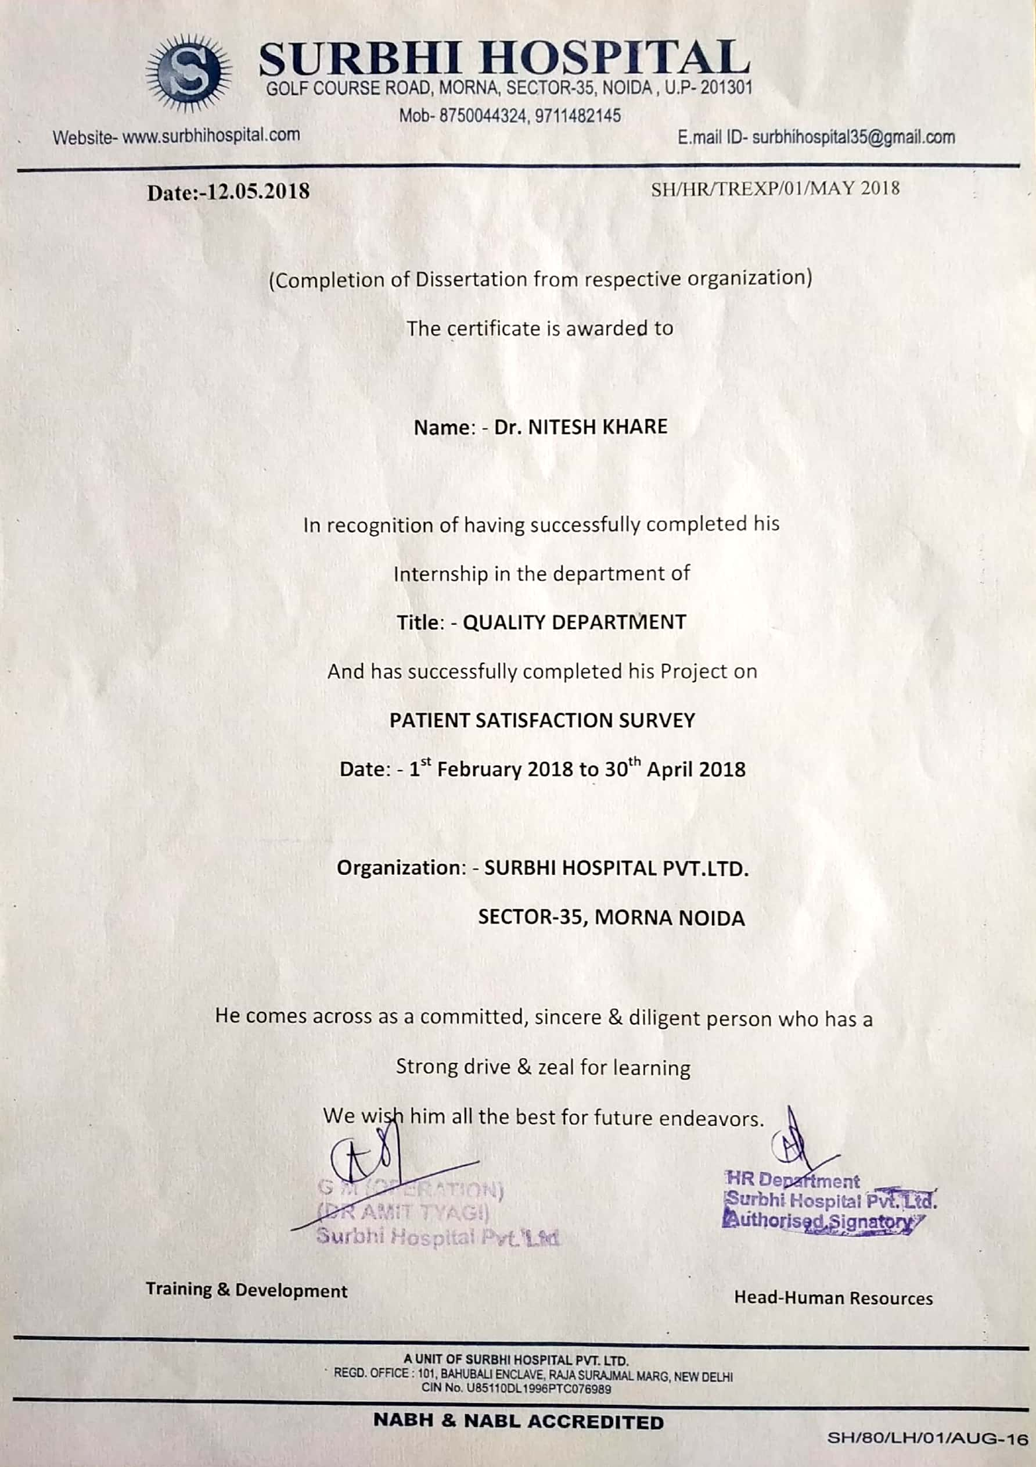

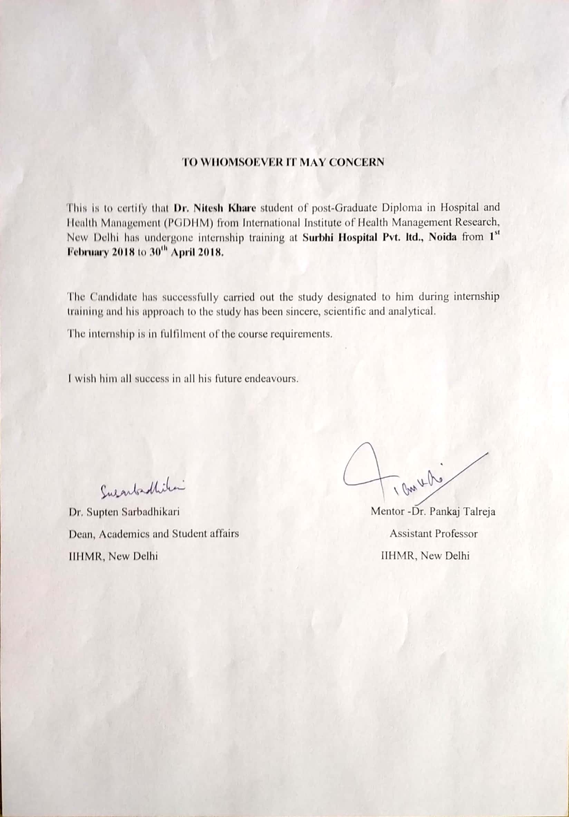

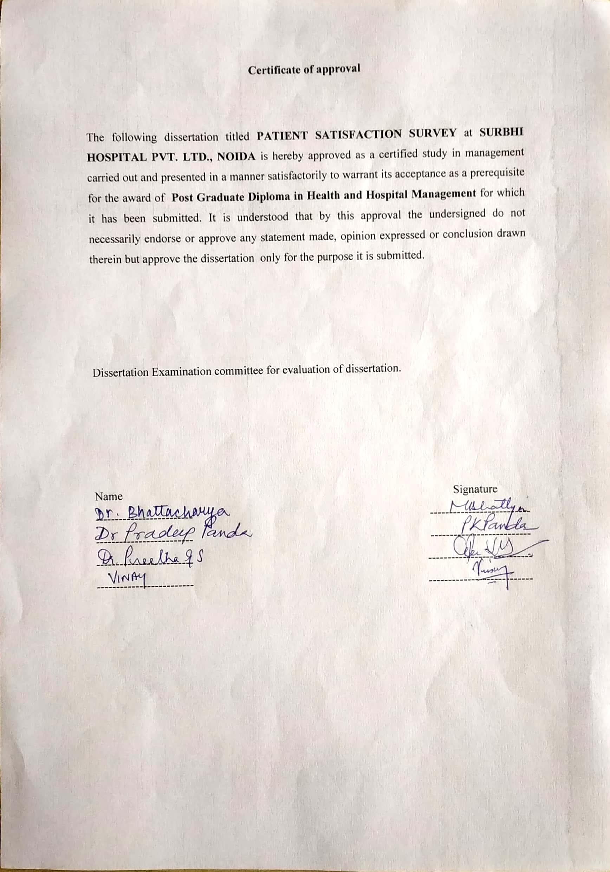

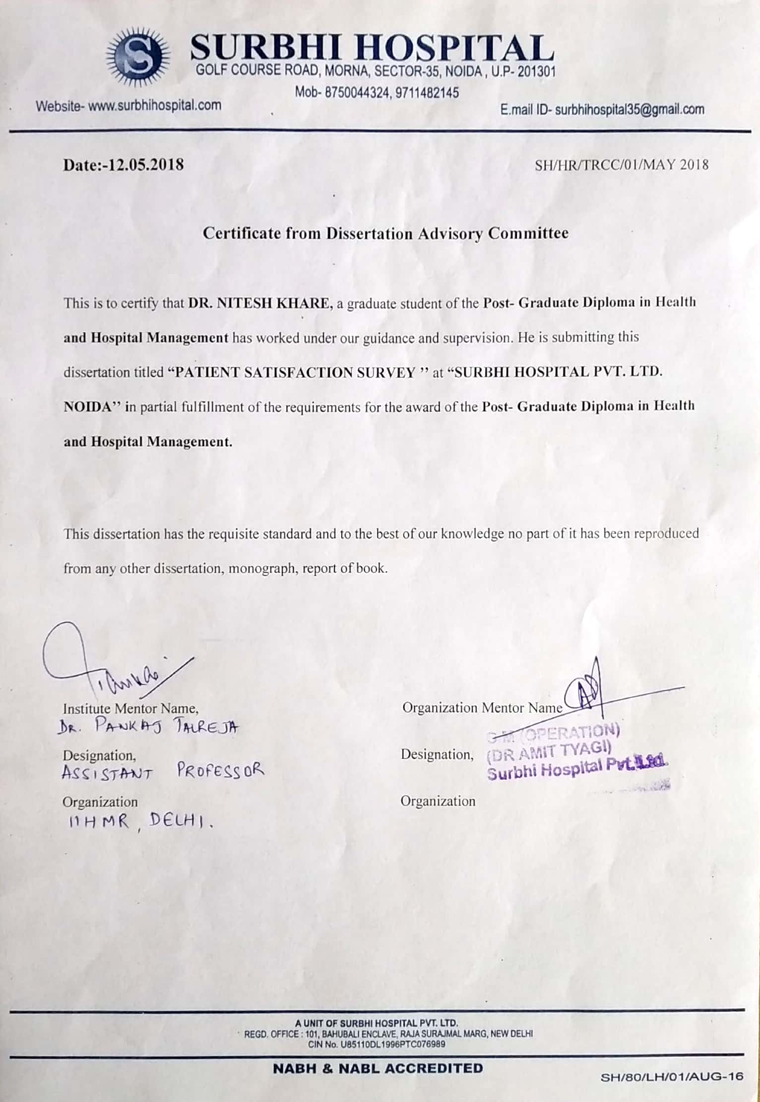

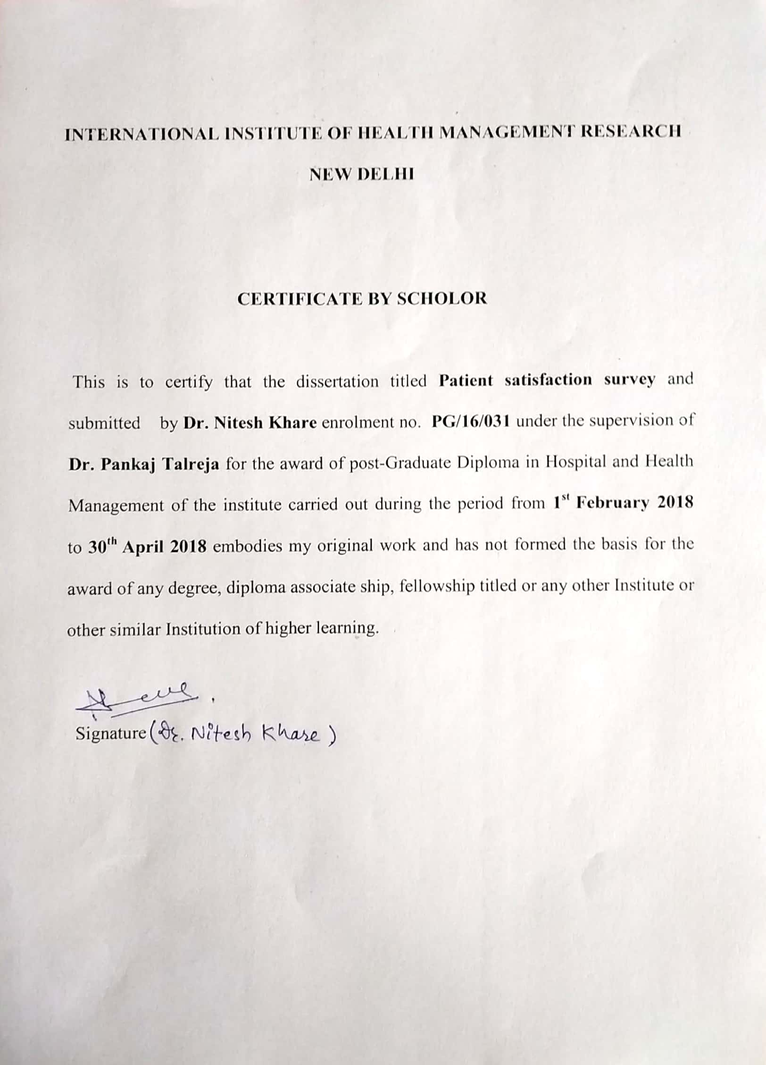

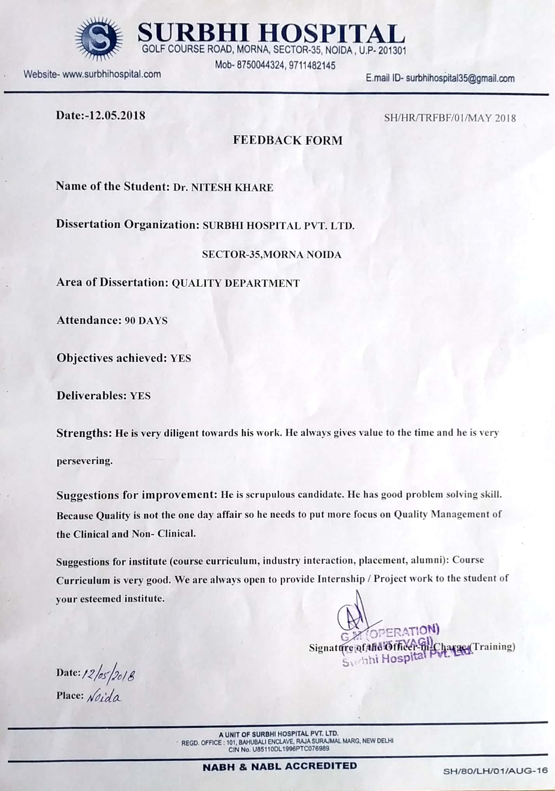

**ABSTRACT**

Precisely considering, quality assurance has become the much needed issue in any organisation for the up-gradation as well as for the sustainability in today’s competitive world. This comes with the concept of contentment and satisfaction with the services received in any organisation. When it includes the healthcare services, the expectations are much higher. In such situation, the patient’s satisfaction plays a vital role. Thus to discover the content share patient satisfaction surveys become a essential tool for the hospitals.

This project deals with the patient satisfaction survey done at a multispecialty hospital in Noida. It is cross sectional study done with the sample size of 100 respondents. With the help of questionnaire as a tool and patients responses on a likert’s scale as a technique. I/OPD of the hospital as a study area. The questionnaire includes the basic seven parameters .The questions are based on these parameters. The result obtains the patients to be fairly satisfied with the overall 93.72% satisfaction level score. Along with this, the areas of improvements are also observed with various levels in the result.

In the nutshell, there are areas of improvement which may be considerable for the sustainability of the current level of patient satisfaction. Thus, this could be helpful to decide further to take step in the direction of continual quality improvement.

**ACKNOWLEDGEMT**

I am using this opportunity to express my gratitude to everyone who supported me throughout the course of this project. I am thankful for their aspiring guidance, invaluable constructive and friendly advice during the project work. I am sincerely grateful to them for sharing their truthful and illuminating views on a number of issues related to the project.

I express my warm thanks to Dr. Amit Tyagi (GM, Surbhi Hospital Pvt. Ltd. Noida) for their support at Surbhi Hospital, Noida, without which, my project would be a difficult task.

I would also like to thanks to my mentor Dr. Pankaj Talreja Assistant Professor IIHMR Delhi, who provided me guidance, support and information being required and conductive conditions for my project. Most of all, I pay my sincere offering to Almighty without whose grace I would not be able to add new dimension to my life.

Dr. Nitesh Khare

PG/16/031

**CONTENTS**

|  |  |  |
| --- | --- | --- |
| **S No.** | **Topics** | **Page No.** |
| 1 | Table list | 5 |
| 2 | Figure list | 5 |
| 3 | Symbols and Abbreviations | 6 |
| 4 | Overview of the organisation | 7 |
| 5 | Departments | 9 |
| 6 | Introduction | 11 |
| 7 | Review of literatures | 13 |
| 8 | General Objective | 15 |
| 9 | Specific Objectives | 15 |
| 10 | Methodology | 16 |
| 11 | Result | 23 |
| 12 | Discussion | 23 |
| 13 | Recommendations | 27 |
| 14 | Conclusion | 29 |
| 15 | References | 30 |
| 16 | Instrumentation | 31 |

**TABLES**

|  |  |  |
| --- | --- | --- |
| **Table No.** | **Details** | **Page No.** |
| Table No. 3.1 | Opted pattern of likert’s scale and numbering | 20 |
| Table No. 3.2 | Types of responses their number and weights | 21 |
| Table No.3.3 | Distribution of question Numbers as per parameter. | 22 |
| Table No. 3.4 | Calculated weights and their percentages as per parameter. | 23 |

**FIGURES**

|  |  |  |
| --- | --- | --- |
| **Figure No.** | **Details** | **Page No.** |
| Figure No. 3.1 | Graph showing comparison in between seven parameters and total output. | 25 |
| Figure No. 3.2 | Pie chart showing segmental distribution of all seven parameters. | 26 |

**ABBREVIATIONS:**

OPD Outpatient department

IPD Inpatient Department

QA Quality Assurance

Pt Patient

I/OPD Inpatient and Outpatient Department

GA General Aspects

TQ Technical Quality

FA Financial Aspects

**OVERVIEW OF THE ORGANISATION**

Surbhi hospital is a multispecialty hospital in Noida UP India. It is located at the prime location of the city in a manner that it is very easy for the patients to access the healthcare facilities in their reach. It has dedicated twenty four hours emergency services. The hospital building has got beautiful infrastructure with all possible basic amnesties in it.

Surbhi hospital is well organised and planned hospital which has got 104 beds working capacity right now. It has good accommodation space and patient care facilities.

**Vision:**

Surbhi hospital aspires to be trusted partner of our community in delivering healthcare services, recognizing quality assurance as an integral part of our growth plans.

**Mission:**

To provide compassionate patient care based on evidence-based practice through our excellent medical and support staff resulting in satisfied services delivery.

**Quality policy:**

The hospital provides medical care through technology to achieve continual improvement in satisfying the changing needs of the patients, belonging to the poor and needy section of society at an affordable cost.

**DEPARTMENTS:**

General Medicine

General Surgery and Laparoscopic Surgery

Paediatrics

Obstetrics and gynaecology

Orthopaedics and joint replacement

ENT

Ophthalmology

Oncology

(Oncosurgery and Chemotherapy)

Neurology

Nephrology and Dialysis

Urology

Dermatology

Anaesthesiology

Radiology and imaging

Gastroenterology

Plastic Surgery

Cardiology (non-invasive)

Pathology

Physiotherapy.

**INTRODUCTION**

In recent time, most of the hospitals are providing medical facilities at their level best. Still there is something which makes the difference in between them for the patient influx. That is the quality of the services the patient receives. And thus the satisfaction and the contentment patients and their attendants receive. Patient satisfaction is now being the most important means of the reflection of the quality of the hospital. It’s important because the feel they get in an organisation remains in person’s mind for long time.

Patient satisfaction is an important and commonly used indicator for measuring the quality in healthcare. Patient satisfaction affects clinical outcomes and patient retention. It affects the timely, efficient and patient-centred delivery of quality health care and QA.

Because the cost of obtaining a patient is high, losing a patient is a substantial loss of investment. We may have attracted a patient through advertising or an insurance contract. It makes every contact with the patient, vital. There is reciprocal relationship between patient satisfaction and continuity of care. Conversely, dissatisfaction and complaints can mean not only loss of business or investment, but also increased risk of malpractice lawsuits.

Surveying patient satisfaction can offer patients an opportunity to participate in their care by reporting their care experiences and building engagements. The value of patient reporting has traditionally been questioned because of the level of most patients’ clinical knowledge in comparison with that of providers. Accreditation, business improvement and risk management are not only reasons patient satisfaction is important. Patient satisfaction surveys represent real-time feedback for providers and show opportunities to improve services or decrease risks.

**REVIEW OF LITRATURE**

Patient satisfaction survey is a vital tool for measuring the quality of health care organisations. Since past few decades, patient satisfaction surveys have gained increasing attention as essential sources of information for identifying gaps and developing an effective action plan for quality improvement in healthcare systems. Many organisations perform the patient satisfaction survey in different manner.

It is important to learn what steps were taken towards the desired direction and what were the outcome and experiences.

Otto Robertson, Michael Dunbar and group:During a validation process of the Swedish knee process, patients were sent a questionnaire to ask if they had been re-operated on. This gave an opportunity to expose patient satisfaction which 95% of patients responded. This made them helpful to get constant patients satisfaction rate. Moreover, this also found to be very useful to get the vital causes of dissatisfaction among few patients. And thus it helped them a lot to change the vital steps of the operative procedures.

Urden:health care consumers are demanding excellence in care and services from care providers, and payers are following in their expectations. Demonstration of quality outcomes and consumer satisfaction with services are now a priority and the primary competitive edge in healthcare. Hospitals and healthcare systems that invest in programs to determine how patients evaluate their experiences will have valuable information to make transformational changes in care delivery and services.

Lea Aharony, Stephen Strasser:Patient satisfaction: what we know about and what we still need to explore 1993; patient satisfaction has emerged as an important component of the quality of medical care. In the last decade, patients have emerged as the central focus of both health care delivery and quality assurance efforts. This new emphasis on quality of care and outcome measurement has led to an increased appreciation of the significance of patient perception of care.

Indian journal of community medicine: One study findings suggest that some measures can be taken by the policy makers to increase the patient satisfaction, includes reducing the patient load at higher level facilities so that doctors and staff can give more attention and time to the patient. And needs to strengthen the infrastructure and human resources at lower level health facilities.

P. Mishra and Shakti:study of patient satisfaction in a surgical unit of a tertiary care hospital suggested various recommendations at different levels including admission level, room preparation, toilets hygiene, staff behaviour, orderlies behaviour, food services, explanation of the diseases and treatment by Doctors etc. not only this but they also included the comments on consume charges and package charges and also media. These are very vital aspects to improve quality care in any hospital.

**GENERAL OBJECTIVE:**

To assess the patient satisfaction level in a multispecialty hospital by patient satisfaction survey.

**SPECIFIC OBJECTIVES:**

1. To assess the patient satisfaction level.
2. To discover the areas of improvement in relation to patient satisfaction.

**METHODOLOGY:**

**Study Design:** Cross Sectional Study.

**Study Area:** OPD and IPD, Surbhi Hospital Noida

**Study Population:** I/OPD patients.

**Data collection Tools and techniques:**

**Tool:** Patient Satisfaction Questionnaire.

**Technique:** Obtaining responses on likert’s scale.

The patient satisfaction survey has become the basic tool for quality assurance in health care system. There are many ways through which the survey can be conducted. The one of the basic method is to detect patient satisfaction by patient satisfaction questionnaire. Interviewing is another effective method of detecting patient satisfaction level.

Though it may sound little common, this is still worth tracing the score of patient satisfaction. To put it simply, patient satisfaction is an indicator of how well the patient is being treated. The **"how well"** part refer not necessarily to the quality of care but to how **content** a patient is with the care they receive. There are number of reasons why patient satisfaction score should be among top priority for every medical facility. Unless we know what our strengths and weaknesses are, we cannot go further in competition effectively. The data collected through patient’s satisfaction measurements reflect care delivered by the hospital as a whole and can serve as a tool in decision making.

In addition to this, patient satisfaction has some parallel effects also.

A happy patient is a loyal patient: in the context of hospitals, a patient receiving services no other hospital can provide is less likely to switch their preferred medical facility.

High patient satisfaction pulls in new patients: The psychology behind this is simple—we want to share our experiences. Patient satisfaction affects clinical outcomes: patients who rate their doctor’s empathy high have better clinical outcomes.

The study design being used is study as a descriptive cross-sectional research design with the objective to assess the patient satisfaction at selected patient departments (I/OPD). The total 5% of the total opd patients are included on each day’s opd. Thus total “100” numbers of the patients are being selected from I/OPD Departments of the hospital, out of which, 10 patients are selected from in patient department. Standard Questionnaire is being used. The respondents mark the number as per their expected and experience lines. Attributer based on the outcome in a manner, the sense of contentment and feel of the services they receive in the hospital.

Based on: below mentioned parameter:

1) General Aspects (GA)

2) Technical Quality (TQ)

3) Interpersonal Manner

4) Communication

5) Financial Aspect (FA)

6) Time spent with the Doctor

7) Accessibility and Convenience

This is based over the scale of 5 i.e. : Strongly Disagree, Disagree, Uncertain, Agree and Strongly Agree. Further, final score will be calculated as per the standards of the organization. This is done by giving different weights to different subscales of responses.

|  |  |  |  |  |  |  |
| --- | --- | --- | --- | --- | --- | --- |
| S no. | Questions | Strongly Disagree | Disagree | Uncertain/average | Agree | Strongly Agree |
| 1 |  | 1 | 2 | 3 | 4 | 5 |
| 2 |  | 1 | 2 | 3 | 4 | 5 |
| 3 |  | 1 | 2 | 3 | 4 | 5 |

The table of the questionnaire is formed in a below mentioned manner in table no. 3.1, in which subscales numbers are given from 1 to 5. It included all positive asking sentences (questions). Total 18 short questions are included and thus each questionnaire form can have 90 maximum marks (weights).

Table 3.1

All subscales are divided by given weights. The weights are given as per the numbers of subscales. Five will be the maximum weight while one will be the minimum. 3 is considered as uncertain or average number of weight which may be considered as the central tendency of the respondents. The details of the weights distribution is given in table no. 3.2 as below mentioned.

|  |  |  |  |
| --- | --- | --- | --- |
| S no. | Responses | numbers | weights |
| 1. | Strongly Disagree | 1 | 1 |
| 2. | Disagree | 2 | 2 |
| 3. | Uncertain/ Average | 3 | 3 |
| 4. | Agree | 4 | 4 |
| 5. | Strongly Agree | 5 | 5 |

Table 3.2

Output response = x1(w1) +x2(w2) +x3(w3) +x4(w4) +x5(w5) / max sum weight

Where x= responses

w = corresponding weight

Out of opted 18 questions in given questionnaire, the distribution of the questions as per the parameter is done. Out of all seven groups, five groups have got two questions in each and two groups have got four questions ie in technical quality and in accessibility and convenience. The distribution is as below mentioned in the table no. 3.3.

|  |  |  |
| --- | --- | --- |
| Question numbers… | 3, 17 | General Aspects |
|  | 2,4,6,14 | Technical quality |
|  | 10,11 | Interpersonal manner |
|  | 1,13 | Communication |
|  | 5,7 | Financial aspect |
|  | 12, 15 | Time spent with Doctor |
|  | 8,9,16,18 | Accessibility and convenience |

Table 3.3

|  |  |  |  |  |  |
| --- | --- | --- | --- | --- | --- |
| S no. | Question no. | Category | Maximum expected weights | Obtained weights | percentages |
| 1 | 3, 17 | General Aspects | 1000 | 925 | 92.50% |
| 2 | 2,4,6,14 | Technical quality | 2000 | 1880 | 94% |
| 3 | 10,11 | Interpersonal manner | 1000 | 946 | 94.60% |
| 4 | 1,13 | Communication | 1000 | 936 | 93.60% |
| 5 | 5,7 | Financial aspect | 1000 | 931 | 93.10% |
| 6 | 12, 15 | Time spent with Doctor | 1000 | 946 | 94.60% |
| 7 | 8,9,16,18 | Accessibility and convenience | 2000 | 1871 | 93.55% |
|  | Total 18 | Total | 9000 | 8435 | 93.72% |

RESULTS AND DISCUSSION:

After the calculation of all responses found, the obtained weights were counted and the detailed outcome in number and in percentages were calculated (as mentioned above). Thus total score along with the parameter vice score were calculated as mentioned in below table (table no. 3.4). Technical quality and accessibility and convenience have 4 questions instead of 2 so the score is relatively outnumbered. The score is being calculated in percentages to have better comparison in between the parameters.

Table 3.4

After the calculation of responses found, the total cumulative satisfaction level is found to be 8435 out of 9000 i.e. 93.72%. This figure confirms the satisfaction level in the sampled patients of the organisation to be optimal. In other words, the patients are found to fairly satisfy with the health care facilities of the hospital. Remaining parameter vice scores are being produced in below list and demonstrated in given graph in figure 3.1.

|  |  |  |  |
| --- | --- | --- | --- |
| General Aspects | 92.50% | 1000 | 925 |
| Technical Quality | 94% | 2000 | 1880 |
| Interpersonal Manner | 94.60% | 1000 | 946 |
| Communication | 93.60% | 1000 | 936 |
| Financial Aspect | 93.10% | 1000 | 931 |
| Time spent with Doctor | 94.60% | 1000 | 946 |
| Accessibility and Convenience | 93.55% | 2000 | 1871 |
| Total | 93.72% | 9000 | 8435 |

Figure 3.1

The total satisfaction score is above 93% which reflects that patients are overall satisfied with the healthcare quality of the hospital. As per the standards of the organisation, the overall score of the under survey patients is found to be satisfactory.

Though, there are some different observations are noted when different segments are considered. It is observed that patients under survey are found to be relatively more satisfied with the “interpersonal manner” and “time spent with doctors”. The score is peaked at 94.6% in both of these conditions. In contrast to this, general aspects are showing minimum values among all others. GA (General Aspects) positioned at lowest position. Technical quality (TQ) is also reflecting fair satisfaction level next to highest peaks. Followed by communication, accessibility and convenience and financial aspects (FA) are peaked in deceasing order respectively.

Figure 3.2

Broadly, as per the pie diagram shown in figure 3.2, apart from two parameters, time spent with doctor and interpersonal manner, all other five parameters are sharing more or less equal part in responses. This somehow may indicate the possible next steps to be taken in the direction of betterment of the QA. This is showing that the scope is existing to have more improvement in all other parameters. Not only to improve but to maintain the achieved position. The scope to have retention and sustainability in the current competitive situation.

**RECOMNDATIONS:**

It is being reflected from facts and figures that patients under survey of satisfaction are found to be fairly satisfied and contented. Still if we consider the further scope of quality improvement and particularly the maintenance of the same achieved level, some relative observations become obvious. Of them, there are some different levels of satisfaction which can be further improved.

1. The general aspects which include the medical management can be more satisfactory by explaining the process of medical management to the patients and their attendant in more elaborative details.
2. For the same, general aspects, attendants can be informed about the ongoing process more frequently so that they can be more aware about the outcomes.
3. The accessibility and convenience and financial aspects, the patients can be made more aware about the different options which can suit to him/her. The means of taking appointment or information about the visits can be further enhanced by more objects of communications.
4. The waiting time can be further modulated by providing the information about the more time slots to the patients.
5. About the communication, the score is fair, the detailed causes of the medical investigations can be explained to the patient up to satisfactory level or different options can be suggested if available.

**CONCLUSION:**

The use of patient satisfaction survey in multispecialty hospital could help in continuity of quality care and in bringing about the much required improvement in all expected fields. Thus we can conclude that the outcome of real time patient satisfaction survey can be used as a parameter for quality level of the organisation and to detect the areas of low satisfaction level. Further, to discover the causes of such areas of low satisfaction and their possible solution can be emerged out.

The survey of patient satisfaction by including different parameters enables the concerned managerial authority to take decision in appropriate manner in such a way that consumers themselves Speak about the desired needs. It is an important vertical of quality management and shall be given its due importance.

**REFERANCES:**

1. Patient satisfaction survey as a tool towards quality improvement-NCBI – NIH <https://www.ncbi.nlm.nih.gov>
2. Measuring and Improving patient satisfaction, book by Patrick
3. Improving patient satisfaction now, book by Nelson
4. <https://www.rand.org>
5. Analysis of patient satisfaction survey [www.reseachgate.net](http://www.reseachgate.net)
6. Indian journal of community medicine.
7. Analysing and interpreting Data from Likert-type scale NCBI-NIH
8. Likert’s scale data analysis [www.researchgate.net](http://www.researchgate.net)

|  |  |  |  |  |  |  |
| --- | --- | --- | --- | --- | --- | --- |
| S no. | **QUESTIONS** | **STRONGLY DISAGREE** | **DISAGREE** | **UNCERTAIN/**  **AVERAGE** | **AGREE** | **STRONGLY AGREE** |
| 1 | Medical professionals and staff are cooperative about explaining the causes for medical investigations. | 1 | 2 | 3 | 4 | 5 |
| 2 | I believe that my clinician’s chamber has everything, needed to provide complete medical care. | 1 | 2 | 3 | 4 | 5 |
| 3 | The medical management which is being provided to me is just complete and perfect. | 1 | 2 | 3 | 4 | 5 |
| 4 | Majority of times, the clinicians make the diagnosis perfect. | 1 | 2 | 3 | 4 | 5 |
| 5 | I believe and feel confident that I can get the medical treatment without any financial difficulty. | 1 | 2 | 3 | 4 | 5 |
| 6 | Health care providers are alert and careful to check everything when treating and examining me. | 1 | 2 | 3 | 4 | 5 |
| 7 | I will hardly need to pay for more of my medical care than I can afford. | 1 | 2 | 3 | 4 | 5 |
| 8 | I can get a clinical specialist I need without difficult approach. | 1 | 2 | 3 | 4 | 5 |
| 9 | Where one person gets medical care, other patients don’t have to wait for long time for medical management. | 1 | 2 | 3 | 4 | 5 |
| 10 | Clinicians don’t behave like business oriented toward the patients. | 1 | 2 | 3 | 4 | 5 |
| 11 | My Doctor treats and interacts with me in a very friendly and courteous manner. | 1 | 2 | 3 | 4 | 5 |
| 12 | Medical professionals and other health care personals give sufficient time while treating. | 1 | 2 | 3 | 4 | 5 |
| 13 | Clinicians most of the times listen when I try to ask any query. | 1 | 2 | 3 | 4 | 5 |
| 14 | I have no doubt about the ability of the doctors who treat me. | 1 | 2 | 3 | 4 | 5 |
| 15 | Doctors usually spend reasonably enough time with patients. | 1 | 2 | 3 | 4 | 5 |
| 16 | Anyone can easily find an appointment for medical care anytime. | 1 | 2 | 3 | 4 | 5 |
| 17 | I am satisfied and contented with most of the medical care I receive. | 1 | 2 | 3 | 4 | 5 |
| 18 | Medical care facilities are mostly available whenever they are needed to me. | 1 | 2 | 3 | 4 | 5 |

**INSTRUMENTATION:**

**QUESTIONNAIRE**

**Given statements are about how you feel about the health and medical care One (s/he) receives in this hospital.**

How strongly you are **satisfied** or **unsatisfied** with the services, kindly **relate** with each of following statements. (please circle one number on each line.)