**SUMMER INTERNSHIP REPORT**

At

Haryana State Health Resource Center (HSHRC), NHM Haryana

(April 18th to June 17th, 2022)

A Report

By: Dr Akanksha

PGDM (Hospital and Health Management)

2021-2023



International Institute of Health Management Research, New Delhi

**Certificate of Approval**

The Summer Internship Project of **titled “EVALUATION OF NUTRITIONAL REHABILITATION CENTERS OF 11 DISTRICTS OF HARYANA”** at “Haryana State Health Resource Centre, Panchkula” is hereby approved as a certified study in management carried out and presented in a manner satisfactorily to warrant its acceptance as a prerequisite for the award of Post Graduate Diploma in Health and Hospital Management for which it has been submitted. It is understood that by this approval the undersigned do not necessarily endorse or approve any statement made, opinion expressed, or conclusion drawn therein but approve the report only for the purpose it is submitted.

**Dr. Rupsa Banerjee**

**Assistant Professor IIHMR, Delhi**

**ACKNOWLEDGEMENT**

The completion of our Research on the Evaluation of Nutrition Rehabilitation Center could not have been possible without the participation, guidance and assistance of our mentors and many other people whose names may not have been enumerated.

We would like to express our immense gratitude to our internship coordinator Mrs. Anju who encouraged us to take summer internship at HSHRC (Haryana State Health Resource Centre), Panchkula.

We are very thankful to Dr. Suresh Dalpath, Deputy Director for his valuable guidance, keen interest and encouragement at all stages of our internship period. Without his thorough and highly valuable discussions, training, guidance, inspiration and support, the completion of this research would not have been possible.

We would also convey our sincere thanks to Dr. Hema and Dr. Nidhi at HSHRC whose guidance, encouragement and suggestions have contributed to expand the horizon of our ideas in the project.

**Mentors in IIHMR**

We are very grateful to Dr. Sutapa B. Neogi, (Director-IIHMR Delhi) for her encouragement and giving us this learning opportunity and Dr. Rupsa Banerjee (Assistant Professor-IIHMR Delhi) for her constant support throughout to strengthen our knowledge and skills. Without their guidance and cooperation, it would not have been possible to conduct this research and complete this training successfully

**TABLE OF CONTENTS**

1. Acknowledgement
2. Acronyms/ Abbreviations
3. Observational Learnings

3.1 Introduction

3.2 Mode of data collection

3.3 General findings on learning

3.4 Conclusive learning, limitations and suggestions for improvement

1. Project Report

4.1 Introduction

4.2 Mode of Data Collection

4.3 Data Compilation

4.4 Data Analysis

4.5 Interpretation

4.6 Recommendation

4.7 Conclusion

1. References
2. Annexure

**ACRONYMS/ ABBREVIATIONS**

ANM- Auxiliary Nurse Midwife

ASHA- Accredited Social Health Activist

AWW- Anganwadi Worker

ICDS- Integrated Child Development Services

MUAC- Mid-Upper Arm Circumference

NFHS- National Family Health Survey

NRC- Nutrition Rehabilitation Center

NRHM- National Rural Health Mission

SAM- Severe Acute Malnourished

SD- Standard Deviation

SNCU- Special Newborn Care Unit

WHO- World Health Organization

**OBSERVATIONAL LEARNING**

**INTRODUCTION**

**HARYANA STATE HEALTH RESOURCE CENTER**

On May 22, 2012, the Haryana State Health Resource Center (HSHRC) was established. The HSHRC serves as an autonomous and independent body that advises the Haryana government on strategic planning and development of health and family welfare services in the state, including health planning, implementation, monitoring, and evaluation of policies and programmes. For this goal, it improves organizational capacities in the State and districts through generating knowledge and information.

The organization's mission is to contribute and strengthen all activities aimed at achieving universal access to health care, as stated in the HSHRC's Vision and Mission.

**OBJECTIVES**

**1)** To evaluate the facility-based management of NRC during a period of two-months in 11 districts of Haryana.

**2)** To assess the quality of services provided by the NRC on SAM (Severe Acute Malnourished) children during a period of two-months in 11 districts of Haryana.

**MODE OF DATA COLLECTION**

The pilot research was undertaken in the Panchkula NRC to analyze our tool before running it on 11 NRCs for evaluation.

The patient area, counseling area, kitchen area, pharmacy, play area, and nursing area were all seen as part of the facility-based checklist. While interviewing mothers and nurses, data was collected using pen and paper-based questionnaires.

The nurses were questioned about their hand hygiene habits, training in facility-based care of SAM children, educational background, and awareness of the immunization schedule for children up to the age of six.

The mothers of the children admitted to the NRC were questioned in order to obtain information on their socioeconomic situation, nursing methods, cleanliness practices, and other social factors that may have contributed to their child's admission. The facility-based services were further reviewed by cross questioning with the mothers.

**GENERAL FINDINGS**

Nutritional rehabilitation centers were taken as the main measure for assessing the services. The NRCs were compared with their compliance based on the 6 areas of concerns.

The **Patient area** accounted for a highest compliance score of 67% in the case of the Ambala District, owing to its dedicated NRC ward with children friendly theme and the essential equipment in place. District Jind, with lowest compliance percentage (35%) ranked last

District Panchkula gave the highest compliance rate of 73% for the **Pharmacy area**. (Ambala District) had no functional pharmacy area, thus showing a lowest compliance of 38%

Hisar district, with compliance level of 81% places the highest w.r.t to the **Kitchen area**. Jind district, with lowest compliance (38%) . Nursing area shows a compliance of 93% in the Panchkula District NRC. Jind NRC, being operational merely for 2 months had no availability of Nursing area, this showing a compliance of only 29%.

A Dedicated **counseling area i**s a must for the NRC. Faridabad NRC showed the highest compliance level of 92%. Ambala district showed the lowest compliance rate of 23%

Jind showed the highest compliance for the presence of available **Manpower** of 70%. Lowest health workforce was seen in the case of Panchkula with a compliance of merely 30%.

Availability of a functional nursing station is crucial for the treatment of the SAM children. **Nursing area** shows a compliance of 93% in the Panchkula District NRC.Jind NRC had no availability of Nursing area, this showing a compliance of only 29%.

**PROJECT REPORT**

**TITLE- EVALUATION OF NUTRITIONAL REHABILITATION CENTER OF 11 DISTRICTS OF HARYANA**

**INTRODUCTION:**

Malnutrition is still observed as a major public health problem all over the globe causing 50% of children’s death under the age of 5 years. Approximately 16% of South Asian children are affected by moderate acute malnutrition and approximately 2% of children in developing countries are affected by severe acute malnutrition. This equals approximately 60 million children suffering from moderate acute malnutrition and 13 million suffering from Severe Acute Malnutrition. If we take India in context, approximately 20% of children under 5 years are severely wasted and 6.4% of children below the age of 60 months are below 3 SD for weight-for-height. Roughly 8 million children below the age of 5 years are affected by severe acute malnutrition.

According to WHO, malnutrition refers to deficiencies, excesses or imbalances in a person’s intake of energy and/or nutrients. The term malnutrition covers 2 broad groups of conditions. One is ‘undernutrition’—which includes stunting (low height for age), wasting (low weight for height), underweight (low weight for age) and micronutrient deficiencies or insufficiencies (a lack of important vitamins and minerals). The other is overweight, obesity and diet-related non-communicable diseases (such as heart disease, stroke, diabetes, and cancer)[[1](https://www.who.int/news-room/questions-and-answers/item/malnutrition)]. To address the issue of malnutrition, the Integrated Child Development Scheme (ICDS) was sponsored by the Government of India and the Special Nutrition Programme provides a package of services that includes supplementary nutrition, immunization, health check-up, referral, and education services to mothers and children up to 6‑years of age. In 2005, to provide affordable, accessible and quality healthcare to the rural population with emphasis on vulnerable groups the National Health Mission, earlier termed NRHM was launched. The aim is to establish a fully functional, community-led, decentralized health delivery system at all levels. It was an umbrella action plan which covered a wide range of determinants of health like nutrition, water, sanitation, education and society as well as gender equality [[2]](https://www.ncbi.nlm.nih.gov/pmc/articles/PMC6547793/pdf/IJPVM-10-66.pdf). The Government of India’s Ministry of health and family welfare launched 1151 Nutrition Rehabilitation Centers countrywide under the National Health Mission. For 7-14 days along with their mothers/caretakers, the SAM children are provided nutritional therapeutic and medical intervention. [.](https://www.ncbi.nlm.nih.gov/pmc/articles/PMC8281876/)[[3]](https://www.ncbi.nlm.nih.gov/pmc/articles/PMC8281876/)

According to the WHO classification of nutritional status of infants and children weight-for-length < -3 z-score, mid-upper-arm circumference <115 mm or/and presence of bilateral pitting edema. Safe drinking water and improper feeding practices are important milestones in the growth and development of SAM children. The use of therapeutic feeds F-75 and F-100 have been capable of increasing community management [4]

Childhood undernutrition results in childhood illness and is a major cause of child mortality in India. 28% of children under the age of five years are stunted. 12% are wasted and 4% are severely wasted which may result from inadequate food intake or a recent illness-causing weight loss.

22% are underweight, which accounts for both chronic and acute undernutrition. Even when almost all the children are exclusively breastfed during the first six months of life, 18% of children are stunted, 25% are wasted and 20% are underweight.

In Haryana, children's nutritional status has dropped since NFHS-4 by all measures. The percentage of children who are stunted has depleted from 34% to 28% in the 4 years between NFHS-4 and NFHS-5 [[5]](http://rchiips.org/nfhs/NFHS-5Reports/Haryana.pdf). The percentage of children who are underweight (29% versus 22%) or wasted (21% versus 12%) has also reduced since NFHS-4. However, the continuing high levels of undernutrition are definitely a major problem in the state of Haryana. Differences in the levels of malnutrition are more noticeable for several background characteristics. Malnutrition generally decreases with an increase in the mother’s education, considerable nutritional status of the mother and the child’s higher anthropometric indices. The level of undernutrition is comparatively higher for rural children and children of higher birth orders. It is seen to be higher among scheduled caste children as compared to children belonging to any other caste/tribal group and lower among Sikh children than among children of any other religion. Malnutrition is observed lower for female children as compared to male children on all three nutritional status measures.

Through this study, we aim at assessing the quality of services being provided at the NRCs of the state of Haryana taking 11 districts of the state in view. The assessments were done by taking the operational guidelines of the NRC in view of infrastructure, adequacy of the pharmacy, adequacy of play area, nursing station, kitchen and counseling area of the NRC. Also, a structured interview was conducted with the nursing staff serving the NRCs and the mothers of the children admitted. The nurses were interviewed and their knowledge of immunization schedules of children aged 0 to 6 years along with the training on facility-based management of SAM children was assessed. The mothers were interviewed to get thorough knowledge about the quality of the services being provided to the admitted children and an overview of the socioeconomic status of the child’s family along with the mother's education status and her knowledge about the caregiving techniques for the child.

**RESEARCH QUESTION:**

What is the effectiveness of facility based management of NRC in the treatment of Severe Acute Malnourished Children over a two-month period in civil hospitals of 11 districts of Haryana?

**OBJECTIVE:**

**1)** To evaluate the facility-based management of NRC during a period of two-months in 11 districts of Haryana.

**2)** To assess the quality of services provided by the NRC on SAM (Severe Acute Malnourished) children during a period of two-months in 11 districts of Haryana.

**MODE OF DATA COLLECTION**:

The pilot study was conducted in the NRC of Panchkula to analyze our tool before we took it to the field for the evaluation of 11 NRCs.

The facility-based checklist was based on observation of 6 parameters of NRC viz. patient area, counseling area, kitchen area, pharmacy, play area and nursing area. Pen and paper-based questionnaires were used for data collection while interviewing mothers and nurses.

The nurses were interviewed to gather information on adherence to hand hygiene practices, training on facility-based care of SAM children, educational background and knowledge about immunization schedules up-to 6 years of age.

The mothers of the children admitted in the NRC were interviewed to collect data on socio-economic status, breastfeeding practices, hygiene practices and other social factors contributing to malnutrition in children. The facilitybased services were further reviewed by asking the same questions to the mothers.

**DATA COMPILATION**

### The data collection tool was prepared in the form of a semi structured questionnaire utilized to interview mothers and nurses along with the facility assessment tool made according to the operational guidelines of NRC laid down by NHM.

We further identified the variables of interest and formed 3 data collection tools.

|  |
| --- |
|  |

**DATA ANALYSIS**

The data collected across the 11 districts were then put into Excel to digitalize the data.

The infrastructure and services-based Questionnaire data was then divided into various areas of concerns namely: Patient area, Pharmacy, Kitchen Area, Nursing Area, Counseling Area, and Play Area. We selected the variables of interest from the mother and nurse questionnaires.

MS Excel was used for data analysis. Descriptive statistics was used to quantitatively summarize the collected data in form of percentages. Further graphs and pie charts were made to analyze the collected data.

**INTERPRETATION**

This study was conducted for the assessment of the infrastructure and the services provided by the NRC for the treatment of Severe Malnourished Children, aged 0 to 5 years. National Health mission, has provided comprehensive operational guidelines for the Nutrition rehabilitation centers. The study finds the adherence and compliance levels of various areas and the services that the NRCs are required to fulfill. This study was intended to identify the gap areas in the infrastructure and services that are needed to be provided in the NRC.

Operational guidelines for Nutritional rehabilitation centers were taken as the main measure for assessing the services. The NRCs were compared with their compliance based on the 6 areas of concerns.

The Patient area accounted for a highest compliance score of 67% in the case of the Ambala District, owing to its dedicated NRC ward with children friendly theme and the essential equipment in place. Provision of 24 hours water and electricity supply, presence of breastfeeding corners for the caregiving mothers contributed to a higher compliance score. District Jind, with lowest compliance percentage (35%) ranked last. Absence of child friendly toilets, hand washing area, no ventilation in the ward and low illumination owed to the low compliance. A general trend of Inadequacy of area between two beds of the NRC and Non maintenance of washroom and toilet facilities was seen.

The pharmacy ensures that the drugs being used in SAM children who are admitted to the NRC are safe and effective, and that their medication therapy is optimized. District Panchkula gave the highest compliance rate of 73% for the Pharmacy area. Out of the total of 11 NRCs, 6 districts had their pharmacy area clubbed with another department. 4 NRCs had their separate pharmacy store and 1(Ambala District) had no functional pharmacy area, thus showing a lowest compliance of 38%. The adequacy and availability of the essential drugs as per the guidelines was not fully compliant in any of the 11 districts. Being the part of 22 essential medicines for NRC Chloramphenicol, Cloxacillin were found to be unavailable in the entire districts whereas the availability of Tetracycline or Chloramphenicol eye drops and Atropine eye drops was less than 10%. In addition to this, essential consumables like IV sets, cannulas and Pediatric Nasogastric tubes were adequately available in almost all the districts.

A functional kitchen area is one of the most crucial components of effective working of the NRC. It was seen that a dedicated kitchen area was available in each Nutritional Rehabilitation center which is important for the growth of children as important diets F75 and F100 are prepared in the kitchen. Presence of a dedicated kitchen area, having all the essential utensils and raw materials is a must. Hisar district, with compliance level of 81% places the highest w.r.t to the Kitchen area. Jind district, with lowest compliance (38%) with no functional provision for cooking, inadequacy of proper drainage of sink and improper storage of raw materials places last, among the 11 NRCs.

Availability of a functional nursing station is crucial for the treatment of the SAM children. The location of the nursing station should enable an easy and direct observation of the ward. The area should have adequate illumination. The records and the case sheet files should be duly maintained. Nursing area shows a compliance of 93% in the Panchkula District NRC. Jind NRC, being operational merely for 2 months had no availability of Nursing area, this showing a compliance of only 29%.

Counseling of the admitted child’s parents, advocacy of feeding practices and life style modification plays a pivotal role in treatment of the SAM children. A Dedicated counseling area is a must for the NRC. The counseling area should have functional equipment for conducting the Anthropometric evaluation like MUAC tape, stadiometer, Infantometer, calculator and a weighing scale. Faridabad NRC showed the highest compliance level of 92%. Ambala district showed the lowest compliance rate of 23%. A general trend of absence of a dedicated Counseling area (in 6 out the total 11 NRCs) and often clubbed with other areas was seen.

The guidelines suggest a dedicated health workforce of 10 for a 10 bedded NRC which includes medical officer-1, Nursing Staff-4, Nutrition counselor-1, Cook cum caretaker-1, Medical social worker-1, Attendant/Cleaner-2. Jind showed the highest compliance for the presence of available manpower of 70%. Lowest health workforce was seen in the case of Panchkula with a compliance of merely 30%. The NRCs faced the challenge of not having staff, which is Dedicatedly working for the NRC. In the majority of the NRCs, the medical officers in charge were not dedicatedly assigned for the NRC. They were assigned additional duties of the other wards like the Pediatric ward or special newborn care unit. Nursing staff was also inadequate in many NRCs. All the nurses that were working for the NRCs were on a contract basis.

The functionality and effectiveness of the NRC is dependent on the inter-coordinated working of all the areas. Considering all the areas of concern for effective working, we saw that the Faridabad district shows the highest compliance among all the districts with a cumulative score of 73%. Jind district shows the lowest score of 39% lacking in Nursing area, Patient area and Kitchen area.

The mothers of the admitted child belonged to the upper lower class were 25 in number, 5 belonged to the lower middle class and 5 belonged to the Lower class according to the Modified Kuppuswamy scale. They were referred to the NRC either by the doctors or by the public health workers which included the ASHAs, AWW or ANMs. Most of these mothers did not have provision of safe drinking water. The drainage facility at their homes was also not satisfactory. In the majority of cases, an open drainage system was seen. 10 out of the 35 mothers were not aware about the VHND day.

**RECOMMENDATION**

* Assigning the health workforce dedicatedly working for NRC, would ultimately lead to effective working of NRCs.
* Providing SAM Based Training for the newly appointed nursing staff, and refresher training for the existing staff.
* Carrying various immunization drives and various interventions related to sanitation I.e. Maintenance of washrooms / toilets for the wards and safe drinking water can help to improve the health of low-birth-weight children.
* Proper calibration and maintenance of equipment as per standard guidelines, and also maintaining separate pharmacy dedicated to the NRC ward
* Proper maintenance of records and budget according to the standard format given by NRCs could ultimately help in finding out the budget expenditure per child, making the treatment/ functioning more efficient and productive.
* Community based assessment could be done in future for digging deeper into the reasons behind children lying under SAM criteria.
* Keeping a Nursing area in direct reach to the ward, also in close accessibility to keep a direct eye on the patients would ultimately result in effective functioning.
* A functional kitchen is pre- requisite of giving nutrition- based care to the patients, especially following F75 and F100 diet for SAM children.

**CONCLUSION**

The data that we obtained showed the compliance levels of various areas of the NRC, which included the Patient area, pharmacy, kitchen area, nursing area, counseling area and play area. Faridabad shows the highest compliance level of 73% while the lowest compliant district was Jind with 39%. Play area and counseling area were the two areas which showed the lowest compliance amongst almost all the districts. Absence of dedicated health workforce in the NRC was seen. The Medical officer in-charge of the NRC were found to be assigned with additional duties in SNCU/Pediatric ward. Effective functioning of the kitchen areas in the NRCs was lacking. Cleanliness and hygiene maintenance of the patient ward, toilet and washing area was found to be a matter of concern. No cleaning checklists were being maintained in many of the NRCs. The play area lacked the availability of safety mats and age specific toys. Major areas of concern like the Counseling area, Pharmacy area were not dedicatedly assigned for the NRC and were usually clubbed with some other department in the Hospital.

**REFERENCE**

|  |  |
| --- | --- |
|  | 1.Malnutrition [Internet]. Who.int. [cited 2022 Jun 9]. Available from:<https://www.who.int/news-room/questions-and-answers/item/malnutrition> |
|  | 2.Tandon M, Qureishi J, Prasanna R, Tamboli AF, Panda B. Performance of Nutrition Rehabilitation Centers: A case study from Chhattisgarh, India. Int J Prev Med [Internet]. 2019;10(1):66. Available from:<http://dx.doi.org/10.4103/ijpvm.IJPVM_194_17> |
|  | 3.Choedon T, Dinachandra K, Sethi V, Kumar P. Screening and management of maternal malnutrition in nutritional rehabilitation centers as a routine service: A feasibility study in Kalawati Saran Children Hospital, New Delhi. Indian J Community Med [Internet]. 2021 [cited 2022 Jun 9];46(2):241–6. Available from:<http://dx.doi.org/10.4103/ijcm.IJCM_491_20> |
|  | 4.Das K, Das S, Mohapatra S, Swain A, Mohakud NK. Risk and adverse outcome factors of severe acute malnutrition in children: A hospital-based study in odisha. Cureus [Internet]. 2021 [cited 2022 Jun 9];13(9):e18364. Available from:<http://dx.doi.org/10.7759/cureus.18364> |
|  | 5.Rchiips.org. [cited 2022 Jun 9]. Available from:<http://rchiips.org/nfhs/NFHS-5Reports/Haryana.pdf>  6. Nawani NP. Indian experience on household food and nutrition security. Regional Expert Consultation of the Asia‑Pacific Network for Food and Nutrition on Household Food Security with Respect to Desirable Dietary Pattern. Bangkok Thailand;1994.<https://agris.fao.org/agris-search/search.do?recordID=XF9548099> |

**ANNEXURE**

**i) TIME SCHEDULE**

|  |  |  |  |  |
| --- | --- | --- | --- | --- |
| **S.**  **No** | **Name of the Department** | **Date(s) of Visit** | **Time Spent** | **Interacted with (Name and**  **Designation)** |
| **1** | **NRC-PALWAL** | **7th may’2022** | **4.5 hours** | **Pooja Sharma(Nurse)** |
| **2** | **NRC-FARIDABAD** | **14th May’2022** | **4 hours** | **Dr. Sandhya (MO)** |
| **3** | **NRC- MEWAT** | **11th May’2022** | **3 hours** | **Dr. Diksha Ahuja(MO)** |
| **4** | **NRC- HISAR** | **8th May.2022** | **3 Hours** | **Dr.Manju Bala (Paed MO)** |
| **5** | **NRC-BHIWANI** | **15th May,2022** | **2.5 Hours** | **Dr.Amit (MO)** |
| **6** | **NRC- NARNAUL** | **18th May,2022** | **3.5Hours** | **Dr.Ankit (MO)** |
| **7** | **NRC-JIND** | **19th May’2022** | **3 hours** | **Dr Seema(MO)** |
| **8** | **NRC- AMBALA** | **7th May’2022** | **4 hours** | **Dr. Shristi(MO)** |
| **9** | **NRC- PANIPAT** | **13th May’2022** | **3 hours** | **Dr. Naveen (MO)** |
| **10** | **NRC-KARNAL** | **11th May’2022** | **4 hours** | **Dr Munish Pruthi(MO)** |
| **11** | **NRC- PANCHKULA** | **2nd May’2022**  **(Pilot study)**  **7 June’2022** | **5 Hours**  **(Pilot study)**  **2.5 Hours** | **Dr. Rohit (MO)** |

**ii) GRAPHS/CHARTS**

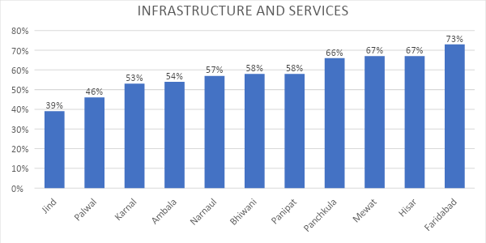

**Fig 1**: This figure shows thecompliance adherence of all the areas of the NRC for the respective districts.

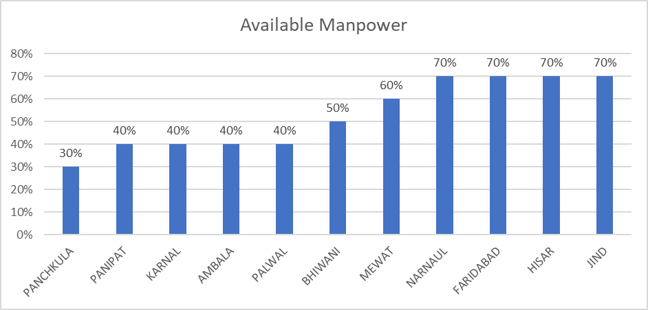

**Fig2** :This figure shows availability percentage of the health workforce in the NRCs of Haryana.

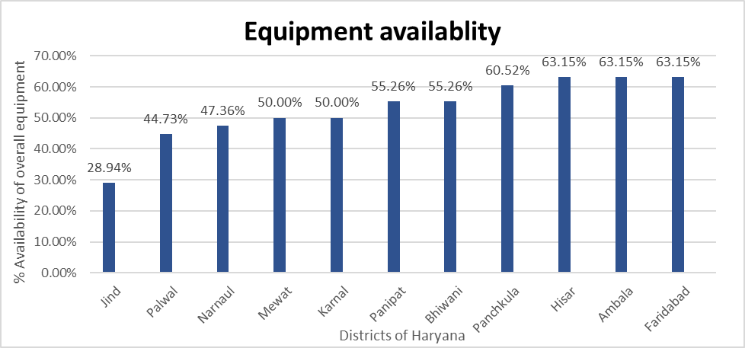

**Fig3**: This shows the availability of overall equipment in 11 districts of Haryana.

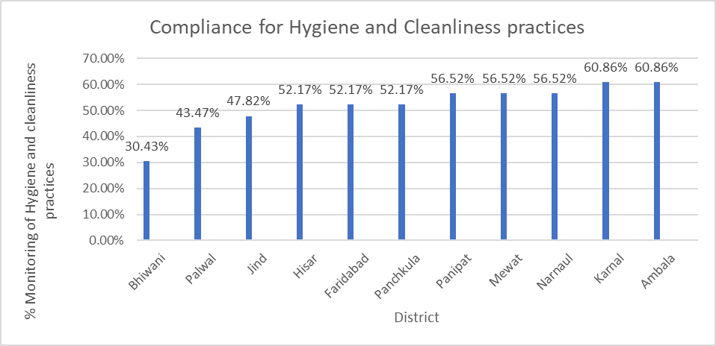

**Fig4**: This figure shows compliance of Hygiene and Cleanliness practices among the NRCs of 11 Districts

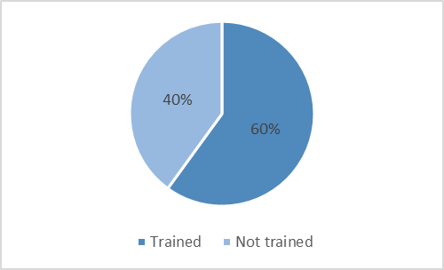

**Fig 5:** This figure shows the percentage of nurses trained in facility-based management of SAM children

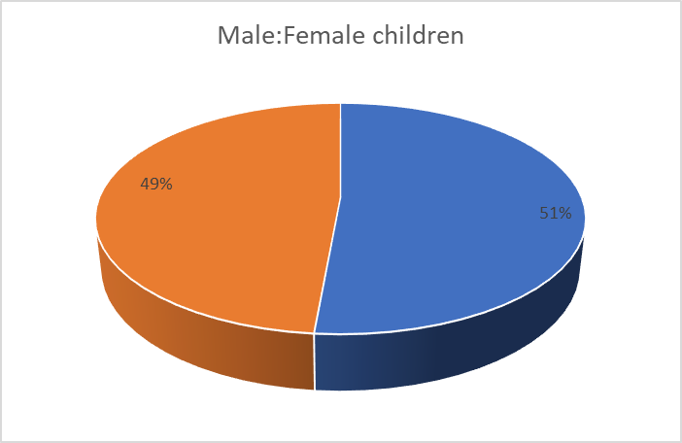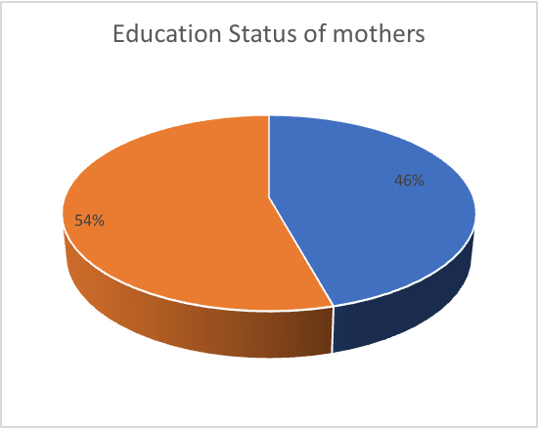

**Fig6**: Male: Female ratio of admitted SAM children and Educational status of mother whose child is being admitted.

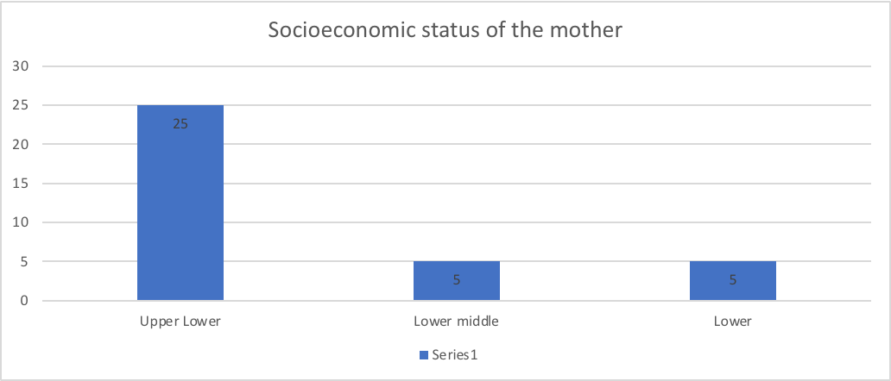**Fig7**: Socio-economic status of the mother.