**Internship Training At**

# “Rajiv Gandhi Cancer Institute & Research Centre”

## (February 7- May 7, 2023)

**A report on**

# “A Study on the Implementation Process of Blood Bank Information Management Module in PARAS at RGCIRC”

**By**

# Dr SHRUTI TYAGI (PT)

**Enrol No. - PG/21/150**

**Under the guidance of**

# Dr. Anandi Ramachandran

## PGDM (Hospital & Health Management) 2021-23



**INTERNATIONAL INSTITUTE OF HEALTH MANAGEMENT RESEARCH, NEW DELHI**

## Internship Training

**At**

# “Rajiv Gandhi Cancer Institute & Research Centre”

### (February 7- May 7, 2023)

**A report on**

# “A Study on the Implementation Process of Blood Bank Information Management Module in PARAS at RGCIRC”

**By**

**Dr SHRUTI TYAGI (PT)**

# Enrol No. - PG/21/150

**Under the guidance of**

# Dr. Anandi Ramachandran

**PGDM (Hospital & Health Management) 2021-23**



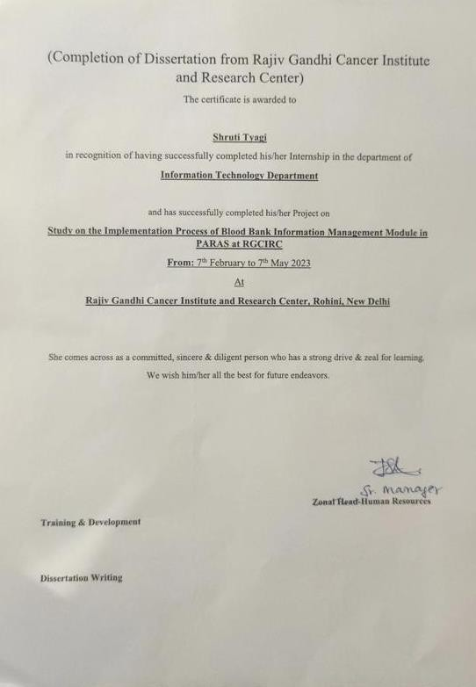

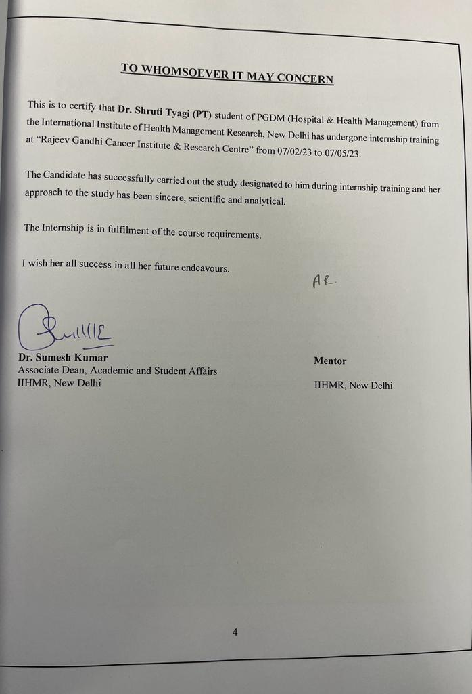

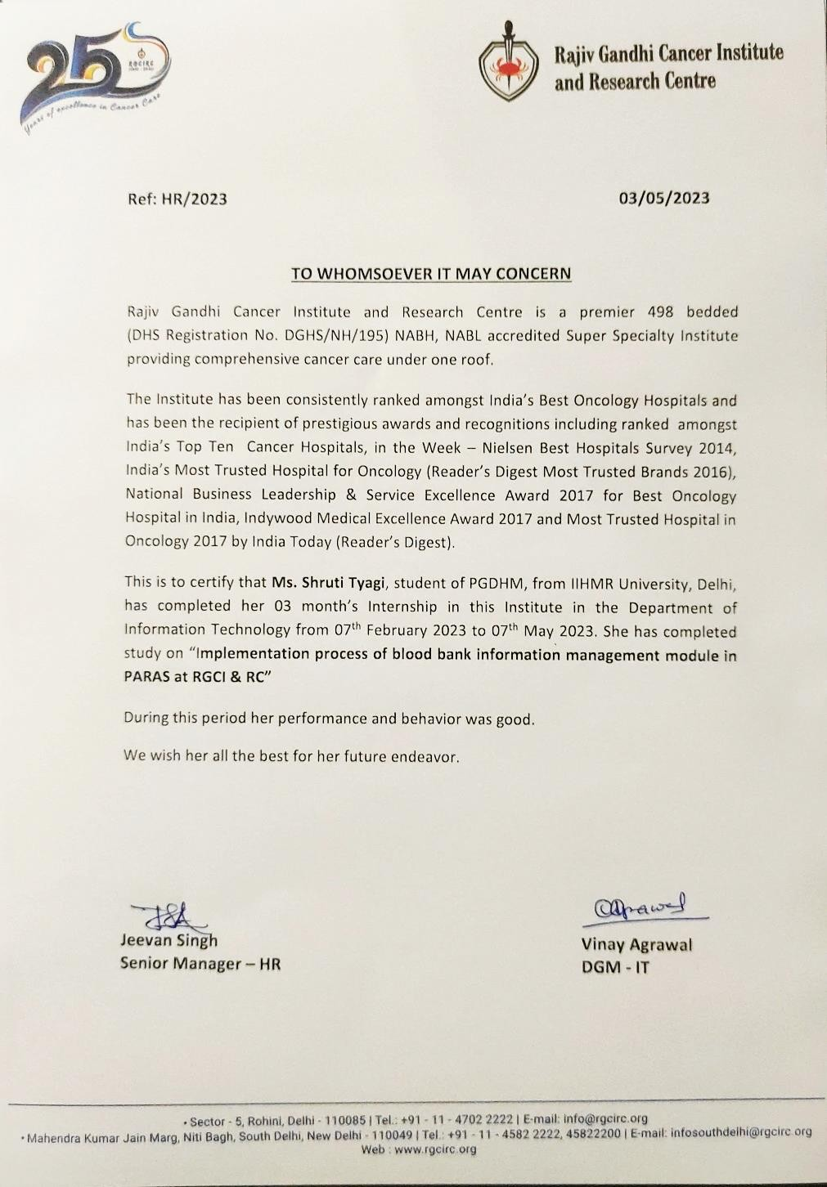

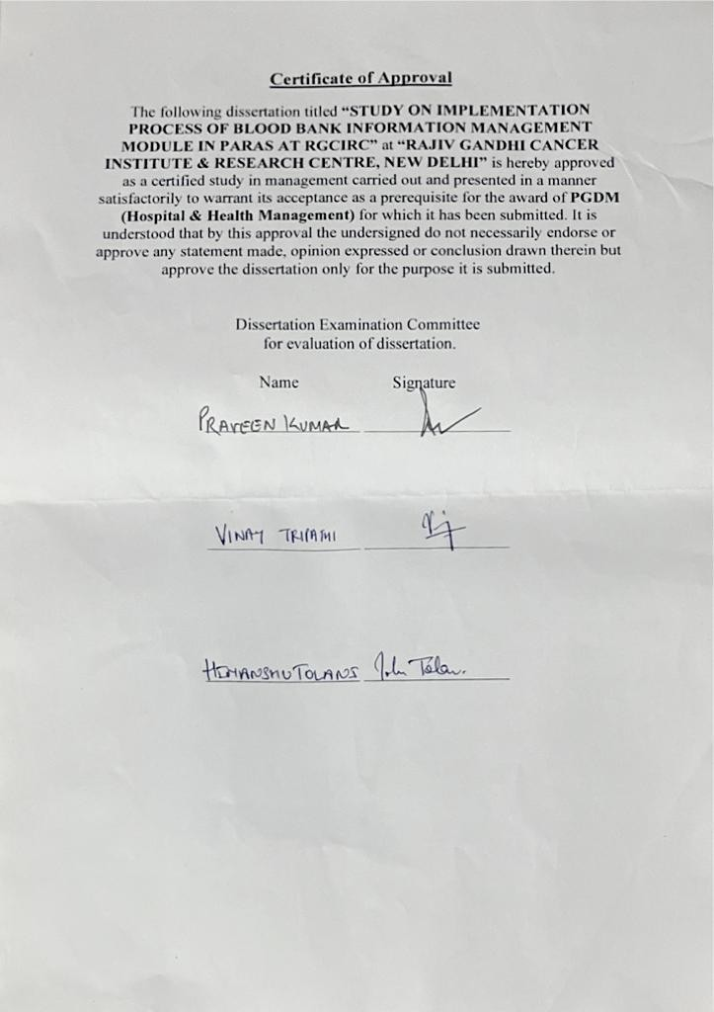

## Certificate from Dissertation Advisory Committee

This is to certify that **Dr Shruti Tyagi,** a participant in the Post-Graduate **Diploma in Health and Hospital Management**, has worked under our guidance and supervision. He is submitting this dissertation titled **“A Study on the Implementation Process of Blood Bank Information Management Module in PARAS at RGCIRC”** in partial fulfilment of the requirements for the Post- Graduate Diploma in Health and Hospital Management award.

This dissertation has the requisite standard and to the best of our knowledge, no part of it has been reproduced from any other dissertation, monograph, report or book.

### Institute Mentor Name, Organization Mentor Name Designation, Designation,

**Organization Organization**

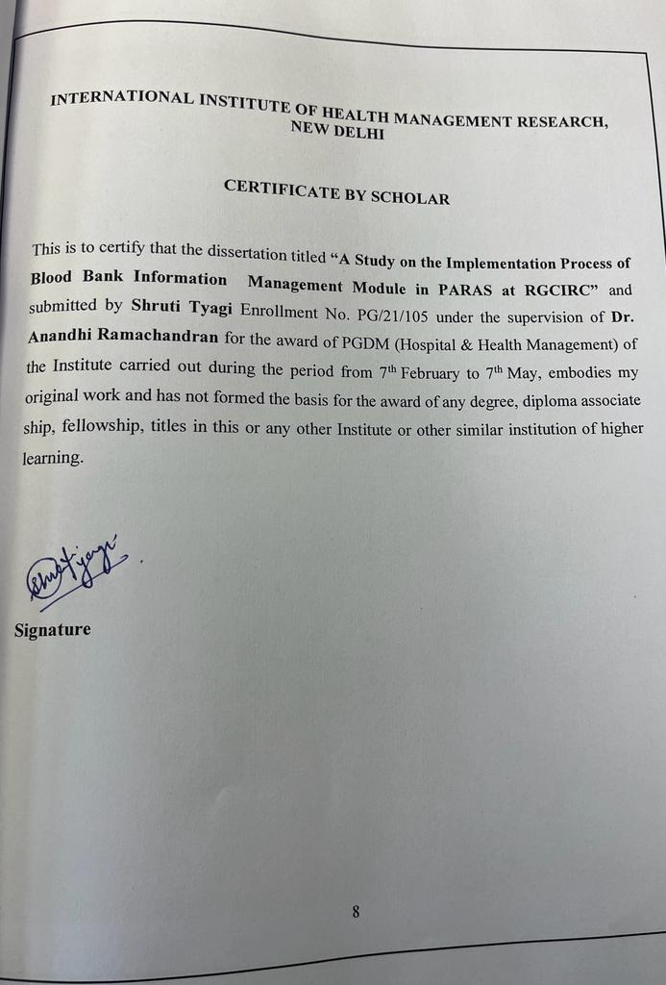

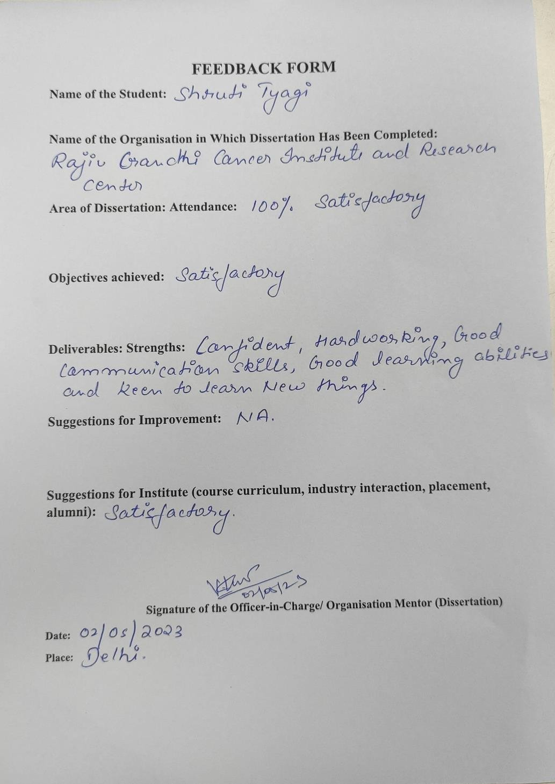

**Acknowledgements**

I am ever grateful to **Mr J.P.Dwivedi** for instilling faith in me to carry out my dissertation in RGCI&RC. I had a very rewarding and enriching experience during my training period. Besides, I would also like to thank the entire Healthcare IT team for their encouragement and cooperation in carrying out the project work.

I sincerely acknowledge Professor **Aanandhi Ramachandran** for their kind assistance and support throughout my dissertation.

Last but not least, I want to give credit to my friends and family for being understanding and encouraging me to finish this project.

Thank You,

### Dr Shruti Tyagi (Pt)

**PGDHHM,**

**IIHMR, New Delhi**

**Table of Contents**

|  |  |  |
| --- | --- | --- |
| **S. No** | **Content** | **Page No** |
| 1. | Acknowledgements | i |
| 2. | Certificates | ii |
| 3. | List of Contents | iii |
| 5. | Part I: Learning from Internship | 13-20 |
| 6. | Part II Chapter 1: Introduction | 21-26 |
| 7. | Chapter 2: Review of Literature | 27-35 |
| 8. | Chapter 4: Methodology | 36 |
| 9. | Chapter 5: Results | 37-43 |
| 10. | Chapter 6: Discussion | 44-45 |
| 11. | Chapter 7: Limitations | 46 |
| 12. | Chapter 8: Recommendations | 47 |
| 13. | Chapter 9: Conclusion | 48 |
| 14. | Chapter 10: References | 49-53 |
| 15. | Abbreviations | 54 |
| 16. | Glossary | 55-57 |
| 17. | Appendix | 58-60 |

**Abstract:-**

**Background:** Blood supply is critical in the healthcare system since it may save lives. Blood banks serve an important role in the collection, storage, and preservation of blood for transfusion services. However, most blood banks continue to operate manually, which can lead to inefficiencies and a lack of adequate documentation. Contaminated blood bags and a lack of coordination among donors, hospital officials, and blood banks might endanger patients' health. As a result, a Blood Bank Information Management System (BBMIS) is critical to ensuring the safety of blood transfusions. This system will handle the procedures involved in gathering, regulating, storing, analysing, and using information. The hazards associated with inadequate blood donor documentation and missing data can be decreased or avoided by establishing a BBMIS, and blood transfusion safety can be enhanced. Furthermore, operations such as blood bag collection, storage, and inventory can be systematised and organised, improving healthcare management. The primary goal of this initiative is to make the blood donation procedure easier for both donors and recipients.

**Objective**: This research aims to look at the process of implementing the blood bank module in PARAS at RGCIRC and conduct user acceptability testing on the module. The study's goal is to evaluate the software's capacity to perform real-world activities, evaluate the development specifications, and allow users to detect and report any faults in the system. This study's major purpose is to guarantee that the blood bank module is completely functional and satisfies the needs of the end users.

**Method:** A cross-sectional approach is used in the study to assess the installation process and user approval of the blood bank module in PARAS at RGCIRC. The study will take place at the RGCI Hospital's blood bank and IT department in New Delhi for three months, from February 7th to May 7th, 2023. A convenience sample approach will be used to gather primary data from 25 end users, including nursing staff, blood bank staff supervisors, and technicians who actively utilise the Blood Bank Module on HMIS. The data collecting technique will be structured questionnaires, with user satisfaction with the Blood Bank Module as the dependent variable and user experience and training/support as independent factors. The data-collecting approach will include getting participants' informed consent and delivering the UAT tool, which will include both open-ended and closed-ended questions. Microsoft Excel will be used for data analysis.

**Result:** A cross-sectional research involving 25 end-users at RGCI Hospital in New Delhi evaluated the user experience of the PARAS BBMIS blood bank information module. A systematic questionnaire was used to gather data, and the findings revealed that most respondents were able to enter and obtain donor information, but faced faults or mistakes when using the module. The majority of customers appreciated the inventory management capabilities and thought the module was more user-friendly than the Global Vista Blood Bank Module. 64% of users were happy, 32% were neutral, and 4% were disappointed with the module's performance. These findings indicate that PARAS BBMIS is beneficial for handling administrative activities, although there may be opportunities for enhancement to address user concerns.

**Conclusion:** Finally, the proposed research seeks to solve issues with the existing blood bank management system at RGCI Hospital by adopting the BBMIS system and conducting user acceptability testing to assess its performance. The proposed system's various characteristics are anticipated to increase the general effectiveness of blood collection, testing, and transfusion services. The research assesses the proposed system's efficacy in resolving the constraints of the current system and offering a user-friendly

interface that minimises manual data entry, assures data correctness, and decreases human efforts. The effective deployment of the proposed BBMIS system is projected to increase efficiency and create a safe environment for system users. By streamlining the blood donation process for both donors and recipients, lowering the hazards associated with incomplete blood donor paperwork and missing data, and reducing the risks associated with subpar blood donor paperwork and missing data, BBMIS implementation can improve healthcare management.

The study's findings may be utilised to improve the usability and functionality of the BBMIS system and the efficiency of RGCI Hospital's blood collection and transfusion services.

.

**Part- I**

# Introduction to Organisation

## Rajiv Gandhi Cancer Institute & Research Centre (RGCIRC)-

RGCIRC is based in Rohini, Delhi. This is a non-profit medical and research institute. This hospital is specialized in Cancer treatment and research. It offers specialized tertiary care services in surgical, medical and radiation oncology. The Specialists in RGCIRC perform Organ-specific multi-disciplinary practice for the diagnosis of cancer and its treatment, tumour board acts as a second opinion clinic for those cases that are much more critical the others.



With a present bed capacity of 300, RGCIRC spans an area of over 2 lakh square feet. The three levels of the RGCIRC's outpatient services include 57 consultation rooms as well as a thoughtfully constructed radiation therapy area. It contains a surgical ICU with 27 beds and a medical ICU with 11 beds. It has a separate Thyroid Ward as well as a Leukaemia Ward. Additionally, it offers a bone marrow transplant service that is independent and is recognised as the first MUD transplant.

Supportive services are offered by RGCIRC, including EBUS and endoscopic ultrasound as well as renal replacement therapy.

This hospital is dedicated to providing its patients with significant advantages of cutting-edge technology. Whole-body Robotic surgery, Intraoperative Brachytherapy, True Beam (Image Guided Radiation Therapy), High-frequency Ultrasound, Tom Synthesis—the first of its revolutionary 3D mammography machine, Nucleic Acid Testing (for the safest blood possible), and advanced diagnostic & imaging techniques, such as PET CT, circulating Tumour cell testing, and Next Generation Sequencing—are just a few of the best in class techniques offered by RGCIRC. Biorepository (Tissue Bank) has been developed by the Institute for use in clinical and research settings.

#### RGCI & RC - A Unit of Indraprastha Cancer Society

The Indraprastha Cancer Society & Research Centre is a non-profit organisation run by a group of philanthropists who take social responsibility seriously. The Society was established in 1994 by the 1860 Society Registration Act. In addition to patient care, one of the society's primary goals is to study and conduct scientific research on all facets of patient care, with a focus on determining the incidence, prevalence, distribution, aetiology, and symptoms of the disease as well as promoting its treatment.

Indraprastha Cancer Society & Research Centre's **Rajiv Gandhi Cancer Institute & Research Centre** is a visionary project that aims to give individuals in need of oncological care the finest possible care. The Governing Council, which oversees governance, and the Management Committee, which oversees the business of the institute, are at the highest level.

The institute began operations on July 1st, 1996, after Sonia Gandhi performed a soft opening. However, on August 20, 1996, Dr Shankar Dayal Sharma, the then-President of India, officially declared it open in the presence of Smt. Sonia Gandhi and other dignitaries.

It started as a 152-bed hospital but has since gradually expanded and never looked back. It currently has 241 beds and state-of-the-art equipment for cancer detection and treatment. It is regarded as one of the top institutions not only in northern India but also throughout the entire nation. Since its founding, the institute has demonstrated its capacity as a Centre of Excellence and has enrolled around 1, 25,000 patients from both India and beyond. The resources of our Institute are also being used by a sizable number of patients from Nepal, Bangladesh, Sri Lanka, and other nearby nations.

The mission of RGCI & RC is to continuously pursue excellence in patient care by utilising cutting- edge technology, qualified staff, and humanitarian touch. This is demonstrated by the addition of an IMRT (Intensity Modulated Radiotherapy Technique) and Colour Doppler methods unit in the years 2000 and 2002, respectively.

The institute installed 40 advanced PET-CT slices for cancer diagnostics in 2007. A 1.5 Tesla MRI with specialised equipment for cancer-specific diagnosis was also installed in the same year. Dexa Scan & PFT services were ordered in 2008–2009.

The institute has now put two cutting-edge Image Guided Radiation Therapy (IGRT) equipment into operation. Tumours that migrate internally or with respiration can be treated with this state-of-the- art technique. Throughout the whole course of therapy, the portion being irradiated is closely monitored using this approach. At RGCI & RC, radiation oncology combines the highest levels of accuracy and quality. Furthermore, we have installed MRI and PET-CT, which are special diagnostic tools. The most recent advancement in technology is the Da Vinci robotic surgical system, the first of its type to be used in an exclusive cancer hospital in India.

* 1. **Vision**

To establish an Oncological Institution of International excellence providing facilities for Cancer Diagnosis, Treatment, Education, Training and Research based upon ethical, scientific, and professional principles following the latest management trends, particularly in quality and environment.

“The Institute strives to meet Major unmet Medical needs in the field of Oncology with its Innovative Diagnostics, Therapeutic Services & Support Services.”

### Mission

To update the Institutional facilities in line with the updated global modernization scenario to ensure that the best in Oncology can be delivered to the maximum possible population in the most cost-efficient manner. To achieve this goal by establishing up to a maximum of 400 beds in the present campus and by outreach programs through satellite centres with collaborations and affiliation with centres of repute and through a telemedicine network.

### Values

Rajiv Gandhi Cancer Institute & Research Centre always holds its patients, who come for diagnostic and therapeutic treatment, in high esteem. It also encourages teamwork, mutual respect and trust among the management, consultants, resident doctors, medical and Paramedical, and the staff of supportive services. Transparency, proper diagnosis, proper treatment and correct advice, to the patients, are the hallmarks of this institute.

### 1. Area of Engagement

During my internship, I was actively engaged in the organization's Blood Bank Implementation Project. The goal of this project was to deploy a newly developed and efficient Blood Bank Information Management System (BBMIS) into the HMIS PARAS. Blood is crucial in the medical field, and it is critical to consolidate and simplify its safe, secure, and timely transactions. To do this, it was required to integrate a BBMIS into the HMIS to decrease human efforts while enhancing efficiency and accuracy.

During my internship, I was largely involved in the BBBMIS Implementation program, which was overseen by RGCI&RC's IT department. My responsibilities included overseeing the smooth installation of the BBMIS and HMIS, as well as assisting the Blood Bank's end-users acceptance of these systems.

### Routine or general management

* Monitoring the Blood Bank's Functional Flow and Activities: The research entailed intensively watching and recording the blood bank's functional flow and activities to understand the present procedures and find opportunities for improvement.
* Training Blood Bank Employees on How to Use the Newly Designed Blood Bank Module on HMIS: Training sessions were held to familiarise blood bank personnel with the features and operation of the newly built HMIS blood bank module. The training intended to guarantee that the person could use the module successfully and efficiently in their day-to-day responsibilities.
* Coordination and Training of Nursing Personnel from Various Nursing Stations: Nursing personnel from various nursing stations were taught the use of the HMIS Blood Bank Module to allow smooth communication and collaboration. This training allowed them to release hints and blood requests via the module.
* Adoption of the New HMIS Blood Bank Module: Observing and Analysing Issues: The study entailed monitoring and analysing the difficulties and issues encountered throughout the implementation phase of the new HMIS Blood Bank Module. The goal of this investigation was to identify adoption hurdles and viable remedies.
* Coordination using "Shukra" for Machine Interfacing with HMIS PARAS: Coordination efforts were performed with the "Shukra" team as part of the research to guarantee the effective interface of machines with HMIS PARAS. This interface enabled the blood bank machines and the HMIS module to exchange data in real-time.
* Running a Parallel Run to Monitor Real-Time Module Usage: A parallel run was carried out to examine the blood bank module's real-time usage by blood bank employees. This allowed the

researchers to evaluate the module's performance, identify any problems, and solicit input from end users.

* Technician and Technical Supervisor Training in Machine Interfacing with HMIS: Technicians and technical supervisors were instructed on how to use HMIS' machine interface capability to test samples and create results. This training was designed to assure their competency with this feature.
* Creating a Risk Management Matrix in Advance of HMIS Blood Bank Adoption: To identify and minimise possible risks connected with the introduction of the HMIS Blood Bank Module, a risk management matrix was created and executed. This phase was designed to facilitate a seamless transition and minimise any negative consequences.
* Supporting End Users During GO-LIVE: During the GO-LIVE phase of the HMIS Blood Bank Module, the researchers offered support and assistance to end users. This assistance aided in addressing any immediate concerns or challenges that users had during the first deployment period.
* Preparing the Daily Adoption Report: A daily adoption report was created during the implementation process to track progress and describe any notable changes or obstacles encountered. This report documented the installation process.
* The research study aims to obtain insights into the deployment process of the Blood Bank Module on HMIS PARAS, assess its acceptance by end-users, and suggest areas for improvement to improve the module's efficacy and usability by carrying out these tasks.

### In-depth study

The introduction of the Blood Bank Module in the HMIS PARAS system at RGCI&RC was the major subject of this research project. Certain modules were previously controlled using Global Vista; however, an ongoing effort is underway to combine all modules into the HMIS framework. The implementation procedure began in 2020 and is still ongoing. The goal of this research was to thoroughly understand the Blood Bank's workflow and to assess the impact of integrating the Blood Bank with the HMIS system. The study's specific goal was to investigate end-user perceptions during the deployment phase.

A cross-sectional approach was used to fulfil the study goals, with the Blood Bank and IT Department of RGCI Hospital in New Delhi being targeted. A standardized questionnaire was issued to Blood Bank Staff, including technicians and supervisors, to collect primary data. A two-week parallel run was done before the distribution of the questionnaire to teach end-users about properly understanding and utilizing the Blood Bank Module inside the HMIS system. Following the User Acceptance Testing (UAT) phase, a questionnaire was distributed to elicit input from end users. The questionnaire was designed to gather information about their experiences and satisfaction with the HMIS Blood Bank Module.

The acquired data was thoroughly analyzed to find any weaknesses or opportunities for improvement. Based on the findings, recommendations were developed to solve the highlighted problems and improve the implementation process. The research study adds to the general understanding of integrating different modules inside the healthcare information management system by providing useful insights into the challenges and accomplishments of installing the Blood Bank Module in the HMIS PARAS system.

### Managerial Tasks Done in Departments

#### In Blood Bank my role was to:-

* + - Coordinate with Blood Bank Supervisors to observe any discrepancy in functional flow/ Activities
    - Coordinate and Observe Blood Bank Technicians to analyse any bugs and errors within the proposed Module
    - Prepare a daily Report of observed Bugs/errors
    - Monitor and Train Blood Bank Staff in using the proposed module
    - Coordinate with IT Supervisors and Project Managers on progress on the adoption of the proposed Module

#### In IPD my role was to:-

* + - Monitor and Train Nursing staff Staff in using the proposed module to release intimations, request Blood and receive Blood.
    - Analysing any bugs and errors in the module
    - Gathering Requirements and change management

### Reflective Learning

During the entire duration of the Internship, there has been a lot of learning from all the quarters’

i.e. from officials on-site as well as off-site. Apart from that the experience of the mentor has been very useful for knowledge transfer.

Some of the learning during the entire internship programme is as under

Practical issues involved in the various stages of the implementation may result in deviations from the project plan.

* + The various perceived risks and benefits among the users regarding the implementation.
  + The various barriers observed during the different stages of implementation and the various strategies mulled to remove the hindrances.
  + The basic workflow followed by the RGCI&RC to carry out their processes, the shine points of the workflows as well as the limitations in the current workflows which can be sorted out.
  + The Blood-Bank Module of the EHR which is in the process of Implementation, the various functionalities supported by it as well as the various areas in the module which require customization as per the user requirements.
  + The various techniques to handle the user are changing the state of mind and convincing the users to accept the change process by informing them of the various benefits of the change process.
  + The various techniques involved ensure the end user participation throughout the implementation process to instil a sense of belongingness in the end user regarding the HMIS Blood Bank Module. This would ensure better acceptability among the users.
  + The techniques to bring the ideas of Top Management and the End users at the same table to ensure similarity between the two and make efforts to iron out any differences between the two. The different ways to gauge the level of competence of the end users are to determine the level of training that needs to be provided to equip them with the necessary knowledge required by the end users to run the EHR efficiently. This will also help in the identification of core end-users who use the module critically which could help in the smooth transition to the new EHR. The interpersonal skills required in such big projects ensure the continuity of operations.

## Key Learning During Internship

* + - Understanding the Functional Flow of Chemotherapy Module
    - Understanding the practical implications of planning and requirement gathering for the implementation of a module
    - Understanding the live issues faced by end-users and how to support and address those issues.
    - How to manage changes in requirements of end-users.
    - How modalities are integrated with HMIS using interfacing
    - Navigating and training end-users to efficiently use the module
    - Understanding the Importance of Functional Testing
    - Understanding and Conducting User-Acceptance Testing
    - Understanding Glitches presented due to Technical errors made by Staff, carefully observing their working style and identifying the underlying issues responsible for glitches
    - Presenting ways to solve habitual issues of staff that lead to technical glitches

**WORKED IN THE FOLLOWING MODULE IN THE ORGANISATION: -**

1. BLOOD BANK MODULE IMPLEMENTATION
2. NURSING- BLOOD BANK MODULE IMPLEMENTATION
3. OPERATION THEATRE (Scheduling, Delay and Cancellation of Surgeries)
4. DISCHARGE MODULE (Discharge TAT)
5. CHEMO MODULE

**PART-II**

## Chapter-1

**Introduction**

A vital part of the medical system is blood. All blood donations are voluntary, and the blood can thereafter be utilised to treat patients or to make therapeutic products. Blood can be divided into different components that can then be utilised as needed in the future. It is essential to guarantee that blood is always available in blood banks because the need for blood in hospitals can develop at any time. Blood banks are special locations with personnel and equipment for the collection, storage, and preservation of blood.20

An establishment where collected blood bags are stored and preserved for use in blood transfusion services in the future is a blood bank, often referred to as a blood collecting centre. A blood transfusion is a medical procedure in which a patient requires blood or blood products to save his or her life. Most blood banks still use a manual approach in their operations4. As a result, there is inefficiency because information regarding donors, blood bag inventories, and blood transfusion services are still collected on paper. Due to the likelihood of contaminated blood bags, a lack of sufficient documentation may harm patients' health. Contamination can occur when a donor's medical history record was insufficient and the shelf life of the blood bags was not properly checked. As a result, a Blood bank information management system may be required to handle these concerns and problems to ensure blood transfusions' safety.8

An information management system for synchronisation between blood donors, hospital administrators, and blood banks whenever blood is urgently needed. Improper communication and a lack of synchronisation in the blood bank render the data vulnerable to inaccuracies, resulting in the waste of available blood and the loss of life. From registration through donation, a high-end, efficient, highly accessible, and scalable system for easy registration of donors and receivers, as well as an automated management system for blood bank desk administrators, must be established.5

Blood Bank Information Management System (BBMIS) deals with the processes associated with collecting, controlling, retaining, analysing and using information. Before each blood donation can be deemed fit for use, a variety of information must be gathered, analysed, and interpreted throughout each step of the blood transfusion chain in a facility that performs any or all of the functions from blood collection to the issuance of compatible blood for transfusion to a patient. Additional information must be processed to ensure compatibility between the donation and the patient.9 The Blood Bank management system is an essential quality system element and contributes to documentation and record keeping.6

A blood bank information management system is expected to increase or improve the safety of blood transfusions. Risks related to incomplete documentation and missing data for blood donors can be minimised or even eliminated. Additionally, operations including blood bag collection, storage, and inventory will be systematised and organised, which will improve healthcare management.6. The Blood bank management system may assist & regulate the blood flow process and close system flaws. The major purpose of this project is to make the blood donation process as simple as possible for donors and recipients.4

## 1.1 Existing System

The Blood Bank is an essential component of every healthcare facility, and it plays an important role in assuring the prompt availability of healthy blood and blood products for transfusion patients4. The hospital's Blood Bank is currently operating on a CIS-Global Vista Platform that is not connected to the hospital's HMIS System. This lack of integration is a serious issue since it leads to system inefficiencies and deficiencies, notably in the areas of Interface, Inventory, and Administrative Management. As a consequence, the present system is constrained and unable to adequately meet the requirements of the user. The inefficiency and insufficiency of the present Blood Bank system illustrate the need for an integrated Blood Bank Information Management System that can solve the existing system's inadequacies while also providing a more efficient and user-friendly experience for patients and staff alike.8

### Problem Found In Existing System

* At present there is no interfacing of Serology and TTI testing Machines with the system
* Required more human efforts in maintaining some modules of Blood Bank Manually such as Testing and Blood Grouping.
* Manually keeping the accounts is also a tedious & risky job which makes data susceptible to human error.
* Difficult to manage and maintain Bulk Blood Issues.
* Increased Human Effort in the Generation of Issue Slips and Blood Reports
* Obtaining, storing, and updating the data take a lot of time.
* It is challenging to remember whom he last gave or received blood from in terms of the donor and recipient records.
* It needs upgradation.

## Proposed System

PARAS BBMIS is an HMIS integrated systematically designed system for fulfilling the requirements of stakeholders and decision-makers. Meet the transfusion demands of all patients includes developing an information system with well-managed and coordinated blood transfusion services as well as a sufficient and timely supply of safe blood and blood products.7 It is intended to store, process, retrieve, and analyse information about the administrative, inventory management, and clinical elements of blood bank service provision. It allows operations like the collection of blood, plasma, and other blood components from low-risk, frequent, voluntary donors by developing donation systems and adequate donor management, including care and counselling.15

* **Donor Registration Form:** Donor information is maintained in the information system. When a donor registers, a unique identification number is immediately provided to him/her, which remains the same throughout the donor's life. Any subsequent gifts made by the same contributor were connected to the same identifying number.
* **Donor physical and medical information:** The system allows the user to save physical and medical information about the donor at registration, which may later be modified during subsequent donations. The application also allows users to examine the eligibility criteria of donors for making gifts, based on vitals that maintain track of delayed donors for future referrals.
* **TTI screening and Serology Testing:** All donated blood is subjected to quality-assured screening for transfusion-transmissible illnesses such as HIV, hepatitis B, hepatitis C, and syphilis. Confirmatory testing is performed on all donor blood that tests positive for infection.
* **Inventory management:** The BBMIS system allows users to organise and manage their blood bank's inventory (Blood bags, blood components, etc.). The user can save data for blood bags

already in the bank, as well as blood components manufactured and imported into the bank. Each unit/component will be allocated a unique ID, from which a bar code may be produced and put on the bags themselves for further identification.

* **Blood donation and cross-matching:** The BBMIS enables users to request blood and blood transfusions, for which cross-matching may be conducted using appropriate technology and the results can be processed and analysed by specialists before the blood is supplied. At the same time, numerous reports for blood procurement and cross-matching may be created.
* **Secured environment and login facility:** The system provides a secure environment for users to operate inside the programme by accepting login IDs and passwords from them.
* **Report generation:** The end user generates a variety of detailed reports to monitor the performance metrics in the blood bank as well as to examine the inventory and other elements in the blood bank.

The proposed PARAS BBMIS intends to improve the present blood bank management system's usability by satisfying users' demands and assuring their satisfaction. The suggested system attempts to provide security by resolving the flaws of the present system by ensuring-

* Security of Data
* Establish the Accuracy of Data
* Minimize Manual Data Entry for Serology and TTI tests through Interfacing
* Minimize the time needed for data processing
* Greater Efficiency
* User-Friendly
* Reduces Human Efforts in Blood Grouping, Testing and Report Generation

## Advantages of the Proposed System

* **Increased Efficiency:** The technology improves the blood bank's inventory management, blood donation, and cross-matching operations, saving time on data processing and blood transfusion requests. This improves the blood bank's operational efficiency.
* **Increased Accuracy:** The system enables the accurate recording, storage, retrieval, and analysis of information relating to the administrative, inventory management, and clinical operations of the blood bank. The integration of the system with HMIS guarantees that patient information is up-to-date and correct, resulting in better patient care.
* **Enhanced Security:** With login IDs and passwords necessary to access the system, the system provides a secure environment for users to function inside the programme. This safeguards the safety and privacy of donor and patient information.
* **User-Friendly:** The system is intended to be user-friendly, allowing users to easily input, retrieve, and analyse data. This decreases the amount of physical effort necessary while increasing production.
* **Donor Management:** The system offers complete donor management, including registration, physical and medical information, and donation eligibility requirements. This assures a consistent supply of safe blood and blood products for patients' transfusion requirements.
* **Report Generation:** The system provides thorough reports to monitor the blood bank's performance indicators and inventory. This enables decision-makers to make educated choices about resource allocation, donor recruitment and retention, and blood product distribution.

Overall, the PARAS BBMIS system has several advantages that can increase blood bank efficiency, accuracy, security, and donor management.

## User Acceptance Testing

During the essential User Acceptance Testing (UAT) stage of software development, the system is tested from the viewpoint of the end user. It concentrates on making sure the system satisfies the user's requirements, performs as anticipated, and is prepared for deployment. UAT is essential because it allows users to validate the system's functionality, usability, and compatibility with their specific needs and workflows. By involving end users in the testing process, UAT helps to identify any issues or discrepancies between the system and user expectations before it goes live. In the context of the proposed Blood Bank Information Management System (BBMIS), including UAT in the research study is important as it provides an opportunity to gather feedback from blood bank staff, healthcare professionals, and other stakeholders involved in the blood transfusion process. Their input and validation during UAT can ensure that the system is user-friendly, efficient, and aligned with the requirements of the healthcare facility. Additionally, UAT helps to uncover any usability or functional issues that may have been overlooked during the development phase, allowing for necessary improvements and adjustments to be made before implementation. By including UAT in the research study, the study can demonstrate the practical benefits and effectiveness of the proposed BBMIS in real-world scenarios, enhancing its credibility and potential for successful adoption.

## Problem Statement:

RGCI Hospital is currently experiencing several challenges with its existing CIS-Global Vista Blood Bank software, which is used for blood bank management. The hospital's blood bank operations suffer from inefficiencies and deficiencies in donor records management, inventory management, and administrative processes. The current system lacks proper donor record management, resulting in inaccuracies and delays in tracking donor history and blood compatibility. Additionally, the inventory management system does not provide real-time updates on blood inventory levels and expiration dates, leading to waste of blood products and potential shortages. Furthermore, the administrative management system is outdated and inefficient, causing delays and errors in appointment scheduling, blood product issuance, and documentation management. To address these issues and improve the efficiency and standardization of blood transfusion services, RGCI Hospital has decided to integrate the existing blood bank information system with the PARAS Hospital Information System. However, to ensure seamless integration and successful implementation, it is essential to conduct a comprehensive evaluation and testing of the system. Therefore, the purpose of this research is to study the implementation process of the Blood Bank Information Management Module (BBMIS) in PARAS at RGCI Hospital and conduct User Acceptance Testing of the module. The goal is to identify and resolve any usability and functionality issues, ultimately leading to higher user satisfaction and acceptance of the system. Through this research, the integration of BBMIS with PARAS HMIS has the potential to significantly improve the efficiency and standardization of blood transfusion services in RGCI hospitals.

## Rationale:

This research study is conducted to address the existing challenges and issues faced by RGCI Hospital in managing its blood bank operations. The implementation of the Blood Bank Information Management System Module in PARAS HMIS is intended to improve the quality, standardization, and efficiency of Blood Transfusion Services. By integrating the existing blood bank information

system with PARAS Hospital Information System, the hospital aims to overcome the shortcomings of the current system and enhance the overall management of donor records, inventory, and administrative processes. This research is crucial to ensure successful integration and to evaluate the effectiveness of the proposed solution in meeting the specific needs and requirements of RGCI Hospital.

## Objectives:-

* Primary Objective:
  + To study the Implementation Process of the Blood Bank Module in PARAS HMIS at RGCIRC and conduct user Acceptance Testing.
* Specific Objectives:
  + Understanding the Blood Bank Management System
  + Carrying Out User-Acceptance Testing to Identify Bugs& Errors in the system.

## Hypothesis: -

* + - The effectiveness and standardization of blood transfusion services at RGCI Hospital will be enhanced through the integration of the Blood Bank Information Management System (BBMIS) with PARAS HMIS.
    - User Acceptance Testing (UAT) of the BBMIS module will identify and resolve any issues related to usability and functionality, leading to higher user satisfaction and acceptance of the system.
    - The results of the UAT will provide valuable insights into the effectiveness of the BBMIS module and can guide further improvements in the system.

## Scope of the Study:-

* + - The study will provide insights into the effectiveness of the integration of the Blood Bank Module with PARAS HMIS and identify areas of improvement for the overall quality, standardization, and efficiency of Blood Transfusion Services at RGCI Hospital.
    - The findings of the study can be used to improve the BBMIS system's usability and functionality, making it more efficient and user-friendly.
    - The study provides an opportunity to identify areas for improvement in the current blood bank management system, leading to better healthcare management.

## Significance of the Study:-

The significance of this study lies in its potential to improve the overall quality, standardization, and efficiency of Blood Transfusion Services at RGCI Hospital by integrating the Blood Bank Information Management System Module with PARAS HMIS and conducting User Acceptance Testing. The study can provide insights into the effectiveness of the integration and identify areas for

improvement, leading to better healthcare management. Additionally, the study's findings can guide further improvements in the system, making it more efficient and user-friendly. Ultimately, the successful integration and implementation of the BBMIS module with PARAS HMIS can have a significant impact on improving patient care and outcomes.

## Chapter-2

**Review of Literature**

1. **"Blood Donation Management System" by Ak`kas Ali et al.** presents a web-based system for managing blood donation activities. While the authors highlight the importance of blood donation and the challenges of managing blood supplies, they do not provide any empirical evidence to support the effectiveness of their proposed system. The article provides a detailed description of the features of the Blood Donation Management System (BDMS), including donor registration, blood screening, inventory management, and donor notification. The authors argue that the BDMS can help blood banks and hospitals to better manage their blood supplies, reduce waste and errors, and improve the quality of care for patients. However, the article does not provide any data or evaluation of the system's effectiveness in practice. Therefore, it is unclear whether the BDMS has achieved its intended goals or whether it has been successfully implemented in real- world settings. Moreover, the article does not address any potential limitations or challenges associated with implementing such a system. In summary, while the article provides a detailed description of a proposed blood donation management system, it lacks empirical evidence to support the effectiveness of the system. Further research is needed to assess the system's impact on blood donation rates, donor satisfaction, and healthcare outcomes, as well as to address any potential challenges associated with implementing such a system.1
2. **Ansari and Site's (n.d.) article focuses on creating an efficient and safe blood bank administration system to replace time-consuming manual methods.** The research emphasises the need for an automated system and reports on how the waterfall model was used to develop and construct the suggested solution. According to the authors, the devised system is user- friendly, dependable, and efficient, allowing for real-time access to blood bank data while reducing human mistakes. The authors surveyed to collect information about the present blood bank management system and to suggest areas for improvement. They designed and implemented the suggested system using the waterfall approach of software development. According to the study, the proposed system is user-friendly, dependable, and efficient, allowing for real-time access to blood bank data while decreasing human mistakes. The study, however, had certain drawbacks. The study methodology was not fully stated, nor was the survey sample size given. Furthermore, the study does not compare the proposed system to existing blood bank management systems. As a result, while the study provides useful information, more research is required to confirm the usefulness of the suggested system and compare it to other current systems.2
3. **Benedict et al. presents an online blood banking management system** based on a framework- based approach to handle blood supply shortages and increase management efficiency. They give a thorough examination of existing systems, identifying their strengths and weaknesses. With a user-friendly interface, real-time updates, and secure data storage, the proposed system comprises modules for donor management, inventory management, and blood request management. The study includes a usability evaluation, which shows that the suggested system is simple to use and outperforms existing solutions. However, a disadvantage is the absence of empirical evaluation beyond usability testing. Additional confirmation would bolster the study's conclusions.3
4. **Jagriti's article "Blood Bank Management System"** presents a summary of a web-based programme developed to manage blood bank activities. The essay discusses the difficulties connected with controlling blood supply and suggests that an effective blood bank management system can assist in addressing these difficulties. The article discusses the Blood Bank Management System (BBMS)'s core features, which include donor registration, inventory management, blood screening, and donor notification. The system also contains facilities for tracking blood consumption and waste, as well as for creating reports to analyse the blood bank's performance. While the article provides a general overview of the BBMS, there is no empirical evidence to support the system's effectiveness. The article provides no statistics on the BBMS's deployment in real-world situations or its influence on blood donation rates, donor satisfaction, or healthcare outcomes. Furthermore, the article makes no mention of any potential limitations or challenges associated with putting such a system in place. The article, for example, makes no mention of any possible privacy or security problems associated with collecting and keeping donor information in a digital system. In conclusion, while the article gives a comprehensive description of a blood bank management system, it lacks actual data to support the system's usefulness. Additional research is required to assess the system's impact on blood donation rates, donor satisfaction, and healthcare outcomes, as well as to identify and address any potential limitations or challenges associated with implementing such a system.4
5. **Chawan et al.'s work "Blood Bank Management System"** describes a software system aimed to improve blood bank administration. The authors describe the difficulties that blood banks have in maintaining an adequate supply of blood, as well as the necessity for an effective system to handle the blood donation and distribution process. The article's suggested system covers functions such as donor registration, inventory management, blood grouping, and cross-matching. According to the authors, the approach will help reduce the time necessary to handle blood donation requests, enhance inventory management, and raise overall efficiency. Furthermore, the article provides no insight into the development process or the technologies used in system implementation. Overall, the study proposes an intriguing proposal for a blood bank management system, however, the absence of empirical proof or technical specifics raises concerns about the suggested system's practicability and efficacy.6
6. A recent paper published in the **International Journal of Scientific Research Engineering & Management (IJSREM) titled "Design and Implementation of Blood Bank Management System"** The research focuses on the creation of a blood bank administration system with PHP and a MySQL database. The page includes a thorough explanation of the system's many components and operations, such as donor and recipient registration, inventory management, and blood requests. The authors also describe the benefits of the suggested system, which include increased efficiency, less manual labour, and increased security. The research does, however, have certain shortcomings, including a lack of a full review of the system's performance and scalability. Furthermore, the research did not take into account the adoption of sophisticated technologies such as artificial intelligence or machine learning, which might increase the system's accuracy and efficiency even further. Overall, the paper is interesting and well-written, but it lacks a more critical study and evaluation of the performance and potential limits of the suggested system. Nonetheless, it makes an important contribution to the field of blood bank management systems and can serve as a starting point for future research.7
7. **Divyabharathi and Kathiresan's research paper presents an automated blood bank and patient management system using Raspberry Pi.** The authors emphasise the importance of a

dependable and efficient blood bank system to enhance patient outcomes and eliminate mistakes. The article offers an in-depth look at the system's development, covering the hardware and software components employed in its implementation. The paper also examines the suggested system's benefits, such as its capacity to handle massive volumes of data and assure proper blood inventory management. The lack of a particular publishing date and peer-review status, on the other hand, may raise concerns about the veracity of the content offered. Furthermore, the research focuses solely on the technical elements of the system's creation and provides no data on its deployment or assessment, limiting its practical usefulness.8

1. **Coelentera's research study on "Blood Bank Management System"** presents an overview of their ERP Blood Bank software, which is designed to manage blood bank operations. The article highlights the software's different capabilities, including inventory management, donor management, blood grouping and testing, and transfusion management. The report, however, lacks specifics on the software's operation and does not present any research-based proof to back up its assertions. While the article presents an intriguing solution to blood bank management, its usefulness is limited by a lack of technical details and research-based evidence. Furthermore, the article does not address any potential limitations or challenges in implementing the software, making evaluating its effectiveness difficult. Overall, while the paper emphasises the significance of competent blood bank management, it falls short of presenting adequate data to justify the efficacy of the recommended approach.9
2. **Halle, Pakhare, and Funde's study "Blood Bank Management System"** details the creation of a web-based system to manage blood bank operations. The research includes a thorough examination of the system architecture, user interface, and functionality. The authors emphasise the significance of a computerised system in managing the complicated operations of blood banking, such as donor registration, blood testing, inventory management, and blood transfusion. The research proposes a complete approach for addressing the different issues that blood banks confront, such as the requirement for accurate record-keeping, effective inventory management, and prompt donor notification. The article also addresses the system's advantages, such as higher data accuracy, improved reporting capabilities, and increased efficiency. However, the study lacks empirical evidence on the actual implementation and evaluation of the system, limiting the findings' generalizability. Nonetheless, by presenting a well-designed system with a comprehensive set of features that can potentially improve blood bank operations, the article adds to the existing literature on blood bank management systems.10
3. The article "**Hospital management information system software company India, Electra HIS"** highlights the ACGIL Blood Bank Management Software. The programme is intended to manage all aspects of the blood banking process, including donor registration, blood collection, processing, testing, and delivery. The article gives a quick description of the software's capabilities and emphasises the benefits of utilising it, such as enhanced efficiency and accuracy in blood bank administration. However, there is no empirical evidence in the article to support the software's effectiveness in improving blood bank management. It also makes no mention of any limits or difficulties involved with utilising the programme. Furthermore, the article is promotional in nature, to promote the software rather than provide a critical analysis of the literature on blood bank management systems. Overall, while the article gives an overview of the capabilities of the programme, it lacks critical analysis and practical data to back up its assertions.11
4. **Kayode et al.'s (2019) research article "An Android-based blood bank information retrieval system"** presents a mobile application that allows efficient and effective blood donation and retrieval activities in a blood bank. The paper presents an outline of the issues that blood banks face, as well as how the suggested system addresses these challenges. The researchers performed a survey to collect data on the issues encountered by blood banks in Nigeria, and a user satisfaction survey was used to evaluate the suggested system. Overall, the study provides a beneficial answer to the difficulties confronting Nigerian blood banks. The Android-based blood bank information retrieval system is a realistic and effective solution that may increase blood bank efficiency and accuracy. The paper presents a thorough review of the issues confronting Nigerian blood banks, which serves to contextualise the relevance of the proposed approach. However, the scope of the study's evaluation is limited, as it only includes a user satisfaction survey. More extensive evaluations of the system's performance and its impact on blood bank operations should be considered in future studies.14
5. The research study **"Blood Bank Management System" by Parmar, Bagadiya, and Chaudhary** describes a web-based programme for blood bank management. The authors stress the need for effective blood bank management to guarantee that blood and blood products are readily available for patients in need. The article describes the system's features in-depth, including inventory management, donor administration, and blood request management. The essay also goes through the benefits of adopting a web-based system, such as access and real-time data changes. Overall, the essay provides useful information about the design and implementation of a blood bank management system. However, a lack of information on the system's performance metrics and user feedback makes assessing the system's effectiveness in meeting the needs of its stakeholders difficult.25
6. The article **"Design and Implementation of the e-blood bank" by Madhu Kumar and Supriya** describes a web-based electronic blood bank management system to increase blood bank administration efficiency. The paper outlines the e-blood bank's design and execution, which includes donor registration, blood collection, testing, storage, and delivery. The writers created the system with PHP and MySQL and tested it on a local server. The study demonstrates that the system can manage the complete blood bank management process, including donor registration, inventory management, and blood issue, efficiently. The research, however, did not assess the system's scalability and usability, which may restrict the system's practical applicability in a real- world situation. Overall, the study shows a potential approach for blood bank management, but further research is required to evaluate its practical utility.18
7. **Kumar (2020) presents a summary of the Online Blood Donation Management System** project in his essay "About the Project Online Blood Donation Management System. The article describes the project's goal, aims, and scope, emphasising the significance of effective blood donation management systems in solving the issues that blood banks confront. However, the article does not provide an in-depth analysis of the challenges, nor does it provide empirical evidence to support the project's feasibility and effectiveness. Overall, while the paper offers a decent overview of the project, there is insufficient evidence to assess the impact of the suggested solution on blood bank administration.16
8. **Lietzen's Master's thesis titled "Designing a Prototype of a Blood Bank Management System"** presents a detailed analysis of the issues encountered by blood banks and suggests a prototype system to handle these challenges. The author's literature study is comprehensive and

contains pertinent information about the state of blood banks and management systems. It analyses the present condition of blood banks and its issues, such as the lack of standardisation in data collecting and management. The author then discusses and examines several blood bank management systems that have been established in the past. The research technique used by the author is sound, with an emphasis on the design and development of a prototype system. The prototype system is well-designed and provides a solution to the problems that blood banks encounter. The author also conducts extensive user testing to assess the system's efficiency. Overall, it contributes significantly to the field of blood bank administration systems. The author's analysis of the literature is thorough, and the suggested prototype solution meets the issues that blood banks confront. The research gains credibility by evaluating the effectiveness of the prototype system through user testing.17

1. **Masram et al.'s essay "Online Blood Bank Management System**" The paper suggests implementing an online blood bank management system to improve the flow of blood and blood products between blood banks and hospitals. The authors contend that the existing manual methods are inefficient, resulting in patient transfusion delays. The proposed system would boost efficiency by offering an automated, user-friendly, and secure platform for controlling blood inventory and tracking donors. The report provides a thorough summary of the system's features and security safeguards, but more study is required to determine its usefulness.20
2. **More, R., Kubde, S., Ahirrao, P., and Patankar, S. N.'s essay "BLOOD DONATION MANAGEMENT SYSTEM"** covers the creation of a web-based Blood Donation Management System to simplify blood donation processes. The essay emphasises the necessity of a well- functioning blood donation system and discusses many issues that present systems face, such as difficulty in recruiting blood donors and arranging appointments. The authors suggest a web- based system that allows donors to register and book appointments while also allowing blood banks to manage their inventory and blood demand. The page describes the system architecture and design in depth, including the usage of numerous technologies such as PHP, HTML, CSS, and MySQL. However, the article lacks information on system testing and evaluation, as well as practical implementation and user feedback. Overall, the study gives an excellent summary of the proposed Blood Donation Management System, but additional information is required to adequately assess its usefulness in solving the issues that blood donation systems confront.22
3. A study by **Pradhan, Manger, and Rai's "BLOOD BANK MANAGEMENT SYSTEM"** outlines the construction of an online blood bank administration system. The literature study is brief and concentrates on the significance of blood donation, the difficulties of operating a blood bank, and the advantages of establishing a blood bank management system. The writers, however, do not give any in-depth study or critical critique of the current literature on this subject. The article focuses mostly on the technical components of creating a blood banks management system, such as system architecture, modules, and functionality. The authors emphasise the system's numerous features, such as inventory management, donor registration, and blood request administration, as well as the advantages of deploying such a system in terms of efficiency, accuracy, and ease. Overall, this article's literature assessment is short and does not give a thorough summary of existing studies on blood bank management systems. While the technical details of the developed system are well described, the article lacks a critical evaluation of the system's effectiveness in addressing blood bank challenges. More research is needed to assess the impact of such systems on blood bank operations, as well as the effectiveness of online blood bank management systems in addressing blood bank challenges.26
4. The paper **"A web-based blood bank system for managing records of Donors and Receipts" by Kaur et al. (2022)** focuses on the construction of a web-based blood bank system. The system is intended to handle donor and receipt information to increase blood bank efficiency. The authors conduct a thorough assessment of the available literature on blood bank management systems and identify the shortcomings of existing systems. They also talk about how important it is to have accurate and up-to-date records of blood donors and receipts to assure the safety and availability of blood for transfusion. The authors provide a full explanation of the system architecture, including the implementation of the system using various technologies and tools. They also go through the system's numerous capabilities, such as donor registration, blood donation, blood testing, and inventory management. The system is intended to be user-friendly and accessible to both blood bank employees and donors. Overall, the article adds to the current body of knowledge on blood bank management systems. However, the system's lack of empirical evaluation limits the ability to assess its effectiveness in improving blood bank efficiency. More research is needed to assess the system's impact on blood bank operations as well as its potential to improve blood safety and availability for transfusion.13
5. **Warnakulasooriya's paper "Blood Bank & Donor Management System"** thoroughly examines the creation of a blood bank and donor management system. The author emphasises the significance of proper blood management and the necessity for an efficient system to handle the donation, storage, and distribution of blood. The essay delves into many system characteristics such as data administration, user interface design, and system security. The author also explains the difficulties encountered during the development process and how they were resolved. The research is well-structured and gives a thorough examination of the system's numerous features and functions. The author exhibits a thorough comprehension of the blood management process as well as the need for a reliable system. However, there is no empirical evidence in the article to support the effectiveness of the developed system. Furthermore, the study does not compare or evaluate the developed system's performance in comparison to other blood bank management systems. Overall, the essay is informative on the establishment of a blood bank and donor management system. However, more research is needed to assess the system's effectiveness and compare it to other existing systems.34
6. Another study by **Shrinivas Vasaikar et al.'s "Online Blood Bank Using Cloud Computing"** offers a method for managing blood bank operations using cloud computing technologies. The authors analyse the drawbacks of the existing paper-based blood bank management system, such as the likelihood of mistakes and delays, and claim that the suggested system would increase blood bank management's efficiency and efficacy. The authors present a full explanation of the proposed system's architecture, which comprises a cloud database, an online interface, and donor and recipient mobile applications. They go through the benefits of cloud computing, such as scalability, accessibility, and cost-effectiveness. The study offers a thorough and well-structured concept for a cloud-based blood bank administration system. On the other hand, the absence of empirical data or evaluation of the suggested system's performance restricts the article's practical usefulness. Nonetheless, the article can be useful for researchers interested in cloud-based blood bank management solutions.31
7. **T. Pandit, S. Niloor, and A.S. Shinde's paper "A Survey Paper on E-Blood Banks and an Idea to Use on Smartphones"** presents a review of electronic blood banks and recommends a smartphone-based solution for the same. The authors emphasise the importance of effective blood

management systems to meet the growing demand for blood transfusions, particularly in emergencies. The article gives a thorough examination of the various electronic blood bank systems available, outlining their benefits and drawbacks. The authors then suggest a smartphone app that would connect blood donors and receivers while delivering real-time information about blood availability and needs. The study offers a potential answer to the issues of blood donor management, but additional research is needed to assess its practicality and usefulness in practice. Overall, the essay is informative on electronic blood banks and suggests a novel way for blood donation management.24

1. **Saif Abdul Razzaq and Sheenu Rizvi's research study on "Online Blood Bank Management System"** covers the creation of a web-based system for managing blood bank inventory and donations. The article's literature research is short and does not give an in-depth overview of the existing methods for managing blood bank operations. The writers briefly discuss the significance of blood donation as well as the requirement for an effective blood bank management system. The evaluation, however, does not give a complete overview of the existing systems, including their features and drawbacks. The text also fails to address the contemporary difficulties and challenges that blood banks confront. Overall, while the article fully discusses the proposed system's design and execution, it does not critically analyse existing systems and their flaws. A more thorough analysis of the literature might have contributed depth and context to the study's results and conclusions.23
2. **Vikas Kulshreshtha and Dr Sharad Maheshwari's research work "Blood Bank Management Information System in India"** The purpose of this article is to present an overview of India's current blood bank management system and to propose a new Blood Bank Management Information System (BBMIS) to address the existing difficulties. The authors performed a survey to determine the present system's flaws and shortcomings before proposing a user-friendly, cost-effective, and customizable BBMIS system that allows for real-time tracking of blood donations, inventory management, and distribution. The study outlines the suggested system's potential benefits, such as improved blood supply management, less blood waste, and higher operating efficiency. The study, however, lacks empirical proof of the system's usefulness and calls for more research to confirm the proposed remedy.15
3. **Thirunavukkarasu's (n.d.) research study focuses on the construction of a blood bank management system. The author recognises the necessity for an automated solution to address the constraints of manual blood bank administration operations**. The paper offers a user-friendly interface, a web-based system, real-time access to blood bank data, and efficient blood bank activity management. The suggested system was designed and implemented using the waterfall methodology of software development. According to the study, the designed system successfully manages blood bank activities and improves overall blood bank efficiency. The study, however, had certain drawbacks. The study methodology was not completely explained, nor was the survey sample size given. Furthermore, the study does not compare the proposed system to other existing blood bank management systems. Finally, Thirunavukkarasu's (n.d.) study provides valuable insights into the need for an automated blood bank management system. However, more research is needed to validate the proposed system's effectiveness and compare it to other existing systems.33
4. The research study by **Archana U and Kiran Kumar M N addresses the construction of a blood bank management system utilising Naksh Solutions**. The authors designed and

implemented the system using the agile approach, emphasising the necessity for automation to enhance blood bank administration. According to the research, the system is dependable and efficient, with security protections to safeguard patient information. The study has limitations, however, it gives vital insights into the need for an automated blood bank management system. However, the research methodology is unclear, and no comparison with existing systems is provided. The system's scalability and use in bigger blood banks are not addressed. More research is required to confirm its efficacy and potential in larger settings.12

1. **Shravani and Raghavendra's (n.d.) article is a survey report aimed at providing an overview of the blood donation system.** The authors conducted a literature review and identified various aspects of the blood donation system, such as the need for blood donation, the types of blood donations, donor eligibility criteria, blood collection and storage, and challenges encountered during the blood donation process. The study contains limitations, even though it completely assesses the blood donation system. The study does not critically analyse the evaluated literature, and the sources used in the review are not adequately defined. Furthermore, the study offers no new insights or recommendations for improving the blood donation system. Overall, Shravani and Raghavendra's (n.d.) paper gives an informative review of the blood donation system. More research is needed, however, to identify new strategies for encouraging blood donation and improving the efficiency of the blood donation process. Furthermore, future research should concentrate on critical literature analysis and the application of technology to address the challenges that the blood donation system faces.30
2. **Talapatra, Kabir, and Shingha Bappy's research paper describe the creation of an online blood management system for a hospital in Bangladesh**. The authors present a comprehensive assessment of the literature on blood management systems and the application of technology in healthcare. They talk about how important efficient and accurate blood management systems are for enhancing patient outcomes and saving waste. The authors also note the potential advantages of online blood management systems, such as enhanced inventory management and real-time blood product tracking. The paper is well-written and contains useful information about the development of an online blood management system in a specific hospital setting. On the other hand, the lack of a particular publication date and peer-review status may raise concerns about the legitimacy and dependability of the material offered. Furthermore, the research focuses primarily on the system's creation and provides no data on its application or assessment, limiting the study's practical significance.32
3. **The paper titled "Design and Implementation of a Blood Bank" by Samuel Adegboyega Akintoye Design and Implementation of a Blood Bank"** describes the design and implementation of a web-based blood bank management system. The author emphasises the relevance of a blood bank management system in increasing the safety and efficiency of the blood transfusion process. The article presents an overview of the proposed system's features and functions, such as donor registration, inventory management, and blood product tracking. The report also highlighted the system's advantages, such as reduced transfusion mistakes, increased blood product availability, and improved operating efficiency. While the article provides an informative overview of the proposed system's architecture and capabilities, there is no actual proof of the system's efficacy or description of the implementation process. Furthermore, the paper's lack of peer-review status may raise doubts about the paper's dependability and validity.
4. **Oloruntoba and Akinode's research paper presents the creation of an Android app for retrieving blood bank information.** The authors discuss the significance of blood banks in supplying patients in need with a safe and appropriate blood supply. They also emphasise the need for efficient and effective blood bank management systems that may aid in the reduction of blood waste, the improvement of inventory management, and the timely delivery of blood products to patients. The article describes the Android app's design and implementation in detail, including functionality such as real-time inventory management, donor registration, and tracking of blood product requests. The writers also go into the app's evaluation, which includes user happiness and the app's influence on blood bank operations. The work is well-written, and the approach and findings are clearly explained. The research, however, mainly focuses on the app's creation and evaluation and does not give a complete assessment of existing blood bank management systems or relevant literature.

## Chapter-3

**Methodology**

* + **Type of Study**: Cross-Sectional Study
  + **Study area**: Blood Bank and IT Department, RGCI Hospital, New Delhi
  + **Duration of study** : 3 Months (7th February 2023- 7th May 2023)
  + **Type of data**: Primary Data collected directly from End-Users

### Sampling Size: 25

* + **Sampling Technique:** Complete Enumeration Sampling of Blood Bank Department
  + **Study Population:** End Users (Blood Bank Staff-Supervisors and Technicians)

### Selection Criteria:-

* + - **Inclusion Criteria**
      * Blood Bank Supervisors and Technicians using Blood Bank Module actively on HMIS.

### Exclusion Criteria

* + - * Nursing Staff that is not actively using Blood Bank Module on HMIS
  + **Data Collection Tool:** Semi-Structured Questionnaire containing both Open-Ended Questions & Closed-Ended Questions
  + **Data Collection Procedure**: An UAT as an evaluation stage will be distributed to End-Users using a questionnaire. Informed Consent will be obtained from participants after explaining the Risks, Potential benefits Procedure and alternatives. Informal discussions with doctors, and staff are to be carried out to explore their experiences.
  + **Data Analysis:** Data visualisation & Analysis using Microsoft Excel
  + **Ethical Clearance:** Clearance obtained from SRB

### Research Ethics:

* Participants were fully informed about the study, including its purpose, procedures, and potential risks and benefits, before giving their consent.
* Participants were guaranteed the freedom to voluntarily participate in the study and had the right to withdraw at any point without any negative consequences.
* Stringent measures were implemented to ensure the privacy and anonymity of participants' data, protecting their identities and maintaining confidentiality throughout the study.

## Chapter-4 Results

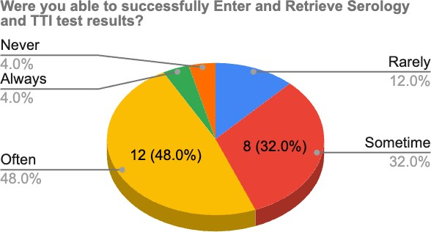

In terms of entering and retrieving serology and TTI test results, 4% of respondents said they could always do so successfully. Furthermore, 48% said they could frequently input and retrieve these findings, while 32% said they could only occasionally do so. On the other side, 12% of respondents said they could only seldom accomplish these activities, and 4% said they could never input and get serology and TTI test results.

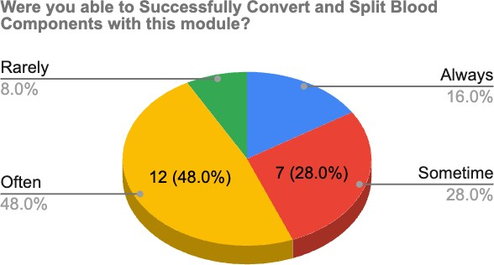

Based on the survey responses, it appears that most users (64%) could successfully convert and split blood components with the module at least sometimes. Specifically, 48% of respondents reported that they were able to do so often, while 28% reported being able to do so sometimes. A smaller percentage of respondents reported being able to convert and split blood components rarely (8%) or always (16%). Additionally, some users reported never being able to convert and split blood components using the module. Issues with component segregation were also reported, with volumes of segregated components not freezing.

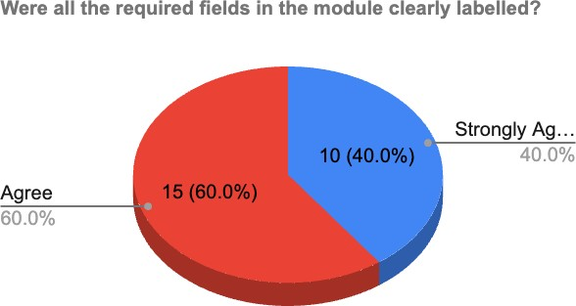

The survey results indicated a high level of satisfaction among the majority of respondents (60%) regarding the clarity of labelling in the module. Additionally, another 40% of respondents expressed a strong agreement with this statement. This positive feedback suggests that the required fields in the Blood Bank Information Management Module were well-defined and appropriately labelled, making it easier for users to understand and input the necessary information.

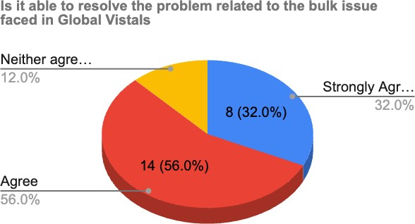

Most respondents (56%) agreed that PARAS BBMIS was able to resolve the problem related to bulk issues faced in Global Vista. Another 32% strongly agreed with this statement, indicating a high level of confidence in the module's ability to address this problem. Only 12% of respondents neither agreed nor disagreed, indicating that a small minority may still be unsure about the module's efficacy in this regard.

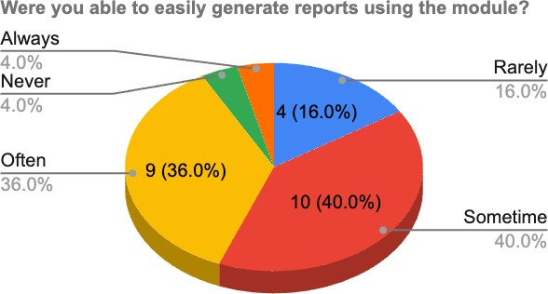

Regarding generating reports using the module, the majority of respondents (40%) reported being able to do so sometimes. Another 36% reported being able to generate reports often, indicating that the module is somewhat effective in this regard. However, a significant minority (16%) reported being able to generate reports rarely, indicating that there may be some issues or limitations with the reporting functionality of the module. No option to reprint compatibility reports was also reported.

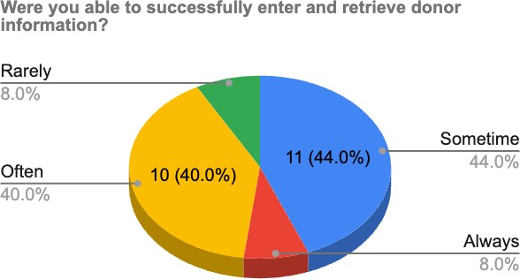

According to the survey responses, the majority of respondents demonstrated a certain level of proficiency in entering and retrieving donor information using the Blood Bank Information Management Module. A significant portion of respondents (40%) reported being able to perform these tasks often, indicating a frequent and successful utilization of the module for donor data management. Furthermore, 44% of respondents stated that they were able to enter and retrieve donor information sometimes, suggesting that they could accomplish these tasks on occasion. However, a smaller percentage of respondents reported being able to do so rarely (8%) or always (8%).

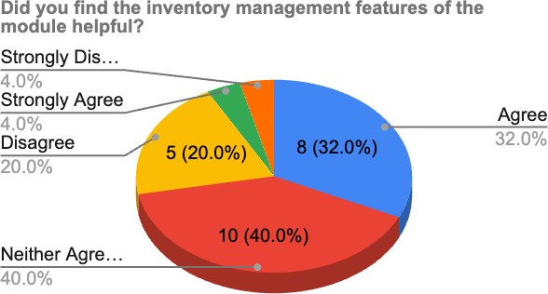

In the research study, it was found that the inventory management features were perceived as helpful by the majority of users (76%). This result underscores the significance of these features in achieving efficient inventory management. However, a noteworthy proportion of users (24%) expressed dissatisfaction, indicating the need to address calculation issues and enhance the overall capabilities of inventory management.

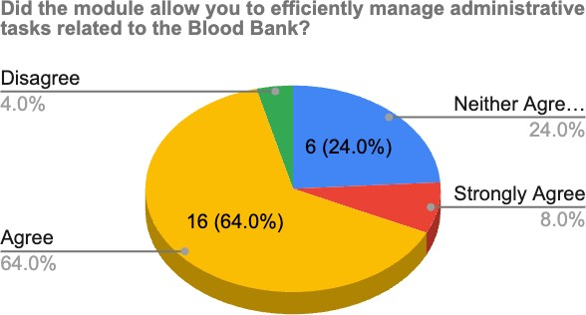

Regarding the module's capacity to manage administrative chores linked to the Blood Bank efficiently, the survey findings show that 8% of respondents strongly agreed and 64% agreed that the module provided efficient administration of these tasks. Furthermore, 24% of respondents did neither agree nor disagree, indicating a neutral position on the module's effectiveness. However, 4% of respondents were not satisfied with the module's ability to manage administrative chores.

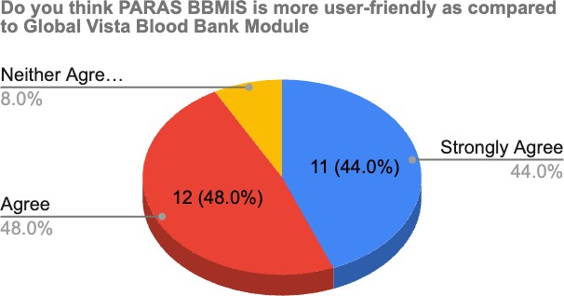

Based on the survey responses, most respondents believe that PARAS BBMIS is more user-friendly than the Global Vista Blood Bank Module. Specifically, 48% of respondents strongly agree with this statement, while 44% agree with it. Only 8% of respondents neither agreed nor disagreed with the statement, while no respondents reported disagreeing or strongly disagreeing. These results suggest that users generally perceive PARAS BBMIS to be more user-friendly than the Global Vista Blood Bank Module.

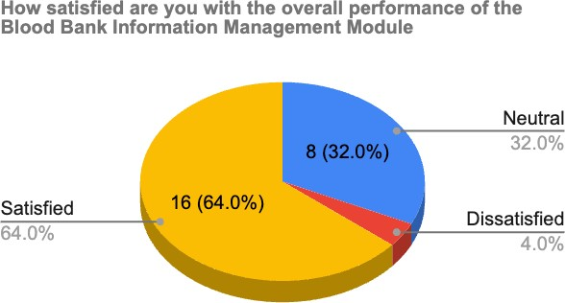

Based on the research findings, a majority of respondents (64%) expressed satisfaction with the overall performance of the Blood Bank Information Management Module. On the other hand, 32%

of respondents remained indifferent, while 4% expressed dissatisfaction. Valuable feedback and recommendations were collected from the respondents regarding enhancements to the module. These suggestions encompassed various aspects, such as improving inventory management, enhancing sticker formatting, providing a more comprehensive stock summary and inventory system, refining the cross-match page, addressing issues related to bill numbers, giving greater attention to testing results, resolving reported issues, improving the unit discarding procedure, implementing significant improvements in the inventory system, and making minor adjustments to freezing and restricted editing of segregated components. These findings indicate a general satisfaction with the module while highlighting areas that require further attention and improvement. The recommendations provided cover a wide range of module elements, including inventory management, formatting, cross- match capabilities, and the accuracy of testing results. These suggested improvements are expected to enhance the module's effectiveness, usability, and overall user satisfaction.

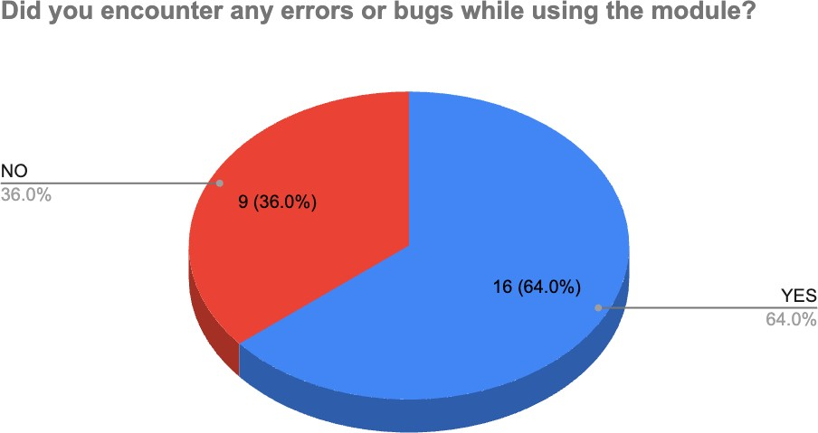

In response to the question about encountering errors or bugs while using the module, the research study found that the majority of respondents (64%) reported encountering errors or bugs, while 36% of respondents stated that they did not encounter any errors or bugs. These findings highlight the presence of issues and challenges with the Blood Bank Information Management Module, indicating the need for improvements and bug fixes to enhance the functionality and user experience of the module.

## Bugs & Errors Encountered:-

The research study identified several bugs and errors reported by respondents while using the Blood Bank Information Management Module. These include:

* Issued By Person Name - Is Not Correct In Issue Slip
* Calculation In Inventory Is Not Correct
* System Rejects Manual Serology Results That Are Not Taken Through Interfacing
* View Option for Crossmatched Units Is Not Available on Crossmatch Page
* An issue with Bill Numbers
* No Option to Reprint Compatibility Reports
* Occasional Errors on the Bulk Issue Page
* Billing Issues for Day Care Patients
* The disappearance of Unit Numbers of Crossmatched Units
* Lack of Automatic Discarding of Rejected Units on the Approval Page
* Calculation In Inventory Is Incorrect
* Issues with Component Segregation - Volumes of Segregated Components Do Not Freeze
* Incomplete Screening Saving Without All the Required Tests (Blood Grouping, Antibody Screening, Rh and Kell)
* Failure to Capture the Last Investigations on the Request Page
* These identified bugs highlight the presence of functional and usability issues within the Blood Bank Information Management Module. Addressing these bugs is essential to improve the module's overall performance, accuracy, and functionality, ensuring a more effective and reliable blood bank management system.

## Chapter 6

**Discussion**

The study's findings on the Blood Bank Information Management System (BBMIS) module, which is integrated with PARAS Hospital Information System, offer useful insights into the module's operation and efficacy and the potential for development. The module's examination through User Acceptance Testing (UAT) and analysis of user comments gave insight into a variety of topics, including user experience, training/support, functionality, and efficiency.

According to the survey results, the majority of users could enter and retrieve donor information to some level, proving the module's effectiveness in handling donor records. It is worth mentioning, however, that a significant number of users found issues or failures in the module, indicating the presence of certain constraints and the need for modifications in the data entry & retrieval process

Most respondents reflected on the module's useful inventory management capabilities, showing its potential to improve inventory management operations. However, several customers were dissatisfied, notably with the calculation mistakes and the lack of key choices, such as reprinting compatibility reports. These findings point to particular areas that need to be addressed and improved to guarantee accurate and effective donor record management and inventory tracking.

When PARAS BBMIS was compared to the previous Global Vista Blood Bank Module, the vast majority of respondents deemed PARAS BBMIS to be more user-friendly. This suggests that attempts to improve user experience and interface design were fruitful. However, the research emphasises the significance of continuing development in the existing module to satisfy user expectations and address usability problems.

During UAT testing, a high percentage of users reported issues or failures, suggesting the presence of flaws and challenges inside the module. There were concerns with information quality, calculation mistakes, and missing features, highlighting the need for targeted efforts to correct these particular issues and enhance the overall performance and usability of the PARAS Hospital Information System module.

Overall, the survey results show that the majority of respondents were satisfied with the overall performance of the BBMIS module, with just a small proportion expressing displeasure. Respondents' ideas for improvement provide useful insights into tackling particular areas of concern. These include improving inventory management, improving sticker layout, providing better stock summaries and inventory systems, and dealing with concerns with test results.

Despite the limitations identified, the study emphasises the Blood Bank Information Management System Module's potential to improve the efficiency and standardisation of blood transfusion services at RGCI Hospital. This is especially crucial for maintaining patient safety and lowering the possibility of negative effects. Future studies should look at the feasibility and cost-effectiveness of using the module in other healthcare settings to obtain insight into its generalizability and scalability. Furthermore, regular monitoring, assessment, and development of the module are required to guarantee that it stays current and capable of addressing the changing needs of end-users and the healthcare system. This may be accomplished by soliciting frequent feedback from end users, conducting system audits, and adopting healthcare trends and technology improvements.

In conclusion, the outcomes of the study reflect both good and negative elements of the PARAS BBMIS module. The good results indicate its efficacy in certain areas, while the highlighted areas for

development highlight the need to address specific problems and gather further input to increase user happiness and system performance. By solving these issues, the module has the potential to greatly improve blood bank operations and patient care.

## Chapter- 7

**Limitations**

* The data collection tool relies on self-report by end-users, which introduces the potential for response bias. Users may provide biased or subjective feedback, which may not accurately reflect their actual experiences with the Blood Bank Information Management System (BBMIS) module. This limitation should be taken into account when interpreting the findings and generalizing the results.
* The study was conducted over a relatively short duration of three months. This limited timeframe may not have allowed for the in-depth data collection on user experience and satisfaction with the BBMIS module. Longer-term evaluations could provide a more comprehensive understanding of the module's performance and user perceptions.
* The study primarily focuses on user acceptance testing of the BBMIS module within the PARAS Hospital Information System. It does not comprehensively evaluate other factors that may influence the implementation and integration process, such as system security and reliability. Considering these additional factors could provide a more holistic assessment of the module's overall effectiveness and impact on blood transfusion services.
* The study's sample size is relatively small, with only 25 respondents participating in the user acceptance testing and questionnaire survey. The limited sample size may affect the findings' generalizability and limit the study's statistical power. Caution should be exercised when drawing broad conclusions based on a small sample, and further research with a larger and more diverse sample is recommended for a more robust analysis.

Addressing these limitations and conducting future research with larger sample sizes, longer study durations, and a comprehensive evaluation of all relevant factors would strengthen the validity and generalizability of the findings, providing a more accurate understanding of the BBMIS module's effectiveness and its impact on blood bank operations**.**

## Chapter -8

**Recommendations**

* **Address the bugs and errors:** A majority of respondents reported encountering bugs and errors while using the module, indicating that there are issues that need to be addressed to improve the system's functionality and usability. The development team should investigate and resolve these bugs and errors to provide a smoother user experience.
* **Enhance the inventory management features:** While a majority of respondents found the module's inventory management features helpful, some users still disagreed or strongly disagreed with this statement. The development team should gather more detailed feedback from these users to identify specific areas for improvement and enhance the inventory management features accordingly.
* **Improve the reporting functionality:** A significant minority of respondents reported being able to generate reports rarely, indicating that there may be some issues or limitations with the reporting functionality of the module. The development team should investigate these issues and improve the reporting functionality of the module to provide a more effective reporting system.
* **Address neutral and dissatisfied respondents**: While a majority of respondents were satisfied with the overall performance of the module, some respondents still felt neutral or dissatisfied. Further analysis and investigation may be required to identify specific areas for improvement that could address these concerns.
* **Train end-users:** End-users should be trained on the module to ensure that they can use it to its fullest potential. Training sessions can be conducted to familiarize end-users with the features and functionality of the module and to address any concerns or issues that they may have.
* **Monitor and evaluate:** The development team should continue to monitor and evaluate the module's functionality and usability to ensure that it remains effective and efficient. Feedback from end-users should be gathered regularly to identify improvement areas and address any issues or concerns that arise.
* **Improve user training and support:** Provide end-users with thorough training programmes and continuous assistance. Training sessions, user guides, FAQs, and a helpdesk or support team to assist users with any issues or challenges they find while using the module are examples of this.
* **Increase your research and development efforts:** Set aside funds for continuous BBMIS module research and development. Keep up with technological advances, healthcare practices, and regulatory requirements to ensure the module is current and in line with industry standards.

## Chapter-9

**Conclusion**

The study assessed the process of implementing and testing the Blood Bank Information Management Module (BBMIS) in PARAS at RGCI Hospital. According to the findings of the study, the BBMIS system is predicted to increase the overall efficiency of blood collection, testing, and transfusion services while also ensuring a safe environment for system users. The study also shows that the suggested system may overcome the limitations of the present system and provide a user-friendly interface that reduces manual data entry, ensures data accuracy, and reduces human effort. End-user survey results offered significant input on the module's functioning and efficiency, highlighting opportunities for improvement in donor records management, inventory management, and administrative administration. While some respondents were able to use the module successfully, others encountered bugs and errors that must be addressed. However, the majority of respondents thought PARAS BBMIS was easier to use than the existing Global Vista Blood Bank Module. According to the study's findings, adopting BBMIS with PARAS HMIS might potentially increase the efficiency and standardisation of blood transfusion services at RGCI Hospital. Users who have found issues with specific areas of the system can receive further training or help to address their concerns and enhance their confidence in utilising the system efficiently.

The research also looks at end-user experiences with the BBMIS system and identifies opportunities for improvement, such as donor records management, inventory management, and administrative administration. Despite certain problems, the majority of users considered the PARAS BBMIS system to be easier to operate than the previous Global Vista Blood Bank Module. According to the findings, combining BBMIS with PARAS HMIS might improve the efficiency and uniformity of blood transfusion services at RGCI Hospital.

Overall, the study underlines the significance of constant feedback and monitoring to guarantee system improvement and user happiness. The study's importance stems from its ability to provide light on the usefulness of the proposed BBMIS system in resolving the difficulties of the present system and enhancing the overall efficiency of blood transfusion services at RGCI Hospital. The study's findings may be utilised to influence decision-making and the ongoing development of the BBMIS system to improve the quality of healthcare services given to patients.

## Chapter 10

**References**

1. Akkas Ali, K. M., Jahan, I., Islam, M. A., & Parvez, M. S.-A. (n.d.). *Blood Donation Management System*. Cloudfront.net. Retrieved May 1, 2023, from https://d1wqtxts1xzle7.cloudfront.net/38147064/O04601230136-libre.pdf?1436509498=&response- content- disposition=inline%3B+filename%3DBlood_Donation_Management_System.pdf&Expires=1682959600 &Signature=bM9fiAbZHKfOqFepivRa4WYms4XGKb8phY07XKilWaTfz3CkRcG6ydcEFbFnEt0qZfJ 1PIa4xnuR5b5GlpLHWOzVCHpCDw4jh11~q8Es2sDNWiVAX35e7tsacpY4y~fhxty0otVicDDd9KEEJ FbjViXGhYGy4TWKmYECPvUH-ufNirun8bcCJrYDkEnDRcT0cf1cgp- vvg~TxO4LvCGgJQlHRNoSlHwr-qdpRzkrlwwoRzw6wjzLxEUVuYJZ4UN6JlYzG4KAfn0Ym- riIcnrW0kZ2xJCqz7xXpmbYgeDL025No5W-9ldlfVvVMDtI7B04gIzO1XUkYslkr3LCcRsSQ &Key- Pair-Id=APKAJLOHF5GGSLRBV4ZA
2. Ansari, S., & Site, S. (n.d.). *A study on the development of blood bank management system*.

Ijrdet.com. Retrieved May 4, 2023, from https:/[/www](http://www.ijrdet.com/files/Volume11Issue9/IJRDET_0922_06.pdf).[ijrdet.com/files/Volume11Issue9/IJRDET_0922_06.pdf](http://www.ijrdet.com/files/Volume11Issue9/IJRDET_0922_06.pdf)

1. Benedict, J., Legaspi, C., Lagman, A. C., Rona, M., Perez, L., De Angel, R. M., Kirk, A. S., Awat, J., & Heland, J. (n.d.). *Online blood banking management solution using a frame-based approach*. Ijstr.org. Retrieved May 1, 2023, from https:/[/www](http://www.ijstr.org/final-).[ijstr.org/final-](http://www.ijstr.org/final-) print/apr2020/Online-Blood-Banking-Management-Solution-Using-Frame-based-Approach.pdf
2. *Blood Bank Management System - blood banking*. (n.d.). Jagriti. Co.In. Retrieved April 26, 2023, from <http://www.jagriti.co.in/solutions/healthcare/blood-bank-management-application>
3. *Blood Bank Management System A Brief Introduction*. (n.d.). Imimg.com. Retrieved April 26, 2023, from https://5.imimg.com/data5/SELLER/Doc/2020/9/UL/AB/AW/2678632/blood-bank- management-software.pdf
4. Chawan, I., Shinde, S., Gaddam, Y., Talele, A., & Dudwadkar, A. (n.d.). *”Blood Bank Management System”*. Irjet.net. Retrieved April 26, 2023, from https:/[/www](http://www.irjet.net/archives/V8/i6/IRJET-V8I668.pdf).[irjet.net/archives/V8/i6/IRJET-V8I668.pdf](http://www.irjet.net/archives/V8/i6/IRJET-V8I668.pdf)
5. *Design and Implementation of blood bank management system*. (2022, March 29). IJSREM; IndoSpace Publications. https://ijsrem.com/download/design-and-implementation-of-blood- bank-management-system/
6. Divyabharathi, P., & Kathiresan, R. (n.d.). The automated *blood bank and patient management system using raspberry pi*. Ijirset.com. Retrieved May 5, 2023, from <http://www.ijirset.com/upload/2020/march/64_EE323_MCS.PDF>
7. *ERP - Blood Bank Management System*. (n.d.). Coelentera.com. Retrieved April 26, 2023, from <http://www.coelentera.com/ERP-BloodBank-Software.aspx>
8. Halle, P., Pakhare, S., & Funde, P. (n.d.). *Blood Bank Management System*. Ijsrset.com. Retrieved April 26, 2023, from https://ijsrset.com/paper/5770.pdf
9. *Hospital management information system software company India, Electra HIS*. (n.d.).

Acgil.com. Retrieved April 26, 2023, from https:/[/www](http://www.acgil.com/products/bloodbank_management_software.htm).[acgil.com/products/bloodbank_management_software.htm](http://www.acgil.com/products/bloodbank_management_software.htm)

1. *International journal of advanced research in science, communication and technology*. (2020).

Naksh Solutions.

1. Kaur, M., Nazir, N., Kaur, N., Faraz Ali, S., Agarwal, C., Dubey, U., Gupta, V., Sarwar, A., Rakhra, M., & Dahiya, O. (2022). A web-based blood bank system for managing records of donors and receipts. *2022 International Conference on Computational Intelligence and Sustainable Engineering Solutions (CISES)*, 459–464.
2. Kayode, A. A., Adeniyi, A. E., Ogundokun, R. O., & Ochigbo, S. A. (2019). An Android-based blood bank information retrieval system. *Journal of Blood Medicine*, *10*, 119–125. https://doi.org/10.2147/JBM.S197350
3. Kulshreshtha, V., & Maheshwari, S. (n.d.). *Benefits of management information system in the blood bank*. Researchinventy.com. Retrieved May 4, 2023, from <http://www.researchinventy.com/papers/v1i12/B0112005007.pdf>
4. Kumar, S. (2020). 3. About the project Online Blood Donation Management System 3.1 introduction. *Sandy*. https:/[/www](http://www.academia.edu/42007914/3_About_Project_Online_Blood_Donation_management_).[academia.edu/42007914/3_About_Project_Online_Blood_Donation_management_](http://www.academia.edu/42007914/3_About_Project_Online_Blood_Donation_management_) System_3_1_Introduction
5. Lietzen, A. (n.d.). *Master’s thesis (YAMK) Business Information Systems*. Core.ac.uk. Retrieved April 26, 2023, from https://core.ac.uk/download/pdf/38085357.pdf
6. Madhu Kumar, V., & Supriya, B. (n.d.). *Design and Implementation of the e-blood bank*. Jetir.org.

Retrieved May 1, 2023, from https:/[/www](http://www.jetir.org/papers/JETIR1712105.pdf).[jetir.org/papers/JETIR1712105.pdf](http://www.jetir.org/papers/JETIR1712105.pdf)

1. Maheshwari, S., & Associate Professor. (n.d.). *Blood Bank Management Information System in India*. Ijera.com. Retrieved May 4, 2023, from https:/[/www](http://www.ijera.com/papers/vol%201%20issue%202/012260263AF.pdf).[ijera.com/papers/vol%201%20issue%202/012260263AF.pdf](http://www.ijera.com/papers/vol%201%20issue%202/012260263AF.pdf)
2. Masram, C., Mulani, A., Bhitale, R., & Koli, J. (n.d.). *Online Blood Bank Management System*.

Irjet.net. Retrieved April 26, 2023, from https:/[/www](http://www.irjet.net/archives/V8/i6/IRJET-).[irjet.net/archives/V8/i6/IRJET-](http://www.irjet.net/archives/V8/i6/IRJET-) V8I6763.pdf

1. May-, A. (n.d.). *BLOOD BANK MANAGEMENT SYSTEM*. 47.12.35. Retrieved April 26, 2023, from <http://103.47.12.35/bitstream/handle/1/2179/17SCSE104037_SHUBHAM%20CHOUDHARY>

%20PROJECT-2%20FINAL%20REPORT%20-

%20Shubham%20Choudhary.pdf?sequence=1&isAllowed=y

1. More, R., Kubde, S., Ahirrao, P., & Patankar, S. N. (n.d.). *BLOOD DONATION MANAGEMENT SYSTEM*. Irjet.net. Retrieved April 26, 2023, from https:/[/www](http://www.irjet.net/archives/V7/i4/IRJET-).[irjet.net/archives/V7/i4/IRJET-](http://www.irjet.net/archives/V7/i4/IRJET-) V7I4977.pdf
2. Oloruntoba, S., & Akinode, J. L. (2020). Development of a blood bank information retrieval system using an Android app. *International Journal of Engineering Applied Sciences and Technology*, *5*(4), 663–673. https://doi.org/10.33564/ijeast.2020.v05i04.105
3. Pandit, T., Niloor, S., & A.S.Shinde, A. S. S. (2015). A survey paper on E-blood banks and an idea to use on smartphones. *International Journal of Computer Applications*, *113*(6), 48–50. https://doi.org/10.5120/19834-1688
4. Parmar, S., Bagadiya, D., & Chaudhary, V. (n.d.). *Blood Bank Management System*. Ijcrt.org.

Retrieved May 1, 2023, from https://ijcrt.org/papers/IJCRT2107125.pdf

1. Pradhan, P., Manger, R. K., & Rai, U. (n.d.). *BLOOD BANK MANAGEMENT SYSTEM*. Irjet.net.

Retrieved May 4, 2023, from https:/[/www](http://www.irjet.net/archives/V8/i10/IRJET-V8I1023.pdf).[irjet.net/archives/V8/i10/IRJET-V8I1023.pdf](http://www.irjet.net/archives/V8/i10/IRJET-V8I1023.pdf)

1. *Project report Topic: blood management system*. (n.d.). Edu. In. Retrieved April 26, 2023, from https://bsssbhopal.edu.in/uploads/naac/criteria_1/students_projects/272%20Simran.pdf
2. *Research paper blood bank management system*. (2021, January 14). Studylib.net. https://studylib.net/doc/25463289/research-paper-blood-bank-management-system
3. Saraf, Y., Ghawate, P. S. B., Wankhade, R., Ware, R., & Jadhav, P. (n.d.). *International journal of research publication and reviews*. Ijrpr.com. Retrieved May 1, 2023, from https://ijrpr.com/uploads/V3ISSUE11/IJRPR7945.pdf
4. Shravani, B. S., & Raghavendra, R. (n.d.). *A survey paper on the blood donation system*.

Ijtsrd.com. Retrieved May 4, 2023, from https:/[/www](http://www.ijtsrd.com/papers/ijtsrd49440.pdf).[ijtsrd.com/papers/ijtsrd49440.pdf](http://www.ijtsrd.com/papers/ijtsrd49440.pdf)

1. Shrinivas Vasaikar, S., Suresh, V., Krupa, Y., Patel, M., & Trupti, S. (n.d.). *Online blood bank using cloud computing*. Ijariit.com. Retrieved May 1, 2023, from https:/[/www](http://www.ijariit.com/manuscripts/v3i1/V3I1-1210.pdf).[ijariit.com/manuscripts/v3i1/V3I1-1210.pdf](http://www.ijariit.com/manuscripts/v3i1/V3I1-1210.pdf)
2. Talapatra, S., Kabir, R., & Shingha Bappy, A. (n.d.). *Development of an online blood management system*. Ieomsociety.org. Retrieved May 5, 2023, from <http://www.ieomsociety.org/ieom2019/papers/235.pdf>
3. Thirunavukkarasu, N. (n.d.). *Blood Bank Management System*. Uom. Lk. Retrieved May 4, 2023, from <http://dl.lib.uom.lk/bitstream/handle/123/19718/Blood%20Bank%20Management%20System.p> df?sequence=1
4. Warnakulasooriya, W. A. V. (n.d.). *Blood Bank & Donor Management System*. Cmb.Ac.Lk.

Retrieved April 26, 2023, from https://dl.ucsc.cmb.ac.lk/jspui/bitstream/123456789/4511/1/2017%20MIT%20086.pdf

1. (N.d.-a). Researchgate.net. Retrieved May 1, 2023, from https:/[/www](http://www.researchgate.net/publication/362396182_EFFICIENCY_WORK_PROCESS_OF_).[researchgate.net/publication/362396182_EFFICIENCY_WORK_PROCESS_OF_](http://www.researchgate.net/publication/362396182_EFFICIENCY_WORK_PROCESS_OF_) BLOOD_BANK_MANAGEMENT_SYSTEM
2. (N.d.-b). Researchgate.net. Retrieved May 4, 2023, from https:/[/www](http://www.researchgate.net/publication/362935450_Online_Blood_Bank_Management_Syste).[researchgate.net/publication/362935450_Online_Blood_Bank_Management_Syste](http://www.researchgate.net/publication/362935450_Online_Blood_Bank_Management_Syste) m
3. (N.d.-c). Afribary.com. Retrieved May 5, 2023, from https://afribary.com/works/design-and- implementation-of-a-blood-bank

## Acronyms/Abbreviations

**RGCI:** Rajiv Gandhi Cancer Institute

**BB:** Blood Bank

**BBMIS:** Blood Bank Information Management System **HMIS:** Hospital Management Information System **UAT:** User Acceptance Testing

**CIS:** Clinical Information System

**IT:** Information Technology

**QA:** Quality Assurance

**UI:** User Interface **UX:** User Experience **Hb:** Haemoglobin **RBC:** Red Blood Cell

**HCV:** Hepatitis C Virus

**HIV:** Human Immunodeficiency Virus

**HBV:** Hepatitis B Virus

**VBD:** Vector-Borne Diseases

**NACO:** National AIDS Control Organization

**TTI:** Transfusion Transmissible Infections

## Glossary

**Blood Bank Information Management System (BBMIS):** A software module designed to manage blood bank operations such as donor registration, inventory management, blood collection, testing and transfusion services.

**Hospital Management Information System (HMIS):** A comprehensive software system used by hospitals to manage patient data, clinical operations, and administrative functions.

**User Acceptance Testing (UAT):** A process of verifying that a particular solution works for the user and validating the system against business requirements.

**Integration:** The process of combining two or more systems to work together as a single, unified system.

**Donor Management:** The process of managing donor registration, screening, testing, and blood collection.

**Inventory Management:** The process of tracking and managing blood products, including blood type, expiration dates, and inventory levels.

**Blood Collection:** The process of collecting blood from donors and ensuring that it is safe and usable for transfusion.

**Blood Testing:** The process of testing blood for infectious diseases, blood type, and other factors to ensure that it is safe for transfusion.

**Transfusion Services**: The transfusing of blood or blood products to needy patients.

**Usability:** The degree to which a system is easy to use and learn.

**Functionality:** The ability of a system to perform the tasks it was designed to do.

**User Experience (UX):** The overall experience a user has with a system, including ease of use, efficiency, and satisfaction.

**User Training:** The process of providing training and support to users to ensure they can use the system effectively.

**Data Management:** The process of organizing and managing data, including patient data, donor data, and blood inventory data.

**System Evaluation:** The process of assessing the effectiveness of a system and identifying areas for improvement.

**Transfusion Transmissible Infections (TTI)** - These are infections that can be transmitted through blood transfusions, such as HIV, Hepatitis B, Hepatitis C, and Syphilis.

**Serology Test -** This is a blood test that detects the presence of antibodies against a particular antigen, which can indicate whether a person has been exposed to a particular infection or not.

**Antibody** - A protein produced by the immune system in response to an infection or foreign substance that helps to fight off the infection.

**Antibody screening:** A laboratory test used to detect the presence of antibodies in a person's blood or other bodily fluids.

## Appendix

### Informed Consent Form

**(Rajiv Gandhi Cancer Institute & Research Centre)**

#### Title of Project: To study the process of Implementation of the Blood Bank Information Management Module in PARAS at RGCIRC

We are conducting a research study ***“To study the process of Implementation of Blood Bank Information Management Module in PARAS at RGCI"*** and we would like to invite you to participate. Before deciding whether or not to participate, we would like you to understand why this research is being done and what it involves. Please take the time to read the following information carefully and feel free to ask any questions you may have. You should only agree to participate in this study if you feel comfortable doing so.

## Purpose of the Research

The research study aims to explore implementing a blood bank information management system in PARAS at RGCIRC hospital, focusing on user acceptance testing.

Approximately *50* people will take part in this research at *Blood Bank in RGCIRC to analyse the effectiveness of User Acceptance Testing and its potential implementation*

## Procedures

The study involves the Pre-Implementation Evaluation process of the BBMIS module with the help of UAT and feedback from End-Users is taken in the form of a Questionnaire. The study will take approximately 1 Month. The data collected will be analysed to study the post-implementation effectiveness of the Blood Bank Module in HMIS.

## Time Duration of the Procedures and Study

If you agree to take part in this study, your involvement will last approximately one month.

## Discomforts and Risks

There are no known risks associated with participating in this study.

## Potential Benefits

The potential benefits of this study include contributing to the advancement of knowledge in the implementation of the Blood Bank Information Management Module in PARAS.

## Statement of Confidentiality

All information collected will be kept confidential to the extent provided by law. Your data will be assigned a unique code number and will not be linked to any identifying information.

### Voluntary Participation

Taking part in this research study is voluntary. If you choose to take part, you have the right to stop at any time. If you decide not to participate or if you decide to stop taking part in the research at a later date, there will be no penalty or loss of benefits to which you are otherwise entitled.

### Signature and Consent

Before deciding on enrollment in this research you should have:

* Discussed this study with an investigator,
* Reviewed the information in this form, and
* Had the opportunity to ask any questions you may have.

Your signature below means that you have received this information, have asked the questions you currently have about the research and those questions have been answered. You will receive a copy of the signed and dated form to keep for future reference.

By signing this consent form, you indicate that you are voluntarily choosing to take part in this research

|  |  |  |
| --- | --- | --- |
| **[Name of participant]**  Name of Participant | **[Signature of participant]**  Signature of participant | **[Date]**  Date |

## Questionnaire:-

### How easy was it to navigate the Blood Bank Information Management Module?

* Very Good
* Good
* Acceptable
* Poor
* Very Poor

### Were all the required fields in the module clearly labelled?

* Strongly Agree
* Agree
* Neither Agree nor Disagree
* Disagree
* Strongly Disagree

### Were you able to successfully enter and retrieve donor information?

* Always
* Often
* Sometime
* Rarely
* Never

### Were you able to successfully Enter and Retrieve Serology and TTI test results?

* Always
* Often
* Sometime
* Rarely
* Never

### Were you able to Successfully Convert and Split Blood Components with this module?

* Always
* Often
* Sometime
* Rarely
* Never

### Did you find the inventory management features of the module helpful?

* Strongly Agree
* Agree
* Neither Agree nor Disagree
* Disagree
* Strongly Disagree

### Did the module allow you to efficiently manage administrative tasks related to the Blood Bank?

* Strongly Agree
* Agree
* Neither Agree nor Disagree
* Disagree
* Strongly Disagree

### Do you think PARAS BBMIS is more user-friendly as compared to Global Vista Blood Bank Module?

* Strongly Agree
* Agree
* Neither Agree nor Disagree
* Disagree
* Strongly Disagree

### Is it able to resolve the problem related to a bulk issue faced in Global Vista?

* Strongly Agree
* Agree
* Neither agree nor disagree
* Disagree
* Strongly Disagree

### Were you able to easily generate reports using the module?

* Always
* Often
* Sometime
* Rarely
* Never

### Did you encounter any errors or bugs while using the module?

* YES
* NO

### If yes, explain the bug/Error observed.

* 1. **How satisfied are you with the overall performance of the Blood Bank Information Management Module?**
* Very satisfied
* Satisfied
* Neutral
* Dissatisfied
* Very dissatisfied

### Do you have any suggestions for improving the module?

61



