**DISSERTATION**

At

**IIHMR, Delhi**

**15th February to 1st June 2023**

**A review on Critical Success Factors (CSFs) of healthcare projects at Global scale**

By Dr Abhaya Gupta

**PG/21/004**

Under the guidance of

**Dr Mukesh Ravi Raushan**

**Assistant Professor,** IIHMR, New Delhi

**PGDM (Hospital & Health Management)**

**2021-2023**

**Organization - Intellio Healthcare Pvt Ltd**

**International Institute of Health Management Research**

**New Delhi**

**CERTIFICATE BY SCHOLAR**

This is to certify that the dissertation titled **“A review of Critical Success Factors (CSFs) of healthcare projects at global scale”** submitted by Dr Abhaya Gupta, Enrolment No. **PG/21/004** under the supervision of **Dr. Mukesh Ravi Raushan** for award of Postgraduate Diploma in Hospital & Health Management of the Institute carried out during the period from **15th February 2023 to 1st June 2023.** Embodies of my original work & has not formed the basis for the award of any degree, diploma associateship, fellowship, titles in this or any other Institute or other similar institution of higher learning.

**Dr. Abhaya Gupta**

**CERTIFICATE**

Dr Abhaya Gupta, worked at Intellio Healthcare with their sister company, Vriseup and conducted secondary research on topic “A review on Critical Success Factors (CSFs) of healthcare projects at Global scale”. The study was conducted from 15th February to 1st June 2023.

**Mentor**

**Dr Mukesh Ravi Raushan**

**Assistant Professor**

**IIHMR, New Delhi**

**CERTIFICATE FROM DISSERTATION MENTOR**

This is to certify that Dr Abhaya Gupta**,** a student of the **Post-Graduate Diploma in Health & Hospital Management** has worked under their guidance & supervision. She is submitting this dissertation titled **“A review of Critical Success Factors (CSFs) of healthcare projects at global scale”** in partial fulfilment of the requirements for the award of the **Post-Graduate Diploma in Health & Hospital Management.**

This dissertation has the requisite standard & to the best of their knowledge no part of it has been reproduced from any other dissertation, monograph, report or book.

**Mentor**

**Dr Mukesh Ravi Raushan**

**Assistant Professor**

**IIHMR, New Delhi**

**CERTIFICATE OF APPROVAL**

The following dissertation titled **“A review of Critical Success Factors (CSFs) of healthcare projects at global scale”** at **“Intellio Healthcare”** is hereby approved as a certified study in management carried out and presented in a manner satisfactorily to warrant its acceptance as a prerequisite for the award of **PGDM (Hospital & Health Management)** for which it has been submitted. It is understood that by this approval the undersigned do not necessarily endorse or approve any statement made, opinion expressed or conclusion drawn therein but approve the dissertation only for the purpose it is submitted.

**Dissertation Examination Committee for evaluation of dissertation.**

**Name Signature**

**TO WHOMSOEVER IT MAY CONCERN**

This is to certify that **Dr Abhaya Gupta,** student of Post Graduate Diploma in Hospital & Health Management (PGDHM) from International Institute of Health Management Research, New Delhi has undergone **Dissertation** at **Intellio Healthcare** from **15th February 2023** to **1th June 2023**.

Dr Abhaya Gupta has successfully carried out the study designated to her during the dissertation period & her approach to the study has been sincere, scientific & analytical.

The Dissertation is in fulfilment of the ctheirse requirements and I wish her all success in all her future endeavtheirs.

**Dr Sumesh Kumar Dr Mukesh Ravi Raushan**

Associate Dean Associate Professor

Academic & Student Affairs Mentor IIHMR, New Delhi

IIHMR, New Delhi

**ACKNOWLEDGEMENT**

I would like to express my sincere gratitude to Intellio Healthcare for providing me with the opportunity to work under their project. This project has been an invaluable experience in enhancing my knowledge and skills in the field of healthcare management.

I am immensely grateful to Dr Mukesh Ravi Raushan, my mentor and guide throughout this project. His expertise, guidance, and unwavering support have been instrumental in shaping my understanding of the healthcare landscape and project management. His invaluble insights, constructive feedback, and continuous enctheiragement have greatly enriched my learning experience.

Next, I would like to extend my heartfelt appreciation to my parents, whose unwavering support and sacrifices have made my educational jtheirney possible. Their constant enctheiragement, love, and belief in my abilities have been a constant stheirce of strength for me. Their unwavering faith in my potential has been a driving force behind my achievements, and I am forever grateful for their unwavering support.

I am truly grateful to all the individuals and organizations involved in this project, as their contributions have been indispensable in my professional growth and development.

**Dr Abhaya Gupta**

**Date –**

**TABLE OF CONTENTS**

|  |  |  |
| --- | --- | --- |
| **S No** | **Topic** | **Page No** |
|  | PART A- Organisational Detail | 10-15 |
|  | PART B- Project Report | 16 |
|  | ABSTRACT | 17 |
|  | INTRODUCTION | 18-26 |
|  | METHODOLOGY | 27-29 |
|  | RESULT & DISCCUSION | 30-36 |
|  | CONCLUSION | 37 |
|  | REFERENCES | 38-39 |

**List of figures**

**1** Phases of Project Management

**List of tables**

**1** Critical Success factors of Project

**2** Literature Review focussing on Critical Success factors at Global level

**3** Summarized Critical Success Factors based on Literature Review

**4** Ranking of Critical Success Factors based on Literature Review

**PART A**

**ABOUT THE ORGANIZATION**

**INTELLIO HEALTHCARE**

**INTELLIO HEALTHCARE**

The healthcare solutions company Intellio is dedicated to offering international assistance that enables governments and organisations to deliver the highest standard of healthcare at the most reasonable price. A global workforce with a passion for innovation and health access comes together at Intellio. The key to their success in delivering the greatest services at the most competitive prices is the knowledge and reach of their personnel. In order to meet their clients' demands in a fast and reliable manner, they have selected and built connections with their partners**.**

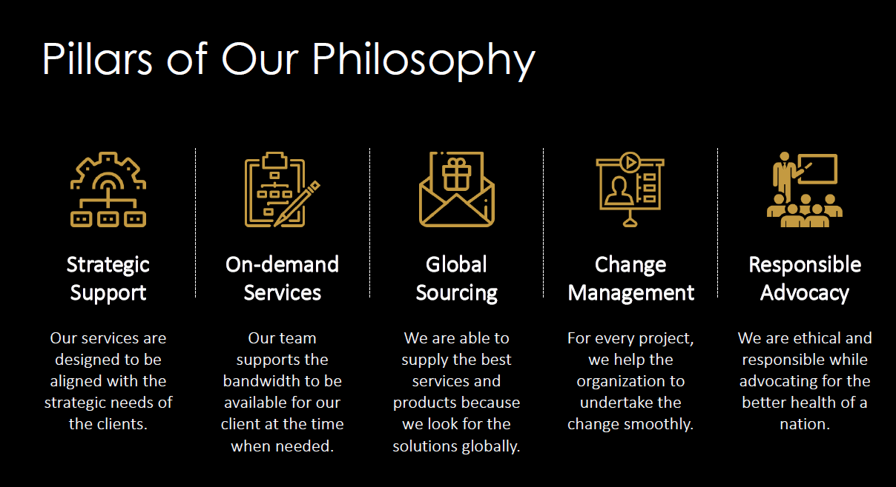

**Services offered by Intellio Healthcare**

Intellio Healthcare provides following services –

* Management Consulting
* Investment Advisor
* Procurement and Supply Chain
* Program Management

1. Management Consulting –

Their skilled professionals have helped businesses and governments create long-term plans that save costs, raise standards, and manage sustainable health systems. Decision-making is derived from patient health data in several contexts. Their assist organisations in using evidence-based decision-making to achieve desired objectives. Their digital health team works hard to give their clients the newest technological solutions because technology is influencing every aspect of life. Digital health is the way of the future, and they are prepared for it. Every country strives to obtain universal healthcare. They reshape the healthcare systems to make it possible for everyone to have access to high-quality medical treatment.

2.Investment Advisory –

Their help nations and corporations in securing the funding from participating countries and non-government organizations. Their clients leverage their network to get right funding. Their connect investors across the globe with the right funding opportunities that mature into win-win deals. The capital investment services form a natural extension of their consulting assignments. The right partnerships share restheirces like finances, technical knowledge, human capital and complementary skills. Their support global JVs to outperform and achieve more as a team. Their business professionals help in developing business cases for the case in point. These business cases are used to make executive decisions, apply for financial assistance, and sell the idea.

3. Program Management –

Their team of doctors would fly-in and out of the managed centre to operate, manage, and follow-up with the patients undergoing surgeries and complex medical interventions. Their programs insulate the clients from drug shortage shocks. They have team to help healthcare organizations to re-evaluate their existing systems and adopt the necessary changes to upgrade these systems for building new business capabilities. They have trained clinical staff including physicians, nurses, and paramedics that run efficient dialysis centres catering to the needs of a chronic care population. With the support of local and global investors, their help the governments and healthcare providers in providing adequate diagnostic capabilities in their regions, improving the access to timely healthcare.

4. Procurement and Supply Chain –

Their pharmacy service offers a full range of quality products supported by supply chain expertise. Their scale of volume supports the best prices and wide variety of products. Their materials management portfolio offers the most comprehensive range of clinical products. In the long run, their also provide the ancillary support services for these products. Their offer a wide range of products and services for hospital hospitality, offices, cafeterias and patient wards. They understand the nuances of healthcare specific to the support services. Their facilitate financing and secure the best price procurement services for medical equipment. Their team works with the client to develop a perfect strategy for making high value investments in equipment.

**PART II**

**RESEARCH STUDY**

**“A review on Critical Success Factors (CSFs) of healthcare projects at Global Scale “**

**ABSTRACT**

In this comprehensive overview, project management's crucial role in achieving healthcare's Triple Aim is highlighted, emphasizing factors like technical expertise, communication, and the use of tools like Gantt charts. Critical success factors, adaptable across diverse contexts, are discussed as key drivers of project management success. The study's methodological rigor, involving content analysis and reputable data sources, lends credibility to its findings. Whether applied to healthcare, social housing in Nigeria, or eHealth initiatives in Uganda, the importance of expert project management and trust in achieving desired outcomes shines through. Ultimately, the report underscores the need for consistent prioritization of public welfare, stakeholder collaboration, and capacity-building efforts to ensure enduring success in various project contexts. Further research is encouraged to deepen our understanding of these critical criteria.

**Keywords-** Project management, healthcare, critical success factors, project development, social housing, e-Health platform, capacity-building, public welfare.

**INTRODUCTION**

Project management is a systematic and organized approach to overseeing processes of change. It entails the application of expertise, skills, tools, and methodologies to various tasks aimed at meeting a project's requirements. The Project Management Institute's "A Guide to Project Management Body of Knowledge: PMBOK Guide" further dissects project management into nine crucial knowledge areas: integration, scope, time, cost, quality, resources, communication, risk, and procurement. These knowledge areas are applied throughout the entire project lifecycle. Additionally, project management can be categorized into five distinct process groups: planning, organizing, executing, monitoring and controlling, and closing. These process groups provide a structured framework for effectively managing projects.[1]

The conversion of a project concept into a practical product is accomplished by integrating five distinct stages: initiation, planning, execution, monitoring, and closure.[2]

Figure 1 – Phases of Project Management [3]

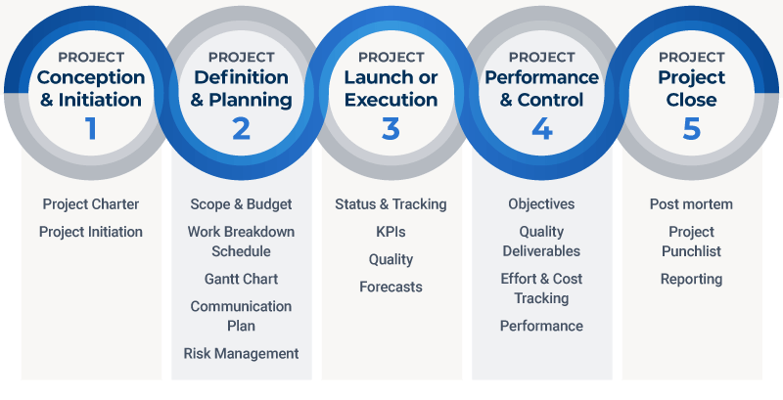

The first stage of a project marks its inception in the project management process, and the results of this phase can have a substantial impact on whether a project is approved, faces delays, or is abandoned altogether. Throughout the entire project lifespan, the primary objective of the initiation phase is to ensure that the project aligns with the organization's business requirements and that there is a shared understanding among stakeholders and the project team regarding the project's success criteria.[3]

The project planning phase is dedicated to the meticulous arrangement of the activities that the team must carry out to fulfill the project's scope, generate the essential deliverables, and achieve the overarching objective. During this phase, project team members concentrate on requirements, tasks, deadlines, and various activities. In collaboration with the project manager, each team member contributes to the development of the plan, constructs a comprehensive task list, and establishes the budget.[3]

During the project execution phase, the project team is actively engaged in carrying out the tasks outlined in the project plan. Their primary emphasis during this stage is on collaborating with team members, ensuring the delivery of top-notch work, resource management, and maintaining communication with stakeholders.[3]

The best way to guarantee advancement and improvement during the project monitoring and evaluation phase is to continuously monitor and evaluate project performance. [3]

The last stage in the project management life cycle entails carrying out all necessary activities to finalize the project. This can include the finalization of the project's ultimate deliverables, fulfilling contractual obligations, finalizing relevant agreements, and appropriately allocating project resources. [3]

The healthcare sector is strongly committed to achieving the Triple Aim, which involves enhancing patient care, reducing expenses, and elevating the overall patient experience and satisfaction. Healthcare professionals are dedicating significant efforts toward this objective. In this context, healthcare project management skills have gained paramount importance, particularly within healthcare organizations. These skills play a pivotal role in cost containment, risk management, and the attainment of improved project outcomes. By utilizing various project management methodologies, which encompass traditional waterfall methods as well as agile approaches, organizations can systematically plan, coordinate, and execute a sequence of activities while optimizing resource utilization and accomplishing specific objectives. [4]

As per Wysocki, Beck, and Crane (2000), a project can be described as a sequence of distinct, intricate, and interconnected tasks aimed at achieving a specific objective, with the necessity of completion within predetermined timeframes, financial limits, and predefined standards This differs from ongoing, routine tasks or processes that lack a predefined endpoint and carry on indefinitely. Projects also possess inherent characteristics, as outlined by Meredith and Mantel Jr. (2000), which include their defined purpose, life cycle, uniqueness, interdependency, and potential for conflicts Expanding upon this notion, Meredyth and Al-Thani (2008) emphasize that a project entails the distinct allocation of resources to achieve particular goals, whether it pertains to producing goods or services for profit or serving the community. Projects are characterized by well-defined commencement and conclusion dates, and they adhere to a specific life cycle. At the core of the concept of projects lies the pivotal role of the project manager, who assumes a critical responsibility in supervising and harmonizing the project's operations. However, it's important to recognize that the achievement or lack of success in a project cannot be attributed solely to the project manager. While the project manager occupies a crucial role within the project management framework, their efficacy heavily relies on the competence and performance of the project team they lead. Consequently, asserting that the project's outcome hinges entirely on the project manager might oversimplify the dynamics at play.

All project aspects must be carefully planned, organised, monitored, and controlled as part of the project management process. According to guidelines provided by the Project Management Institute (PMI) in 1996, it also includes everyone's drive to successfully complete the project's goals within specific time, cost, and performance limits. The project manager needs to have the necessary project management knowledge and abilities for the project to achieve success. As per PMI's guidelines in 2008, project management involves the application of this knowledge, in addition to utilizing tools and processes, to effectively execute project tasks. According to Pinkerton's 2003 thesis, project management serves as a unifying force that brings together diverse skill sets, enabling individuals to collaborate towards achieving project objectives and ensuring project success. Quality plays a pivotal role in assessing the effectiveness of both projects and project management methodologies.

**Project Management Techniques and Project Quality**

Projects are typically assessed using Key Performance Indicators (KPIs) related to time, cost, and quality, commonly known as the "iron triangle." According to Orwig and Brennan in 2000, project quality holds significant importance. Evaluating project quality can be intricate due to a blend of subjective and objective variables, some of which can be challenging to define. In 1996, Stevens introduced a comprehensive approach to assess project quality, aiming to address this complexity. This approach includes modern criteria like customer satisfaction, leadership, employee engagement, collaboration, training, and responsiveness, in addition to traditional project success indicators like cost, schedule, and safety.

In the same year, McConachy introduced a dual methodology, distinguishing between "conventional project quality" and "contemporary project quality." The former emphasizes objective measurements that gauge how well the project aligns with client requirements concerning financial aspects, timelines, and technical specifications. Conversely, "contemporary project quality" involves a subjective evaluation of how well the project meets the expectations of both customers and project team members. This assessment considers factors like goal and value communication, peer review, customer expectations, collaboration, and technical requirements.

Furthermore, in 1996, Paquin, Couillard, and Paquin introduced a similar approach for enhancing quality within engineering or construction projects by analysing "earned quality." This method contributes to the management of quality growth during project development.

It is crucial to time quality evaluations appropriately throughout a project's life cycle. Project quality is normally evaluated upon project completion, although evaluations can be made at other phases, according to Toakley and Marosszeky in 2003. It's interesting to note that while the majority of quality management tasks are carried out during the project's execution phase, the planning and design phases are when the most important quality-related choices are taken. In terms of accountability for project quality, The primary responsibility for the project lies with the project manager and the project team. They have to put best practises into action to guarantee effective project management and sustain quality standards.

**Key Factors for Successful Project Management**

Due to the ambiguity in defining project success, it can be difficult to comprehend project management and assess its efficacy. But it is generally acknowledged that a project's success or failure depends on a number of interrelated elements. This covers the project's capacity to carry out its technical goals within the limitations of scope, time, and budget. Additionally, an important factor in assessing success is how the project's beneficiaries, sponsors, and team members view its usefulness. This also applies to the project's overall performance. This perspective aligns with Kerzner's writings in 1992, 2001, and 2003, which state that the assessment of a project's success or failure should take place only after it has been concluded. This viewpoint is consistent with Baccarini's 1999 definition, which evaluates a project's success or failure by considering the elements specified in the project log-frame and the efficient utilization of its results. Commonly reported reasons for project failure include the absence of robust monitoring and control mechanisms, frequent scope changes impacting budgets and timelines, and inadequate initial planning. In 2001, Boyd introduced five principles for assessing project satisfaction, regardless of the project's scale, duration, or scope. These principles include adhering to the customer's prescribed timeline, offering adequate feedback, establishing a fair dispute resolution process, and delivering quality that corresponds to the cost paid, among other ideas.

The significance of project assessment is highlighted by Baccarini's 1999 definition of project success, which revolves around the components outlined in the project log-frame and the efficient utilization of project outcomes. As mentioned earlier, prevalent factors contributing to project failure encompass inadequate planning, insufficient monitoring, and frequent alterations to project scope, which can disrupt both timelines and budgets. In 2001, Boyd presented five core principles for evaluating project contentment, regardless of the project's scale, scope, or duration. These guidelines include meeting the wants or desires of the customer when delivering the product, balancing price and quality, meeting deadlines established by the client, soliciting the right amount of feedback, and putting in place a fair dispute resolution process.. In essence, effective project management is seen as a combination of various factors. These include technical competence in carrying out precise technical tasks using the required knowledge and technology, client acceptance strategies aimed at successfully introducing the final product to the target market, prompt monitoring and feedback mechanisms throughout the implementation process, troubleshooting capabilities to address unforeseen crises and deviations from the plan, and effective communication that ensures the provision of a suitable network and necessary information to all key project stakeholders. These practises are essential to obtaining efficient and effective project management, according to numerous scholars, including Cooke-Davies in 2001 and Cleland and Gareis in 2006.

Given the complexities involved in project management, especially in the aspects of monitoring and control, and the continuous time pressures on the project team, several tools and methodologies have been created to address these challenges. These tools include Gantt charts, computer-based procedures, and critical path methodologies, all designed to ensure project progress. It's essential to acknowledge that these technological tools can deliver results only when the project management team is skilled at identifying the crucial success factors at each phase of the project's life cycle from the very beginning. To ascertain whether a project is on the correct trajectory, the project team must continually assess several key factors. These factors involve evaluating whether the project aligns with the client's requirements, enjoys management support, possesses the requisite knowledge and expertise, and is effectively addressing the core issue it was intended to resolve. This ongoing assessment helps the team in pinpointing the essential elements that ultimately determine the project's success or failure of a project..

The project's result can be influenced by either maximizing or minimizing a set of project variables or characteristics referred to as critical success factors, depending on whether they are positive or negative aspects. The few areas where generating good results ensures effective competitive performance for a person, department, or organisation were named by Rockart as essential success elements in 1981. These represent the critical areas where an organization must excel, and if its performance in these domains is less than satisfactory, its efforts during that period will not meet expectations. In 2003, Frese and Sauter emphasized the crucial role of excellent project management, effective governance, clear communication, thorough planning, well-defined ownership, and accountability, as well as rigorous schedule control in achieving project success. This underscores the importance of having a well-defined project plan, a robust risk management strategy, and the support and collaboration of stakeholders as key elements for successful project management. In 2008, Khang and Moe further expanded on this concept by providing lists of critical success factors tailored to each stage of the project life cycle.

Table 1 – Critical Success factors of Project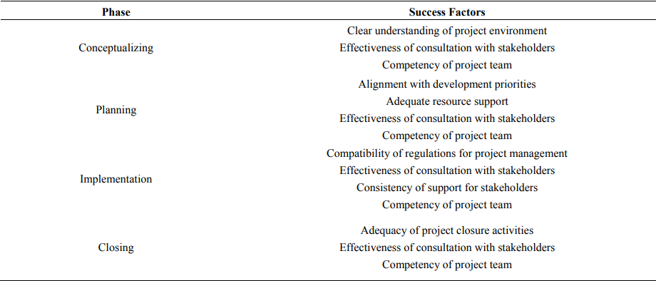

Determining the factors contributing to the success or failure of a project can be just as complex as overseeing the project itself, especially considering the various interpretations of what constitutes success and failure. The varying definitions of critical success indicators provided by different authors underscore that the traditional "iron triangle" of project management, which includes scope, time, and cost, is not the exclusive yardstick for assessing a project's result. In their 2006 study, Fortune and White found limited consensus among authors concerning the factors influencing project performance while analyzing 63 articles focusing on key success factors (CSF). The formation of clear and attainable objectives, the creation of a successful strategy, and the need of senior management support for a project were found to be the top three often highlighted features. Bakar, Razak, Abdullah, and Awang stressed the necessity for project managers to be proactive in identifying the aspects vital to the success of their projects in a 2009 literature review on project success and failure. This emphasises that a variety of complicated elements interact to determine whether a project will succeed or fail, and that a one-size-fits-all strategy may not always be appropriate.

**The main goal of this research is to examine the Critical Success Factors in healthcare projects carried out on a global scale.**

**METHODOLOGY**

The document technique is used in this paper to compile pertinent narrative data for the investigation. The validity of the paper's results was strengthened by classifying, examining, interpreting, and noting the limitations of the many sources and pieces of information in relation to the phenomenon under examination.

The research design process comprises various phases, spanning from establishing the theoretical foundation to data collection and analysis, as outlined by Creswell in 2009. For this investigation, the document data collection technique is employed to gather significant narrative materials. This approach involves the classification, examination, interpretation, and identification of limitations within multiple sources and information related to the phenomenon under study, thereby enhancing the validity of the research findings, as suggested by Mogalakwe in 2006. The study encompassed a range of printed, online, and visual publications.

The analysis of this data collection tool incorporates various criteria such as authenticity, credibility, representativeness, and significance. These criteria are employed to assess and extract the worth and relevance of the documents, in accordance with the guidance provided by Bryman (2008), Macdonald (2006), Mogalakwe (2006), and Scott (1990).

The utilization of content analysis methods for the qualitative data generated in this paper was guided by four key criteria: authenticity, credibility, representativeness, and meaningfulness. This approach was adopted because each of the numerous documents examined in this study possesses its own unique characteristics.

The data sources used were the Project Management Institute portal, Google Scholar, Scopus, and PubMed. Critical success factors, project management, and healthcare are important terms.

**Duration** – March to May 2023

**Ethics** – The IIHMR Student Review Board have reviewed this study for ethical compliance.

**Important variables determining project management success.**

These success criteria, according to Pinto and Slevin (1987), are theoretical rather than empirical, which may mean that while some of the success elements are intended to address particular concerns of significance in the development of specific projects, others are intended to have a more universal impact.

In Belassi and Tukel's study in 1996, they categorized the factors influencing project development success into four distinct groups: those related to the project manager and team members, organizational factors, and environmental factors associated with the project's progress. Similarly, Chan et al. in 2002 took a similar perspective on project success, stating that elements such as the commitment of the project team, the contractor's expertise, assessments of risk and responsibility, the client's capabilities, the needs of end users, and the limitations of end users all play a significant role in determining a project's success.

The cornerstone for project management success criteria across the whole body of research under consideration continues to be the twelve success aspects outlined by Pinto and Slevin (1987). However, all efforts and businesses can benefit from these success criteria. Based on the notion that diverse organisational structures and project development environments exist. Project development success is not assured, and it's important to recognize that a single set of success factors may not apply universally across different construction sectors, as pointed out by Lim et al. (1999). Nevertheless, certain critical success factors can be adaptable from one project development context to another, offering general guidance for facilitating the project's progression.

**RESULTS AND DISCUSSION**

As seen in the above table, this essay outlines various essential success factors along with the viewpoints of each contributor. The main goal of the article was to quantify the frequency of each factor in the frameworks proposed by various writers. The study was able to conceptualise the idea that specific elements or sets of criteria should be given greater weight in the context of project management thanks to the prioritisation and ranking procedure.

The analysis of frequency data demonstrates that 15 Critical Success Factors (CSF) have a significant impact on project success. Among these factors, the second-ranked one, which is project manager authority/leadership, stands out since it is present in six out of the eight author frameworks identified in the literature. Furthermore, the study's findings emphasize that four of these fifteen crucial success factors—project understanding, top-level management support, client engagement, and a shared project mission/objective—are common in five of the eight frameworks developed by these authors. Sufficient project resources, accurate cost and time estimates, as well as effective information and communication, also emerge as essential components for success, ranking fourth and being shared by four of the frameworks.

The study's findings have also brought to light the existence of five additional critical success factors that receive comparatively less emphasis in the research frameworks, as indicated by the data tables. These factors include project risk management, thorough project planning, project ownership, and robust project monitoring measures and feedback mechanisms. These factors were ranked as the fifth most crucial elements contributing to the success of project management.

**Table - Literature Review focussing on Critical Success factors at Global level**

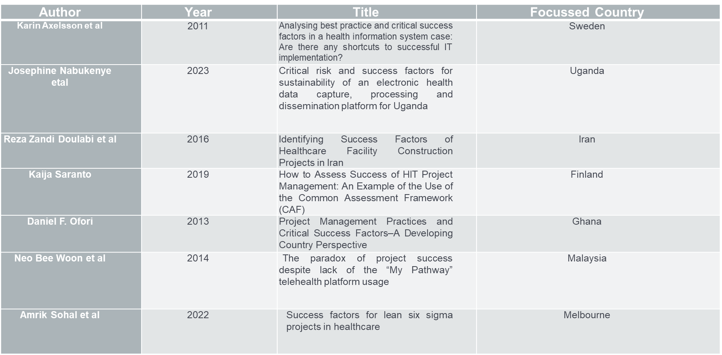 The table data clearly indicates that there are 22 crucial requirements for establishing and effectively delivering sustainable social (public) housing complexes in Nigeria. The research findings also emphasize that the proficiency of project managers, the overseeing organization's capabilities, the qualities of team members, and the external project environment are vital factors that profoundly influence a project's success.

**Table - Summarized Critical Success Factors based on Literature Review**

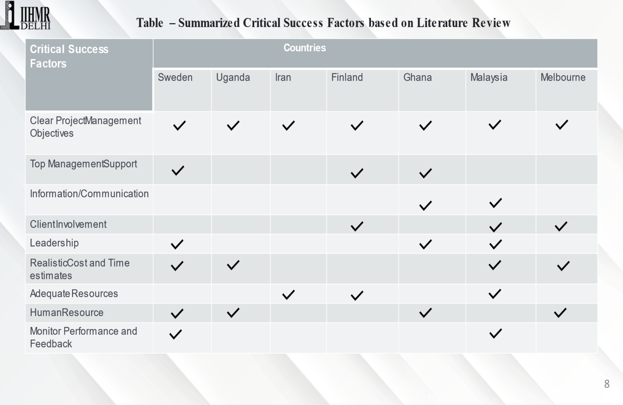

According to the table, there are 22 essential requirements for guaranteeing the establishment and successful completion of sustainable social (public) housing complexes in Nigeria. Moreover, the research results highlight the importance of the project manager's competence, the overseeing organization's expertise, the attributes of team members, and the external project environment as pivotal factors affecting a project's success.

Rather than relying solely on the deployment of project team members based on federal character representation, the establishment of sustainable housing estates calls for competent team members who possess the necessary expertise and capabilities to efficiently carry out projects. As an example, the National Housing Policy of 2011 underscored the importance of successful execution, coordination, monitoring, and evaluation in achieving the sustainable delivery and provision of housing across the country. This approach also mandated the establishment of a framework that fosters strong partnerships and collaborations with all stakeholders involved.

While the concerns mentioned earlier are unquestionably significant, addressing issues related to land is equally crucial for the successful development of adequate and sustainable housing estates. The rigid framework of the Land Use Act (1978), compounded by its integration into the country's constitution, imposes limitations on the accessibility of land for housing purposes, rendering even minor adjustments to it a formidable endeavor. According to Aluko's findings in 2012, this not only complicates the process of acquiring property certificates of occupancy but also perpetuates administrative complexities and financial constraints. It's important to highlight that this research does not delve deeply into many of the broad and critical success factors outlined in the table.

The National Housing Policy of 2011 characterizes resources and funding for housing projects as the driving force behind the housing sector, and this study underscores the importance of this concept. It pertains to the financial support required to construct suitable housing estates and provide the necessary infrastructure for these communities. Achieving this hinges on the presence of a reliable and efficient housing finance system. To ensure ongoing liquidity in the national housing fund program, it is recommended to channel any proceeds generated by the housing finance institution into the Federal Mortgage Bank of Nigeria (FMBN). The significance of financial resources has been a recurring theme in this discussion.

**Table – Ranking of Critical Success Factors based on Literature** 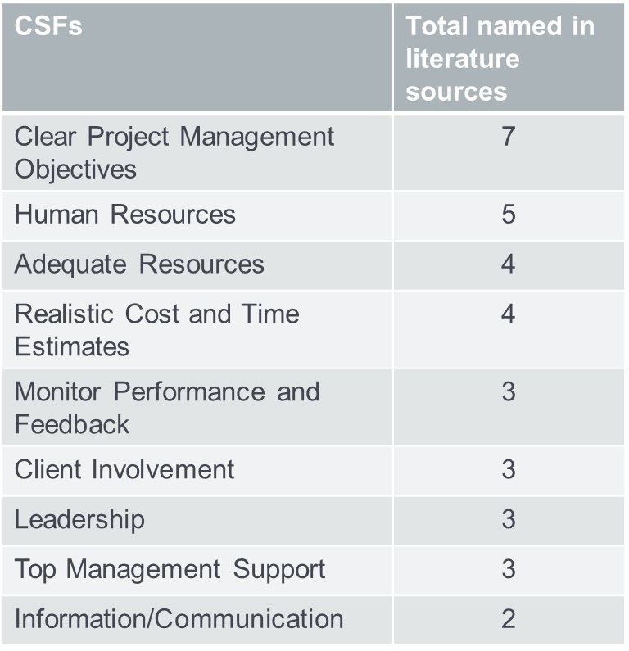

The prevailing issues, such as the insufficient commitment from all government levels to the housing sector, the protracted and costly land acquisition and transfer processes in the country, and the persisting bureaucratic hurdles in securing loans from financial institutions for the delivery of adequate housing, are all pervasive challenges that underscore the need for enduring reforms.

This study's examination of the critical success factors for establishing an eHealth data collection, processing, and dissemination platform in Uganda was based on the premise that achieving these objectives would be advantageous for the nation and bring about positive effects. Critical success factors can be categorized into two types: those that are essential for success and those that are already in place, facilitating smoother implementation.

Successfully completing a project on time, within budget, and meeting the desired quality standards serves as a clear indicator of effective project management. Just like past health and medical research projects, the current project had well-defined time and budget constraints, underscoring the importance of proficient project management from project initiation to conclusion. Given the project's complexity and the multitude of tasks involved, there was a risk of subpar outcomes and exceeding the budget, emphasizing the need for expert project management.

The outcomes of our post-project evaluation reveal that the researchers acknowledged the significance of project management in ensuring the timely and budgeted production of high-quality project deliverables. This recognition is pivotal because the failure to complete projects according to schedule, budget, and quality standards typically leads to a suboptimal return on investment.

Researchers must strive to prevent research waste resulting from poorly executed and unevenly disseminated work. Chalmers and Glasziou have indicated that as much as 85% of research resources could be squandered. While they did not explicitly state that project management could directly mitigate this waste, we propose that its more widespread adoption in health and medical research projects could contribute to reducing this percentage.

In the telehealth literature, the most frequently mentioned facilitator is the quality of system performance. This quality level is assessed based on factors such as content, data reliability, utility, flexibility, and usefulness. Another crucial enabler is managerial support, ensuring that there are ample resources and backing for the adoption and utilization of telehealth, as well as a sustained commitment from healthcare professionals. Additionally, the expectation of effort, closely linked to the ease of using technology, is a commonly acknowledged facilitator, with Nisha et al. asserting its significant influence, particularly in the initial stages of technology adoption. Similarly, numerous studies highlight that trust directly and positively affects the intention to use technology and the perceived value of it. By influencing these aforementioned facilitators, trust also plays an intermediary role in achieving success and, consequently, indirectly impacts outcomes.

Through its influence on the facilitators mentioned earlier, trust serves as a mediator of success, thus indirectly shaping the outcomes of telehealth initiatives. Empowering patients is a fundamental aspect of telehealth, as it enables them to access and manage relevant health information as required. Granting patients the autonomy to take charge and make decisions concerning their own behavior and healthcare is a central element of empowerment

**CONCLUSION**

In conclusion, the report highlights the significant challenges associated with the development of housing estates in Nigeria, a matter of concern for both Federal and State Governments across various administrations. Despite these concerns, the issue of insufficient housing has often been neglected, primarily due to the lack of implementation of essential success factors in project management for sustainable social (public) housing estate delivery and provision. Given the pivotal role that sustainable social housing estates play in the socioeconomic progress of the country, it becomes imperative to comprehend and apply these criteria for successful project management not only in Nigeria but also in other developing nations.

Government policies should prioritize the broader needs of the population over narrow political or financial interests when it comes to the development and delivery of sustainable social (public) housing estates. These policies should be a steadfast foundation and be upheld regardless of changes in government administrations. It is crucial for all stakeholders in the housing industry to support these policies. Government agencies responsible for housing estate units should also initiate capacity-building programs to educate professionals, decision-makers, and other organizations about their objectives for providing enduring social (public) housing estates.

To enhance our understanding in this field, the study suggests further empirical research using both qualitative and quantitative methods. This is essential because the study primarily relied on documentary evidence to establish these critical criteria.

**REFERENCES**

1. Pmi.org. [cited 2023 Mar 18]. Available from: [https://www.pmi.org/learning/library/quality-project-management-tools-7177#](https://www.pmi.org/learning/library/quality-project-management-tools-7177)
2. 5 phases of project management process - A complete breakdown [Internet]. Kissflow.com. Kissflow; 2022 [cited 2023 Mar 18]. Available from: <https://kissflow.com/project/five-phases-of-project-management/>
3. Donato H. 5 phases of project management life cycle you need to know [Internet]. Project-management.com. 2022 [cited 2023 Mar 18]. Available from: <https://project-management.com/project-management-phases/>
4. Lorange, Y. (2018, December 28). Healthcare project management techniques: A pragmatic approach to outcomes improvement. *Health Catalyst*. <https://www.healthcatalyst.com/insights/healthcare-project-management-techniques-pragmatic-approach-outcomes-improvement>
5. Saranto K, Kivekäs E, Rosenlund M, Jylhä V, Liljamo P, Arvonen S, et al. How to assess success of HIT project management: An example of the use of the Common Assessment Framework (CAF). Stud Health Technol Inform [Internet]. 2019 [cited 2023 Jun 28];264:783–7. Available from: <https://pubmed.ncbi.nlm.nih.gov/31438031/>
6. Ofori DF. Project management practices and critical success factors–A developing country perspective. Int J Bus Manag [Internet]. 2013;8(21). Available from: [https://pdfs.semanticscholar.org/5851/d209da26663f2921a02d30d0c502febd80eb.pdf?_gl=1*1dhyr50*_ga*MTk2NzY0ODYwNy4xNjg3NzczNDAy*_ga_H7P4ZT52H5*MTY4Nzc3MzQwMS4xLjAuMTY4Nzc3MzQwNy41NC4wLjA](https://pdfs.semanticscholar.org/5851/d209da26663f2921a02d30d0c502febd80eb.pdf?_gl=1*1dhyr50*_ga*MTk2NzY0ODYwNy4xNjg3NzczNDAy*_ga_H7P4ZT52H5*MTY4Nzc3MzQwMS4xLjAuMTY4Nzc3MzQwNy41NC4wLjA)
7. Axelsson K, Melin U, Söderström F. Analyzing best practice and critical success factors in a health information system case: Are there any shortcuts to successful IT implementation? [Internet]. Diva-portal.org. [cited 2023 Jun 28]. Available from: <https://www.diva-portal.org/smash/get/diva2:453802/FULLTEXT01.pdf>
8. Nabukenya J, Drumright L, Alunyu AE, Semwanga AR. Critical risk and success factors for sustainability of an electronic health data capture, processing and dissemination platform for Uganda. Health Informatics J [Internet]. 2023 [cited 2023 Jun 28];29(2):14604582231180576. Available from: <https://pubmed.ncbi.nlm.nih.gov/37256870/>
9. Müller SD, Wehner DL, Konzag H, Vesterby M, Høybye MT. The paradox of project success despite lack of the “My Pathway” telehealth platform usage. Health Informatics J [Internet]. 2021;27(1):1460458220976734. Available from: <http://dx.doi.org/10.1177/1460458220976734>