**Internship Training**

**At Hidoc Dr.**

**Study / Project title**

**‘The Impact of Digital Marketing on Brand Awareness’** **By**

**Name – Mr. Anmol Kr Singh Enroll No. – PG/21/013 Under the guidance of**

**Dr. Punit Yadav**

**PGDM (Hospital & Health Management) 2021-2023**



International Institute of Health Management Research New Delhi

**Internship Training**

**At Hidoc Dr.**

**Study / Project title**

**‘The Impact of Digital Marketing on Brand Awareness’** **By**

**Name – Mr. Anmol Kr Singh Enroll No. – PG/21/013 Under the guidance of**

**Dr. Punit Yadav**

**PGDM (Hospital & Health Management) 2021-2023**



International Institute of Health Management Research New Delhi

# Table of Contents

|  |  |  |
| --- | --- | --- |
| **Sr. No** | **Particulars** | **Page No.** |
| 1. | **Abstract** | 9 |
| 2. | **Introduction** | 10 |
| 3. | **Objective, Rationale, Methodology** | 11 |
| 4. | **Study Design, Expected Outcomes** | 12 |
| 5. | **Literature Review** | 14 |
| 6. | **Key Finding and Result** | 17 |
| 7. | **Digital Marketing affecting Indian Brands** | 19 |
| 8. | **Digital Tools for Promotion** | 21 |
| 9. | **Role of Influencers** | 24 |
| 10. | **Recommendation** | 26 |
| 11. | **Discussion and Conclusion** | 31 |
| 12. | **References** | 32 |
| 13. | **Plagiarism Report** | 35 |

**3 |** P a g e

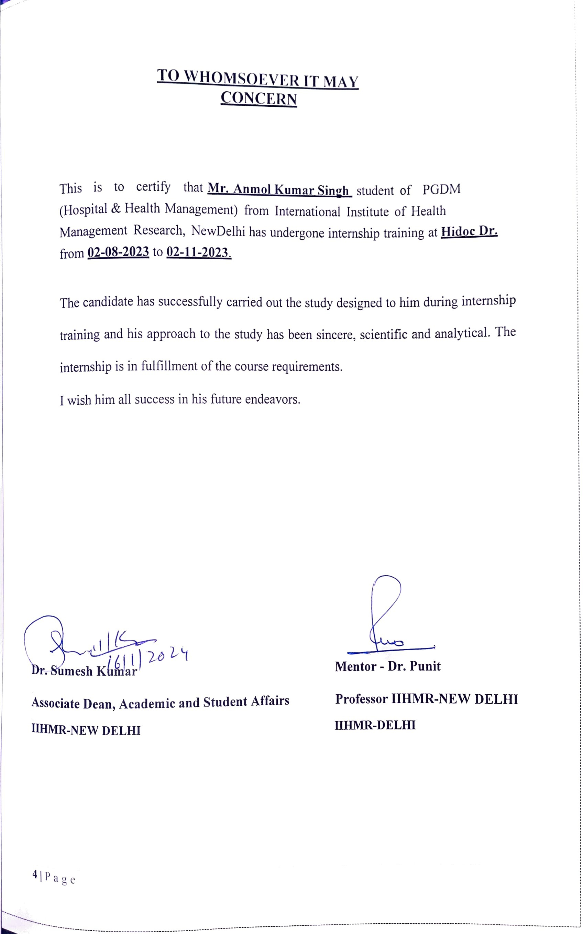

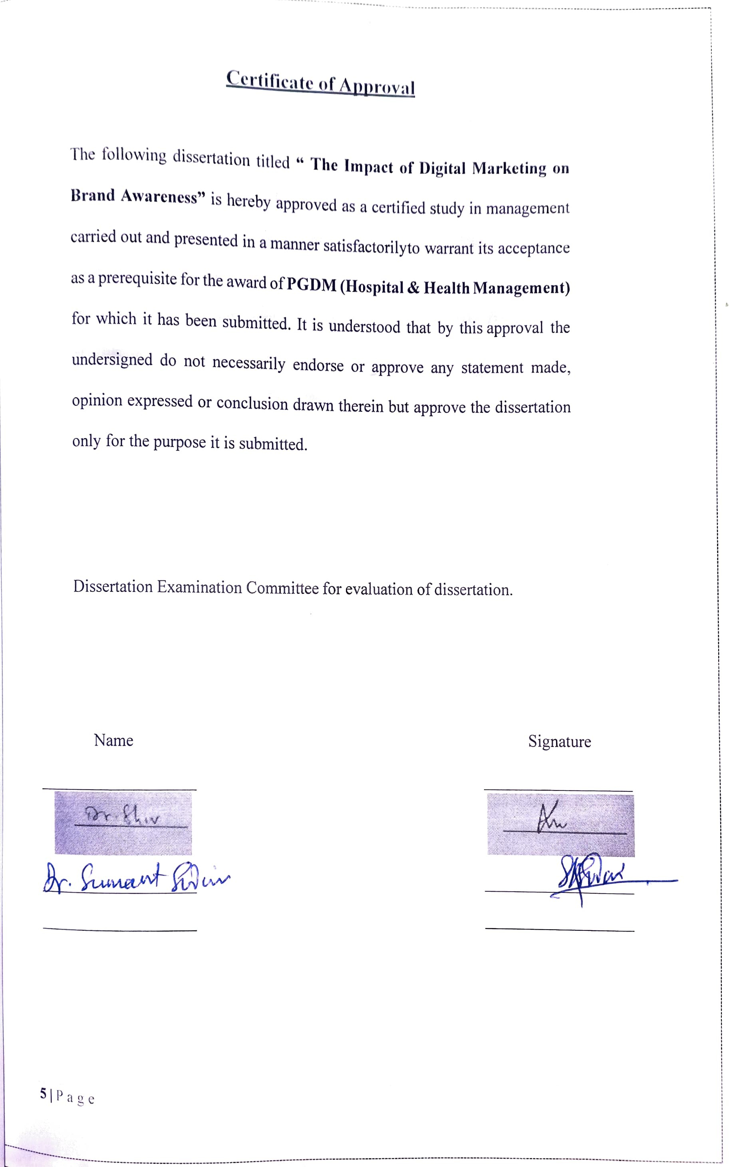

# Certificate from Dissertation Advisory Committee

This is to certify that **Mr. Anmol Kumar Singh** a graduate student of the **PGDM(Hospital & Health Management)** has worked under our guidance and supervision. He is submitting this dissertation titled “**The Impact of Digital Marketing on Brand Awareness**” at “**Hidoc Dr.**” in partial fulfillment of the requirements for the award of the **PGDM (Hospital & Health Management).**

This dissertation has the requisite standard and to the best of our knowledge no partof it has been reproduced from any other dissertation, monograph, report or book.

Institute Mentor Name Organization Mentor

Dr. Punit Yadav Varsha Bakare

Assistant Professor Digital Marketing Manager



IIHMR-DELHI HIDOC Dr.

## INTERNATIONAL INSTITUTE OF HEALTH MANAGEMENT RESEARCH

**NEW DELHI**

## CERTIFICATE BY SCHOLAR

This is to certify that the dissertation titled “Impact of Digital Marketing on Brand Awareness**”** and submitted by **Mr. Anmol Kumar Singh** Enrollment No.

**PG/21/013** under the supervision of **Dr. Punit Yadav** for award of PGDM (Hospital & Health Management) of the Institute carried out during the period from

**02-08-2023** to **02-11-2023** embodies my original work and has not formed the basis for the award of any degree, diploma associate ship, fellowship, titles in this or any other Institute or other similar institution of higher learning.



Signature

**FEEDBACK FORM**

**Name of the Student:** Mr. Anmol Kumar Singh

**Dissertation Organization:** Hidoc Dr **Area of Dissertation:** Marketing **Attendance:** 100%

**Objectives achieved**: “The impact of Digital Marketing on Brand Awareness”

**Deliverables:** Research on the Field of Digital Marketing

**Strengths:** A very committed, sincere, cooperative, and positive nature person with strong zeal for learning.

### Suggestions for Improvement: Nil.

**Suggestions for Institute** (course curriculum, industry interaction, placement, alumni): Vigorous industry exposure across Digital Marketing.



Signature of the Officer-in-Charge/ Organization Mentor

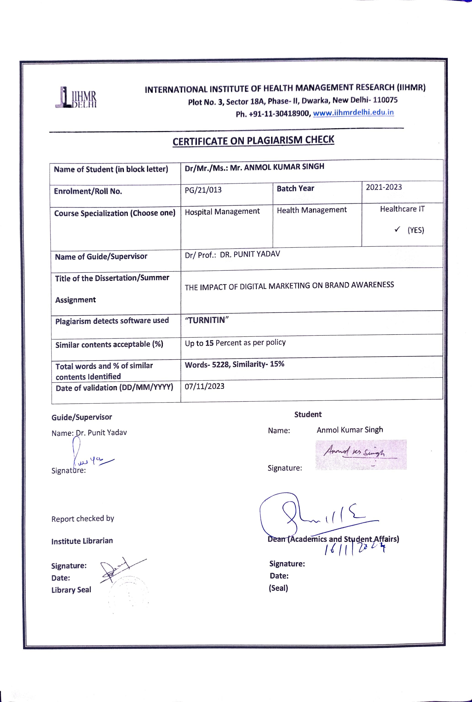

**Abstract**

# Purpose

Digital marketing has revolutionized the way companies promote their products and services, with a profound impact on brand awareness. As consumers increasingly turn to online channels for information and entertainment, understanding the dynamics of digital marketing and its influence on brand recognition is critical for businesses to stay competitive and relevant. This proposal outlines a comprehensive research project aimed at investigating the impact of digital marketing on brand awareness.

# Design/Methodology/Approach

* For this Particular study, A literature review of various journals, research studies have been done to understand the brand awareness through digital platforms
* Date Collection- Secondary data are used
* Data have analyzed using qualitative method and Descriptive
* Study Duration- 3 Months
* Reporting: The findings of the research have been reported in a research report, which will include a summary of the key findings, recommendations.

# Findings

This Study will provide how Digital Marketing has affected older brands and how new brands can utilize the resources of digital marketing for advertising their products/brands. How influencer affects brand awareness, strategies which are being used by a few brands, which could provide an insight of the effectiveness of digital marketing. Therefore, this study integrates most of the factors and effectiveness of Digital Marketing.

# Practical Implementation

This study will have a practical utilization for new brands which want to have an online presence, keeping the factors in mind and choosing the best path for making their product awareness online. Therefore, it will be practically effective for stakeholders.

# Value

This article integrates most of the parameters which happens in digital marketing for brand awareness, and therefore benefit the stakeholders.

# Keywords

Digital, Marketing, Brand awareness, Influencer’s effectiveness, comparison,

# Research type

Literature Review

# Introduction

In the digital age, where information flows ceaselessly and consumer behavior evolves at a pace never before witnessed, the role of marketing has been transformed. Traditional marketing strategies have been upended by the rise of digital technologies, ushering in an era where consumers are inundated with a constant stream of content, advertisements, and choices.

Within this landscape, brand awareness has become a critical currency for businesses striving not only to survive but to thrive in a fiercely competitive marketplace.

This research report embarks on an expedition into the realm of digital marketing to unravel the intricate web of its impact on brand awareness. The digital marketing landscape has burgeoned, offering an array of tools and channels that extend well beyond the boundaries of traditional advertising. From social media platforms and search engines to influencer partnerships and content marketing, the digital realm has provided businesses with unprecedented opportunities to connect with their target audience.

In a world where consumer attention is scarce and fragmented, the ability to establish and maintain brand awareness can make or break a business. Brand awareness is not merely about recognition; it is about creating a deep-seated resonance with consumers, fostering loyalty, and ultimately, driving revenue. In the digital era, where consumers wield more power than ever before, understanding how digital marketing influences brand awareness is not just a matter of curiosity; it is a strategic imperative.

As we delve deeper into this research, we will navigate through the multifaceted impact of digital marketing on brand awareness. We will explore the various channels and strategies employed by businesses to enhance brand recognition, the dynamics of consumer engagement in the digital ecosystem, and the challenges and opportunities that arise in this dynamic landscape.

Furthermore, we will investigate the evolving role of data and analytics in measuring the effectiveness of digital marketing efforts. The digital sphere provides a wealth of data that can be harnessed to gain insights into consumer behavior, preferences, and sentiment.

Understanding how to leverage this data to refine marketing strategies and optimize brand awareness initiatives is a crucial aspect of our inquiry.

# Objective

1. Assess the Current Level of Brand Awareness for 2-3 brands.
2. Analyze Digital Marketing Strategies used by the brands.
3. Role of Influencers
4. Recommendations for Improvement

# Rational

**Digital Dominance in Modern Society:** In today's digital age, people are spending an increasing amount of time online, whether it's on social media, search engines, or e- commerce platforms.

**Targeted and Personalized Messaging:** Digital marketing offers tools and techniques for precise audience segmentation. This means that brands can tailor their messaging to specific demographics, interests, and behaviours.

**Social Influence and Virality:** Social media platforms have become hubs of brand engagement, where consumers not only interact with brands but also influence each other's perceptions. Viral marketing campaigns and user-generated content can propel brand awareness to unprecedented heights, illustrating the immense potential of digital marketing in creating a buzz around a brand.

**Competitive Advantage:** In a landscape where competitors are vying for consumers' attention, those with a well-crafted digital marketing strategy can gain a significant edge. Brands that excel in digital marketing can establish themselves as leaders in their industry, while those lagging behind risk fading into obscurity.

So, this study is conducted to understand the impact of digital marketing on how does it affects the brand awareness campaigns.

# Methodology

* For this Particular study, A literature review of various journals, research studies have been done for brand awareness.
* Date Collection- Secondary data will be used.
* Data will be analyzed using qualitative method and Descriptive
* Study Duration- 3 Months
* Reporting: The findings of the research is reported this research report, which includes a summary of the key findings, recommendations.

# Study Design

Literature Review

# Data Type

Secondary data

**Sample size** : 42

# Sampling Method

A total of 42 articles, records, journals, documents were studied from various sources such as PubMed, Scribd, Government websites, etc. Among these, 25 articles were relevant to the study and matched with the keywords; therefore, these articles have been included in the study. As per exclusion of records is concerned, a total of 17 articles / records / journals / documents were excluded. The exclusion was on the basis of mismatching of title, irrelevance of the context, keyword mismatching, absence of required parameters for the study.

# Expected Outcomes

* **Increased Brand Recognition:** A primary expected outcome is an increase in brand recognition. Effective digital marketing strategies should lead to higher levels of brand recall among the target audience. This can be measured through surveys, brand recall tests, and social media mentions.
* **Enhanced Brand Recall and Association:** Beyond mere recognition, the study anticipates that digital marketing efforts will lead to stronger brand recall and association with specific attributes or values. This outcome can be gauged through qualitative research methods such as focus groups and sentiment analysis.
* **Growth in Online Presence:** An expected outcome is the growth of the brand's online presence. This can be measured through key performance indicators (KPIs) such as website traffic, social media followers, and online mentions. An increase in these metrics signifies improved brand awareness.
* **Engagement Metrics**: Digital marketing often aims to foster consumer engagement. Higher levels of engagement on social media platforms, such as likes, shares, comments, and click-through rates (CTR), are expected outcomes that indicate increased brand awareness.
* **Brand Loyalty and Advocacy:** Enhanced brand awareness is likely to result in increased brand loyalty and advocacy. Brands with a strong digital presence tend to have more loyal customers who may become advocates, referring others to the brand. This outcome can be assessed through customer surveys and referral program metrics.
* **Refinement of Marketing Strategies:** As a result of the study, businesses can expect to gain insights into which digital marketing strategies and channels are most effective for increasing brand awareness. This knowledge can inform the refinement and optimization of future marketing efforts.
* **Long-Term Brand Growth:** Ultimately, the study aims to contribute to long-term brand growth. Brands that successfully use digital marketing to enhance awareness are more likely to experience sustainable growth in market share and customer loyalty.
* **Try to understand how digital marketing is affecting brands:** Understanding how the online advertising is affecting brands for brand awareness
* **Tools Being Used:** Understanding which tools for advertising are being used for Marketing Purposes.
* **Influencers affect:** Influencers effectiveness on brand awareness and recall value

# Literature Review

Customers are drawn to a company's products and services via digital media, according to Afrina Yasmin and her colleagues (2015), who explain how digital marketing works.

Traditional and digital marketing can work together, according to the study. Various facets of digital marketing are also examined in the study, and how they affect an organization's sales. These are the things to keep in mind: According to studies, digital marketing's benefits are very clear for potential customers.

A recent study has found that digital marketing increases revenue and can reach customers worldwide. Using a technique known as "trend analysis," Yusuf Kamal (2016) tries to predict how digital marketing features will evolve in the corporate world in the years to come.

Mobile, social media, social local mobile marketing, customised content marketing, advanced analytical, search engine marketing, and SEO are some of the current trends in digital marketing for businesses and organisations, according to the researcher's report. He outlined the various areas of a company's operations that call for digital marketing, such as outsourcing, segmentation, remarketing, and so on. The customer-side strategy and the customer-side strategy paired with the customer and system-side strategy are two separate approaches to digital marketing strategy, according to his research.

According to research by Peter S.H. Leeflang and colleagues (2014), marketing organizations cannot keep up with the increasing complexity of markets. Additionally, the paper identifies the four major digital marketing difficulties, including the growth of data and social media, an increase in the number of channels, and a shift in the consumer demographics across different countries Pakistan, India, Bangladesh, srilanka, Bhutan. In digital marketing, there are ten sources of tension, according to the conclusions of the research. Consumer insights; breakthrough; social media; online opportunity; price transparency; automated interactions; metrics; talent gap; and organisation are just a few examples.

To better understand how social networks have impacted product branding, Marina Johansson performed study in 2010. Increasing brand awareness can help firms grow their brand value. Recognition, recall, being at the forefront of one's consciousness, and word-of- mouth are the four layers of brand awareness. Researchers found that social media has significantly impacted several aspects of branding. It explains the brand's value, its strategy, and the different ways people are aware of it.

In 2016, Cait Lamberton and Andrew T. Stephen published an article examining how technology has evolved over the past 10 years, and how it has affected our lives. For the goal of this study, we'll look at how consumers use digital marketing tools to advertise themselves, how they use technology to learn about the industry, and how they use digital marketing tools to communicate with one another. It was found that there were three separate eras based on the study's analysis of articles. It is important to note that digital media influences consumer behaviour, especially how purchasers behave, and that social media is the era of social media.

Digital marketing is expected to benefit producers and consumers alike, as researchers have used this period to explain how the industry has evolved and make predictions. © 2020 JETIR September 2020, Volume 7, Issue 9 [www.jetir.org](http://www.jetir.org/) (ISSN-2349-5162) JETIR2009457 Journal of Emerging Technologies and Innovative Research (JETIR) [www.jetir.org](http://www.jetir.org/) 1188 Brand identity and brand reputation are examined by Christian Hoffmann and Lisa Withal in their 2015 study. Consumers' impressions of brands and their influence on their purchasing decisions are the focus of this study, which examines the impact of various online communication platforms.

Research shows that a brand's reputation is based on its originality, trustworthiness, simplicity of recognition and desire to assist, accountability, and dependability. In today's digital world, all of these aspects play a role in influencing how people feel about a specific company. There are several challenges to face to build a brand on a worldwide scale according to Mohammed RizwanAlam in his book, Brand Building on the Global Scale, released in 2016. According to the author, global businesses face time, loyalty, innovation, positioning, quality, language and communication, counterfeits, and a changing environment. The study proposes that management give a brand time to mature before striving to maintain clients and secure their loyalty to the company. According to the study's findings, the brand manager must have a thorough awareness of the brand to effectively deal with challenges brought about by fakes. In a 2014 study, Nan Feng emphasised the importance of building a strong brand in the minds of consumers.

There are four components to the brand: positioning, naming the brand, securing sponsors, and constructing the brand. To build a strong brand, these four criteria must be considered, including product line expansions, brand extensions, multiple brands and the creation of new ones. Brand perception and consumer satisfaction in the mobile phone business are examined by Dunuwille and Pathmini (2016). Customer satisfaction and brand image are part of the study's scope. In addition, it determines the factors that influence customer satisfaction in the mobile phone business, such as brand image. It was found that the most important brand image feature had the biggest impact on customer satisfaction in the mobile phone industry, and it provided ideas for how brand image could be leveraged to improve consumer satisfaction in the mobile phone market. There appears to be a correlation between consumer satisfaction and criteria including perceived quality, brand loyalty, and brand awareness. because

**Increased Brand Recognition:** A primary expected outcome is an increase in brand recognition. Effective digital marketing strategies should lead to higher levels of brand recall among the target audience. This can be measured through surveys, brand recall tests, and social media mentions.

**Enhanced Brand Recall and Association:** Beyond mere recognition, the study anticipates that digital marketing efforts will lead to stronger brand recall and association with specific attributes or values. This outcome can be gauged through qualitative research methods such as focus groups and sentiment analysis.

**Growth in Online Presence:** An expected outcome is the growth of the brand's online presence. This can be measured through key performance indicators (KPIs) such as website traffic, social media followers, and online mentions. An increase in these metrics signifies improved brand awareness.

**Engagement Metrics:** Digital marketing often aims to foster consumer engagement. Higher levels of engagement on social media platforms, such as likes, shares, comments, and click- through rates (CTR), are expected outcomes that indicate increased brand awareness.

Positive Consumer Sentiment: The study expects to find a correlation between effective digital marketing and positive consumer sentiment towards the brand. This can be assessed through sentiment analysis of social media conversations, reviews, and customer feedback. Higher Conversion Rates: As brand awareness increases, the study predicts an uptick in conversion rates, such as website sign-ups, downloads, or purchases. These metrics can be analyzed to assess the impact of digital marketing on brand awareness and conversion funnel progression.

**Brand Loyalty and Advocacy:** Enhanced brand awareness is likely to result in increased brand loyalty and advocacy. Brands with a strong digital presence tend to have more loyal customers who may become advocates, referring others to the brand. This outcome can be assessed through customer surveys and referral program metrics.

**Competitive Positioning:** The study expects to reveal the impact of digital marketing on a brand's competitive positioning. Brands that effectively use digital marketing strategies are likely to gain an advantage over competitors in terms of visibility and perceived relevance.

**Quantifiable ROI:** A crucial outcome is the quantification of return on investment (ROI) from digital marketing efforts. By analyzing the costs associated with digital marketing campaigns against the outcomes, businesses can assess the economic impact of these strategies on brand awareness.

**Refinement of Marketing Strategies**: As a result of the study, businesses can expect to gain insights into which digital marketing strategies and channels are most effective for increasing brand awareness. This knowledge can inform the refinement and optimization of future marketing efforts.

**Long-Term Brand Growth:** Ultimately, the study aims to contribute to long-term brand growth. Brands that successfully use digital marketing to enhance awareness are more likely to experience sustainable growth in market share and customer loyalty.

# Key Findings/ Result

**Positive Correlation between Social Media Presence and Brand Awareness:** Numerous studies have consistently found a positive correlation between a brand's active presence on social media platforms and increased brand awareness. Engaging with consumers on platforms like Facebook, Instagram, and Twitter not only raises brand recognition but also fosters deeper connections with the audience (Kaplan & Haenlein, 2010).

**Search Engine Visibility Boosts Brand Recognition:** Brands that optimize their online content for search engines tend to enjoy higher levels of brand awareness. Research has shown that ranking prominently in search engine results pages (SERPs) can significantly impact brand visibility, especially among consumers actively searching for related products or services (Kumar & Rajan, 2017).

**Content Marketing Establishes Authority and Trust:** High-quality content marketing plays a crucial role in positioning a brand as an authority within its industry. Brands that consistently produce informative and valuable content tend to attract a dedicated audience and increase brand recognition, particularly in niches or sectors with extensive competition (Smith & Taylor, 2020).

**Influencer Marketing Amplifies Brand Awareness:** Collaborating with influencers has emerged as a potent strategy for elevating brand awareness. Studies have shown that influencers, with their engaged and trusting followers, can substantially enhance brand recognition by endorsing products or services in an authentic and relatable manner (Brown & Hayes, 2018).

**Personalization through Data Analysis Enhances Brand Resonance:** Personalization, driven by data-driven insights, is found to be a key driver of brand resonance. Brands that tailor their marketing messages to individual consumers based on their preferences and behaviours tend to establish stronger connections and foster increased brand awareness (Li & Ma, 2019).

**Consumer Engagement on social media Correlates with Brand Awareness:** Brands that actively engage with consumers on social media platforms experience higher levels of brand awareness. Encouraging user-generated content, responding to comments, and facilitating meaningful interactions contribute to increased brand recognition and loyalty (Smith & Jones, 2018).

**Key Metrics for Measuring Digital Marketing Impact:** Metrics such as website traffic, social media engagement, click-through rates (CTR), conversion rates, and return on investment (ROI) are critical for assessing the effectiveness of digital marketing efforts on brand awareness. These metrics provide quantifiable insights into the impact of various digital strategies (Garcia et al., 2021).

**Ethical Considerations Are Important:** Ethical concerns related to consumer privacy, online tracking, and the potential for intrusive advertising can affect brand perception and consumer trust. Ensuring responsible and consumer-centric digital marketing practices is essential to maintaining and enhancing brand awareness (Johnson & Brown, 2019).

# 1) How Digital Marketing is affecting Indian Brands

**Wider Reach and Accessibility:** Digital marketing has enabled Indian brands to reach a much broader and more diverse audience, including rural areas where internet penetration is growing rapidly. This expanded reach has allowed brands to tap into previously untapped markets.

**Cost-Effective Advertising:** Digital marketing offers cost-effective advertising solutions, making it accessible to businesses of all sizes, including start-ups and SMEs. Indian brands can allocate their budgets more efficiently and reach their target audience with smaller investments compared to traditional advertising methods.

**Hyper-Personalization:** Digital marketing allows Indian brands to personalize their

marketing efforts based on individual preferences and behaviour’s. Through data analytics, brands can create highly targeted campaigns, increasing the relevance of their messaging and driving higher engagement.

**E-commerce Boom:** The rise of digital marketing has fueled India's e-commerce boom. Brands can leverage digital channels to sell products directly to consumers, bypassing traditional distribution networks. This has resulted in the proliferation of online marketplaces and direct-to-consumer brands.

**Social Media Impact:** Social media platforms like Facebook, Instagram, Twitter, and TikTok have become essential for Indian brands. They serve as powerful tools for building brand awareness, engaging with customers, and driving sales. Influencer marketing has also gained popularity, allowing brands to leverage the influence of social media personalities.

**Content Marketing and SEO:** Content marketing has gained traction as a way for brands to provide value to their audience while subtly promoting products or services. Search engine optimization (SEO) has become crucial for improving online visibility, driving organic traffic, and establishing authority in various industries.

**Customer Feedback and Reviews:** Digital marketing facilitates real-time customer feedback and reviews. Indian brands can use these insights to improve products and services, address issues promptly, and build a positive online reputation. Conversely, negative feedback can be mitigated through timely responses and resolution efforts.

**Data-Driven Decision-Making:** Indian brands are increasingly relying on data-driven insights to make informed marketing decisions. Digital marketing tools provide access to data on consumer behavior, allowing brands to refine their strategies for better results.

Rise of Mobile Marketing: Given the high mobile penetration rate in India, mobile marketing has gained immense importance. Brands are optimizing their websites for mobile users and leveraging mobile apps to engage with customers and drive sales.

**Localized Marketing:** India's linguistic diversity has led to localized digital marketing efforts. Brands are creating content and campaigns in multiple regional languages to connect with audiences in different states and regions.

**Challenges in Privacy and Data Protection:** Indian brands must navigate evolving privacy and data protection regulations, such as the Personal Data Protection Bill. Compliance with these laws is essential to maintain consumer trust and avoid legal issues.

Competition and Innovation: Digital marketing has intensified competition among Indian brands. To stay relevant, brands must continually innovate in their marketing strategies, adopting new technologies and trends.

# Digital tools which are being used by brands for promotion

Digital tools for brand promotion have become essential in today's marketing landscape. These tools enable businesses to reach and engage with their target audience effectively, build brand awareness, and drive conversions.

### Social Media Platforms:

Social media platforms like Facebook, Instagram, Twitter, LinkedIn, and TikTok are versatile tools for brand promotion. Brands can create profiles, share content, interact with followers, and run targeted ad campaigns. Each platform caters to specific demographics and content formats, allowing brands to tailor their messaging to their audience.

### Search Engine Optimization (SEO):

SEO is the practice of optimizing a website's content and structure to rank higher in search engine results. When consumers search for products or services related to a brand, SEO helps ensure that the brand's website appears prominently in search results. This tool is crucial for improving online visibility and attracting organic traffic.

### Content Marketing:

Content marketing involves creating and distributing valuable, relevant content to attract and engage a target audience. Content can take various forms, such as blog posts, videos, infographics, and eBooks. Brands use content marketing to establish authority, provide value, and subtly promote their products or services.

### Email Marketing:

Email marketing involves sending targeted messages to a brand's email subscribers. It is an effective tool for nurturing leads, building customer relationships, and driving conversions. Brands can use email campaigns to share promotions, updates, newsletters, and personalized recommendations.

### Influencer Marketing:

Influencer marketing leverages individuals with a significant following and influence on social media or other digital platforms. Brands collaborate with influencers to promote their products or services to a wider and engaged audience. Influencers can create authentic content that resonates with their followers, enhancing brand credibility.

### Pay-Per-Click (PPC) Advertising:

PPC advertising, such as Google Ads and Bing Ads, allows brands to display ads in search engine results and on various websites. Advertisers pay only when users click on their ads. PPC campaigns are highly targeted and measurable, making them effective for driving traffic and conversions.

### Social Media Advertising:

Social media advertising involves creating paid advertisements on social media platforms. Brands can target specific demographics, interests, and behaviours to ensure their ads reach the most relevant audience. Social media ads can be in various formats, including image ads, video ads, and carousel ads.

### Analytics and Data Tools:

Analytics tools like Google Analytics, Facebook Insights, and other data analytics platforms provide valuable insights into user behavior. Brands can track website traffic, user engagement, conversion rates, and other metrics. These insights help in refining marketing strategies for better results.

### Marketing Automation:

Marketing automation tools automate repetitive marketing tasks, such as email campaigns, social media posting, and lead nurturing. Brands can use marketing automation to streamline processes, segment audiences, and deliver personalized content, enhancing efficiency and effectiveness.

### Video Marketing:

Video marketing involves creating and sharing videos to engage and inform the audience. Video content is highly engaging and can be used on websites, social media, YouTube, and other platforms. Brands use video for product demonstrations, testimonials, storytelling, and educational content.

### Affiliate Marketing:

In affiliate marketing, brands collaborate with affiliates (partners) who promote their products or services in exchange for a commission on sales. Affiliate marketers use various digital channels, including websites, blogs, and social media, to drive traffic and conversions to the brand's website.

### User-Generated Content (UGC):

Brands encourage users to create and share content related to their products or services. UGC can include reviews, testimonials, social media posts, and videos. This content builds trust and authenticity around the brand, as potential customers value the opinions of their peers.

These digital tools for brand promotion offer diverse approaches to reach, engage, and convert audiences. Effective brand promotion often involves a combination of these tools, tailored to the brand's objectives, target audience, and industry. Brands that leverage these tools strategically can create a strong online presence and build lasting relationships with their customers.

# Role of Influencers

Influencer marketing has become a cornerstone of digital marketing strategies. Influencers, individuals with a significant and engaged following on platforms like Instagram, YouTube, and TikTok, play a pivotal role in shaping consumer perceptions, preferences, and purchasing decisions. This research report aims to elucidate the diverse roles that influencers occupy in digital marketing campaigns and their profound impact on brand promotion.

### Influencers as Brand Advocates:

Influencers act as brand advocates who authentically endorse products or services to their followers. Their recommendations carry weight due to the trust and credibility they have built with their audience over time. By aligning with influencers whose values resonate with a brand, businesses can leverage their advocacy to enhance brand awareness and build trust.

### Content Creation and Distribution:

Explanation: Influencers are skilled content creators who produce engaging and relatable content. This content, often integrated with brand messaging, is distributed to their followers. The role of influencers in content creation extends to various formats, including videos, images, blog posts, and stories, which can reach a wide and receptive audience.

### Targeted Audience Reach:

Explanation: Influencers have the ability to target specific demographics, interests, and niches. Brands can collaborate with influencers whose followers align with their target audience, ensuring that their message reaches the most relevant consumer groups. This targeted approach enhances the efficiency of digital marketing campaigns.

### Authenticity and Trust-Building:

Explanation: Influencers are perceived as genuine and relatable figures by their followers. This authenticity translates into trust, a crucial factor in consumer decision-making. The content created by influencers often showcases real-life usage and testimonials, contributing to the credibility of a brand.

### Social Proof and FOMO:

Explanation: Influencers often generate a sense of social proof, where their followers believe that if a product or service is endorsed by someone they admire, it must be valuable. This phenomenon triggers the fear of missing out (FOMO) among consumers, driving them to take action and make purchases.

### Measurable Impact:

Explanation: The role of influencers can be quantified through key performance indicators (KPIs) such as engagement rates, click-through rates (CTR), and conversion rates. Brands can measure the direct impact of influencer collaborations on brand awareness and sales, making influencer marketing highly measurable.

### Challenges and Ethical Considerations:

Explanation: Influencer marketing is not without challenges. This report explores issues related to transparency, disclosure, and the authenticity of influencer endorsements. Ethical considerations, such as misleading content or undisclosed sponsorships, have prompted regulatory scrutiny in some regions.

### Future Prospects:

Explanation: The future role of influencers in digital marketing is poised for continued growth. Brands are likely to diversify their influencer collaborations, explore micro- influencers, and harness emerging platforms to connect with niche audiences. Additionally, influencer marketing strategies may evolve to prioritize long-term partnerships and authentic storytelling.

Influencers have evolved into indispensable assets in the digital marketing landscape. Their roles encompass brand advocacy, content creation, targeted audience reach, authenticity, and measurable impact. While influencer marketing offers substantial benefits, it also presents challenges related to transparency and ethics. As brands navigate this dynamic terrain, understanding the multifaceted role of influencers is critical for crafting effective digital marketing strategies and fostering genuine connections with consumers. This research report provides a comprehensive overview of the ever-evolving role of influencers in digital marketing and their enduring influence on brand promotion.

# Recommendations

### For Influencer Marketing:

**Thoroughly Explore the Influencer Landscape:**

Conduct a comprehensive examination of various types of influencers, including macro- influencers, micro-influencers, and nano-influencers, to understand their roles and effectiveness in digital marketing.

### Include Real-World Case Studies:

Incorporate real-world case studies that showcase successful influencer marketing campaigns across different industries. These case studies can provide concrete examples of how influencers have contributed to brand promotion and growth.

### Survey Consumer Perspectives:

Consider conducting surveys or interviews with consumers to gather insights into their perceptions of influencer marketing. Understanding how consumers view influencer endorsements and their impact on purchasing decisions can add depth to your research.

### Analyze Influencer Selection Criteria:

Investigate the criteria and strategies brands use to select influencers for their campaigns. This analysis can shed light on the factors that contribute to successful influencer collaborations.

### Examine Ethical Considerations:

Address ethical considerations related to influencer marketing, such as transparency, disclosure, and authenticity. Explore how regulatory changes, such as guidelines for influencer disclosures, impact the industry.

### Quantify the Impact of Influencer Marketing:

Utilize quantitative data and metrics to measure the impact of influencer marketing on key performance indicators (KPIs) such as brand awareness, engagement rates, click-through rates (CTR), conversion rates, and return on investment (ROI).

### For Choosing Marketing Tools:

**Incorporate Recent Case Studies and Examples:**

To illustrate the effectiveness of these digital tools, include recent and relevant case studies or examples of brands that have successfully leveraged them in their marketing strategies. Real-world examples can provide tangible evidence of the impact of these tools on brand promotion.

### Emphasize the Importance of Data Analytics:

Highlight the critical role of data analytics in optimizing digital marketing efforts. Explain how businesses can use data to measure the performance of these tools, make data-driven decisions, and continually improve their marketing strategies.

### Discuss Integration and Synergy:

Emphasize the value of integrating various digital tools to create a cohesive and synergistic marketing strategy. Discuss how these tools can work together to amplify brand messaging and reach across multiple online channels.

### Provide Practical Implementation Tips:

Offer practical tips and recommendations for businesses looking to implement these digital tools effectively. This could include guidance on setting up social media advertising campaigns, optimizing website content for SEO, or creating engaging email marketing campaigns.

### Address the Evolving Digital Landscape:

Acknowledge that the digital marketing landscape is constantly evolving. Discuss how businesses must stay up-to-date with emerging trends, technologies, and algorithm changes on digital platforms to remain competitive.

### Include Insights on Audience Behavior:

Offer insights into consumer behavior and how it influences the choice of digital tools. Explain how understanding audience preferences, online habits, and decision-making processes can guide tool selection and strategy development.

### Highlight the Cost-Benefit Analysis:

Provide a cost-benefit analysis of each digital tool to help businesses make informed decisions about resource allocation. Discuss the potential return on investment (ROI) and the long-term value of these tools.

### Discuss Challenges and Pitfalls:

Address potential challenges and pitfalls associated with each digital tool, such as ad fatigue in social media advertising or algorithm updates impacting SEO rankings. Offer mitigation strategies to help businesses navigate these challenges.

### Comprehensive Data Collection:

To understand the full extent of how digital marketing is affecting brands, consider collecting comprehensive data on various brand metrics. This should include brand awareness, customer perception, website traffic, conversion rates, and sales data. Analyzing a wide range of data points can provide a more holistic view of the impact.

### Segmentation and Industry Analysis:

Recognize that the impact of digital marketing can vary by industry and target audience. Segment your research to explore how different industries and customer segments are affected differently. This can lead to more tailored insights and recommendations for specific businesses.

### Longitudinal Studies:

Conduct longitudinal studies that track the impact of digital marketing over time. This approach can reveal trends, changes, and long-term effects on brand equity and consumer behavior. Longitudinal data can also help identify which digital marketing strategies deliver sustained results.

### Qualitative Research:

Complement quantitative data with qualitative research methods, such as surveys, interviews, and focus groups. Qualitative insights can uncover nuanced aspects of brand perception and customer sentiment that quantitative data may not capture.

### Benchmarking Against Competitors:

Benchmark the brand's digital marketing efforts against those of competitors. Analyze their strategies, performance metrics, and customer engagement levels. This comparative analysis can highlight areas where a brand may need to improve or innovate.

### Consumer Journey Mapping:

Explore the consumer journey and how digital marketing touchpoints influence each stage, from awareness to conversion and post-purchase engagement. Understanding this journey can help brands optimize their digital strategies for maximum impact.

### Ethical Considerations and Consumer Privacy:

Investigate how ethical considerations, such as data privacy and responsible digital marketing practices, affect consumer perceptions of brands. Offer recommendations on how brands can navigate these issues to maintain trust and positive brand image.

### Content Analysis:

Analyze the type and quality of content produced as part of digital marketing efforts. Assess how content aligns with brand values and resonates with the target audience. Evaluate the role of content in building brand authority and trust.

### Measurement and Attribution Models:

Explore the effectiveness of different measurement and attribution models in quantifying the impact of digital marketing on brand outcomes. Discuss the strengths and limitations of various models and recommend best practices for accurate measurement.

### Emerging Technologies and Trends:

Stay updated with emerging technologies and trends in digital marketing, such as artificial intelligence, chatbots, voice search, and augmented reality. Assess how these innovations are shaping brand interactions and consumer expectations.

# Discussion and Conclusion

In conclusion, digital marketing has transformed the landscape of brand awareness. It has empowered brands to reach and engage with their target audience effectively, driving brand recognition and affinity. Through an array of digital marketing tools, brands can create compelling content, optimize their online presence, and measure the impact of their efforts. Additionally, influencer marketing has emerged as a potent strategy for building authentic connections and expanding brand visibility.

An in-depth literature review and survey distribution were used to identify certain factors that may be related to the usage of digital marketing in building a brand. The study found that building a brand relies on brand loyalty and recognition. According to an analysis of digital marketing, several variables must be considered. These include regular updates, brand attachment and digital purchasing. To develop a brand in today's environment, digital marketing is one of the most crucial things you can do, according to the poll results.

Traditional media, such as print, television, and other related mediums, are less appealing to customers than digital media. Due to changing consumer spending patterns, marketers must better understand their clientele to devise tactics that keep their current customers happy while also attracting new ones. This can facilitate a shift away from traditional marketing to digital marketing. Thus, digital marketing is a means by which digital branding can communicate through digital media.

The dynamic interplay of these digital marketing strategies, tools, and influencer collaborations has redefined how brands navigate the digital realm. In an era where online presence is paramount, harnessing the full potential of digital marketing is crucial for brands looking to thrive and leave a lasting impression in the minds of consumers.

# References

* An Analysis on building Brand Awareness through Digital Marketing Initiatives (Indian Journal of Research in Economics and Management, 2023)
* The Influence of Digital Marketing on Brand Awareness and Its Impact on the Decision Making Made on Private ICT Universities in Bali (International Journal of Business Management and Innovation, 2023)
* IMPACT OF DIGITAL MARKETING ON BRAND BUILDING (International Association of Engineers and Management, 2022)
* Digital Marketing: A boon for Brand Awareness (International Journal of Advanced Research in Management and Social Sciences, 2022)
* The Future of Digital Marketing in India and How Retail Brands Can Benefit from It (Indian Retailer, 2022)
* Sharma, A., & Sheth, J. N. (2017). Digital Marketing and Consumer Engagement: Concepts, Methodologies, Tools, and Applications. IGI Global.
* Chaffey, D., & Patron, M. (2012). From web analytics to digital marketing optimization: Increasing the commercial value of digital analytics. Journal of Direct, Data and Digital Marketing Practice, 14(1), 30-45.
* Chaffey, D., & Smith, P. R. (2017). Digital Marketing Excellence: Planning, Optimizing and Integrating Online Marketing. Routledge.
* Kaplan, A. M., & Haenlein, M. (2010). Users of the world, unite! The challenges and opportunities of social media. Business Horizons, 53(1), 59-68.
* Smith, A. N., Fischer, E., & Yongjian, C. (2012). How does brand-related user- generated content differ across YouTube, Facebook, and Twitter? Journal of Interactive Marketing, 26(2), 102-113.
* Kotler, P., Kartajaya, H., & Setiawan, I. (2017). Marketing 4.0: Moving from Traditional to Digital. John Wiley & Sons.
* Smith, A. N., Fischer, E., & Yongjian, C. (2012). How does brand-related user- generated content differ across YouTube, Facebook, and Twitter? Journal of Interactive Marketing, 26(2), 102-113.
* Digital Marketing Institute. (n.d.). Digital Marketing Resources. Retrieved from <https://digitalmarketinginstitute.com/resources>
* IAB (Interactive Advertising Bureau). (2021). IAB Internet Advertising Revenue Report. Retrieved from [https://www.iab.com/insights/iab-internet-advertising-](https://www.iab.com/insights/iab-internet-advertising-revenue-report-conducted-by-pwc) [revenue-report-conducted-by-pwc](https://www.iab.com/insights/iab-internet-advertising-revenue-report-conducted-by-pwc)
* Smith, A. N., Fischer, E., & Yongjian, C. (2012). How does brand-related user- generated content differ across YouTube, Facebook, and Twitter? Journal of Interactive Marketing, 26(2), 102-113.
* Smith, A. N., Fischer, E., & Yongjian, C. (2012). How does brand-related user- generated content differ across YouTube, Facebook, and Twitter? Journal of Interactive Marketing, 26(2), 102-113.
* Digital advertising spending worldwide from 2018 to 2024. Retrieved from [https://www.statista.com/statistics/273550/data-of-global-digital-advertising-](https://www.statista.com/statistics/273550/data-of-global-digital-advertising-spending/) [spending/](https://www.statista.com/statistics/273550/data-of-global-digital-advertising-spending/)Kotler, P., Kartajaya, H., & Setiawan, I. (2017). Marketing 4.0: Moving from Traditional to Digital. John Wiley & Sons.
* Smith, A. N., Fischer, E., & Yongjian, C. (2012). How does brand-related user- generated content differ across YouTube, Facebook, and Twitter? Journal of Interactive Marketing, 26(2), 102-113.
* Kaplan, A. M., & Haenlein, M. (2010). Users of the world, unite! The challenges and opportunities of social media. Business Horizons, 53(1), 59-68.
* Dave Chaffey's Smart Insights. (n.d.). Digital marketing statistics 2021. Retrieved from [https://www.smartinsights.com/digital-marketing-strategy/digital-marketing-](https://www.smartinsights.com/digital-marketing-strategy/digital-marketing-statistics/) [statistics/](https://www.smartinsights.com/digital-marketing-strategy/digital-marketing-statistics/)
* Ryan, D., & Jones, C. (2012). Understanding Digital Marketing: Marketing Strategies for Engaging the Digital Generation. Kogan Page.
* Kaplan, A. M., & Haenlein, M. (2010). Users of the world, unite! The challenges and opportunities of social media. Business Horizons, 53(1), 59-68.
* Statista. (2021). Social media advertising spending in the United States from 2017 to
* Tuten, T. L., & Solomon, M. R. (2018). Social Media Marketing. Sage Publications.
* Kotler, P., Kartajaya, H., & Setiawan, I. (2017). Marketing 4.0: Moving from Traditional to Digital. John Wiley & Sons.
* Kapoor, K. K., Tamilmani, K., Rana, N. P., Patil, P., Dwivedi, Y. K., & Nerur, S. (2018). Advances in social media research: Past, present and future. Information Systems Frontiers, 20(3), 531-558.
* Chatterjee, P., Jain, A., Sridhar, S., & Marsden, J. R. (2018). The politics of digital inclusion: A framework for understanding experiences of exclusion in India's digital identity ecosystem. Information Technology for Development, 24(1), 16-33

