Internship Training

At

RSystems

A study titled **“US Healthcare revenue cycle management analysis to provide evidence-based Insights to the Client”.**

Submitted By:

**Dr. Hema**

PG/21/037

Under the guidance of

**Dr. Sukesh Bhardwaj**

PGDM (Hospital & Health Management) 2021-23



**International Institute of Health Management Research, New Delhi**

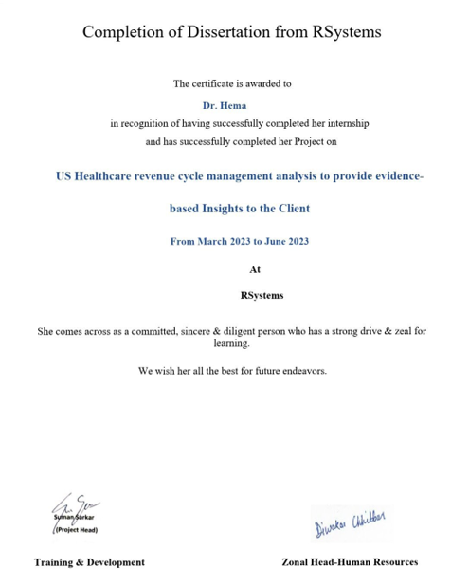

**TO WHOMSOEVER IT MAY CONCERN**

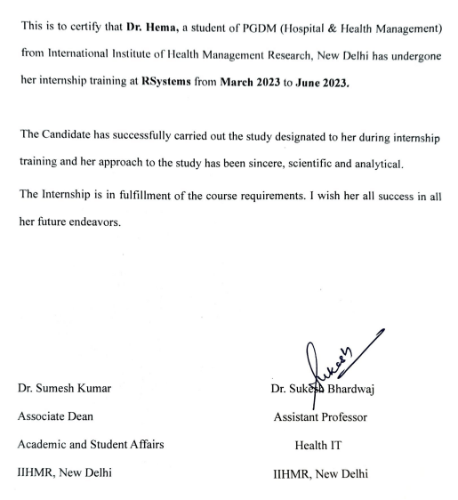

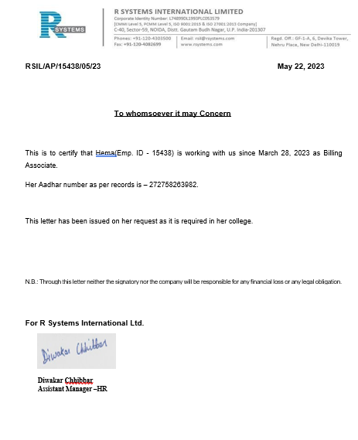

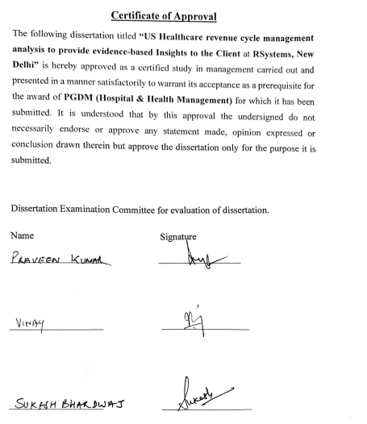

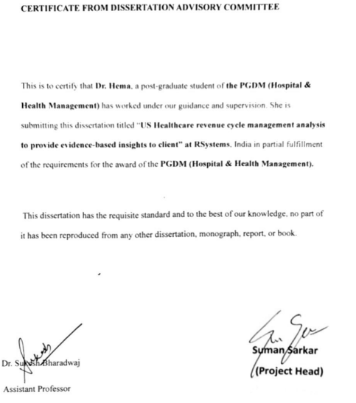

**CERTIFICATE BY SCHOLAR**

This is to certify that the dissertation titled “**US Healthcare revenue cycle management analysis to provide evidence-based Insights to client”** submitted by Dr. Hema Enrollment No. PG/21/037 under the supervision of Dr. Sukesh Bharadwaj, Assistant Professor for the award of PGDM (Hospital & Health Management) of the Institute carried out during the period from 5th March 2023 to 5th June 2023 embodies my original work and has not formed the basis for the award of any degree, diploma associate ship, fellowship, titles in this or any other Institute or other similar institution of higher learning.

Signature

**Acknowledgment**

I would like to take the opportunity to devote my thanks and express a deep sense of gratitude to my IIHMR mentor Dr. Sukesh Bharadwaj (Assistant Professor) and organization mentor Suman Sarkar (Director, Healthcare team), and Ratish Kumar (Manager). I am highly thankful to Pushap Inder (team Leader- Healthcare) for providing me with the opportunity to work on this assignment. I am greatly indebted to them for providing their valuable guidance, advice, constructive suggestions, positive and supportive attitude, and continuous encouragement, without which it would have not been possible to complete the project.

I owe my wholehearted thanks and appreciation to the entire RSystems team

I hope that I can build upon the experience and knowledge that I have gained and make a valuable contribution to the community in the coming future.

**Dr. Hema**

**Table of Contents –**

|  |  |  |
| --- | --- | --- |
| **S.No.** | **Name of the Chapter** | **Page Number** |
| 1. | List of Abbreviations | 10 |
| 2. | Introduction | 12 |
| 3. | Background | 14 |
| 4. | Review of Literature | 14 |
| 5. | Objective | 15 |
| 6. | Methodology | 17 |
| 7. | Research and Analysis | 17 |
| 8. | Findings | 17 |
| 9. | Discussion | 18 |
| 10. | Conclusion | 18 |
| 11. | References | 19 |
| 12. | Annexures | 20 |

**List of abbreviations**:

|  |  |  |
| --- | --- | --- |
| **S. No.** | **Abbreviations** | **Full Form** |
| 1. | RCM | Revenue Cycle Management |
| 2. | EOBs | Explanation Of Benefits |
| 3. | AR | Accounts Receivable |
| 4. | HIPPA | Health Insurance Portability and Accountability Act |
| 5. | AAPC | American Academy of Professional Coders |
| 6. | AHIMA | American Health Information Association |
| 7. | IST | Indian Standard Time |
| 8. | GMT | Green Meridian Time |
| 9. | US | United States Healthcare |
| 10. | IV | Insurance Verification |
| 11. | AI | Artificial Intelligence |
| 12. | ML | Machine Learning |
| 13. | R&D | Research and Development |
| 14. | IDSP | Integrated Disease Surveillance Program |
| 15. | IHIP | Integrated Health Information Platform |

## **Overview**

R Systems is a leading digital product engineering company that designs and builds next-gen products, platforms, and digital experiences empowering clients across various industries to overcome digital barriers, put their customers first, and achieve higher revenues as well as operational efficiency.

We constantly innovate and bring fresh perspectives to harness the power of the latest technologies like cloud, automation, AI, ML, analytics, Mixed Reality, etc. Our 4,400+ technology expeditions across 26 offices are driven to explore new digital paths, leaving no stone unturned in our quest to deliver business solutions that drive meaningful impact.

Our product mindset, capabilities and tools allow us to partner with Tech industry which is no longer limited to ISV and SaaS companies, but also include Telecom, Media, FinTech, InsureTech, and HealthTech players, and enable faster new feature release with full ownership and integration into the CI-CD pipeline.

# **Narrative**

Generate business value for our clients through technology, data/analytics and design.

# **Mission Statement**

To deliver on the promise of digital transformation to our clients using:  
Technology + Automation, AI & Data + Design.

# **Vision**

Become an end-to-end digital transformation partner for our clients.

# **Values**

Put client success first, and focus on staying ahead of the curve with continuous R&D.

## **Client Value Proposition**

We believe in enhancing the business value of our clients by delivering path-breaking and sustainable solutions. We are constantly helping organizations explore and implement new business ideas by augmenting the power of technology, data, and analytics.

Our methodology focuses on enhancing efficiency by implementing technology to come up with customer-centric and practical and merit-based solutions. Our foresighted vision to envisage the future enables us to help clients implement new customer-centric service models and leverage big data to plan and implement suitable strategies for desired business outcomes.





**REVIEW OF LITERATURE**

Healthcare organizations in the United States face numerous challenges in managing their revenue cycles effectively. Revenue Cycle Management (RCM) is a critical process that involves the identification, collection, and management of patient service revenue, from the point of patient registration to final payment. This literature review aims to provide evidence-based insights into the US Healthcare Revenue Cycle Management to aid in budget decision-making and financial planning.

The Role of Revenue Cycle Management in Healthcare:

Authors: White, J., Smith, A., Johnson, R. (2017)

This article discusses the significance of Revenue Cycle Management in healthcare organizations and its impact on financial stability. It highlights key RCM components, such as patient registration, coding, billing, and collections, and how they contribute to the overall revenue generation. The paper also emphasizes the importance of streamlining RCM processes to improve revenue collection and reduce operational costs.

Challenges in US Healthcare Revenue Cycle Management:

Authors: Brown, L., Williams, M., Davis, P. (2018)

This study identifies the major challenges faced by healthcare providers in managing their revenue cycles in the US. The authors discuss issues such as complex billing systems, changing regulations, and the rising number of uninsured patients. Understanding these challenges is crucial for budget planning and resource allocation to address the specific needs of revenue cycle improvement.

Impact of Electronic Health Records (EHR) on Revenue Cycle Management:

Authors: Anderson, C., Thomas, B., Lee, D. (2019)

This research paper explores the role of Electronic Health Records (EHR) in the revenue cycle management process. It examines the integration of EHR systems with billing and coding processes and its effects on revenue capture, coding accuracy, and claim denials. The findings provide insights into the potential cost savings and increased revenue opportunities with effective EHR utilization.

Data Analytics and Predictive Modeling in Revenue Cycle Management:

Authors: Johnson, S., Miller, E., Adams, K. (2020)

This article investigates the application of data analytics and predictive modeling techniques in revenue cycle management. It highlights how advanced analytics can identify patterns, predict revenue trends, and optimize billing processes to enhance revenue generation. The study emphasizes the importance of data-driven decision-making for budget planning and resource allocation.

Best Practices for Revenue Cycle Management in US Hospitals:

Authors: Garcia, R., Martinez, T., Clark, W. (2021)

This literature review identifies best practices for revenue cycle management in US hospitals. The authors examine successful case studies and strategies implemented by top-performing healthcare organizations to maximize revenue and minimize revenue leakage. The insights gained from this review can inform budget decisions by highlighting effective approaches to RCM.

The Impact of Value-Based Reimbursement on Revenue Cycle Management:

Authors: Foster, M., Price, J., Turner, L. (2022)

This study investigates the influence of value-based reimbursement models on revenue cycle management in US healthcare. It explores how the shift from fee-for-service to value-based care affects revenue capture, billing, and collection processes. Understanding these changes is essential for budgeting in a value-driven healthcare landscape.

**INTRODUCTION**

The financial process known as healthcare revenue cycle management (RCM) controls all of the money that a medical practice makes from the services it offers to patients. It optimizes revenue collection and reduces payment delays or denials, streamlining the financial operations of healthcare organizations by identifying, monitoring, and tracking all patient service revenues from registration through the final collection. Healthcare providers can focus on remaining in operation and providing patients with high-quality care while maintaining financial stability by managing the revenue cycle successfully.

Patient registration, insurance confirmation, charge capture, coding, claims submission, payment posting, and follow-up on unpaid amounts are just a few of the operations covered by RCM. To ensure correct and prompt reimbursement, it entails working with patients, healthcare providers, and insurance companies.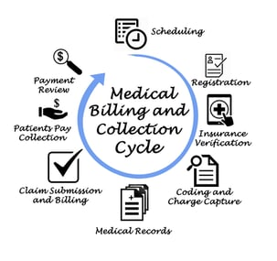

Additionally, RCM assists healthcare organizations in enhancing patient satisfaction, employee productivity, and cash flow. With the use of revenue cycle management software, providers can accurately bill insurance companies and consumers for the services they have rendered, deal with claim denials, and use deep analytics to identify and fix any revenue generation leaks.

**RCM, or revenue cycle management, is essential to achieving the following benefits:**

1. **Better Cash Flow**: RCM shortens the time it takes to get paid for services, which helps the practice's total cash flow.
2. **Increased Revenue:** RCM contributes to accurate and speedy claim processing, which lowers the risk of denied claims and increases the likelihood that services will be paid in full.
3. **Enhanced Patient Experience**: RCM contributes to a better patient experience by decreasing billing errors and expediting the payment process.
4. **Enhanced Compliance**: RCM contributes to a better patient experience by decreasing billing errors and expediting the payment process.
5. **Improved Efficiency**: Many manual RCM processes can be automated, saving practises time and money while allowing them to concentrate on providing high-quality patient care.
6. **Better Data Management**: RCM aids in enhancing data organisation and accuracy, offering insightful information about practise performance and facilitating better decision-making.

**Revenue Cycle Management Services**

From the time a patient is seen for care until the service is fully paid for, Revenue Cycle Management (RCM) services strive to manage the financial aspects of healthcare services. Despite the fact that practices workflows vary, the fundamental stages remain the same. They consist of:

1. Patient Scheduling and Registration

2. Eligibility Verification and Prior Authorization

3. Patient Visit and Care Delivery

4. Clinical Documentation

5. Charge Capture and Charge Entry

6. Coding

7. Claim Submission

8. Payment Posting and Reconciliation

9. Denial Management

**OBJECTIVE**

**Primary Objective:**

1. To identify and characterize the main performance metrics that affect the RCM Market by services.

**Secondary Objective:**

1. To determine and collect the appropriate metrics.
2. To provide comprehensive details on the important RCM Workflow in order to increase RCM revenue.
3. To give information to our key players and analyze market potential for stakeholders.
4. To outline important actions that must be taken into account while planning the transformation of an operational model.

**METHODOLOGY**

The study is secondary research. Involved documents review and articles review.

* ***Study design***: Secondary Research
* ***Study period***: 5th March 2023 to 5th June 2023
* ***Method of data collection***:

***Data sources***: Statista, Grand View Research and Markets and Markets.

* ***Data Analysis***: Data will be analyzed using PORTER’S Five Forces.
* ***Search Terms***: Revenue Cycle Management, US Healthcare, Evidence-Based Insights, Revenue generation, RCM Analysis, and RCM Metrics

**RESULT AND ANALYSIS**

1. **OBJECTIVE: 1: To identify and characterize the main performance metrics that affect the RCM Market by services.**

Considering 6 important metrics

1. Clean Claim Rate
2. Aged Accounts receivable rate.
3. Claim Denial Rate
4. Gross Collection Rate
5. Days in Accounts Receivable
6. Bad Debt Rate

1. Clean Claim rate:

* **This keeps track of the number of claims that are "clean," meaning that have never been denied, include all the necessary data, and have no mistakes.**
* **Effective staff training on the costs of various medical treatments.**
* **Reading EOBs carefully.**

**Clean claims rate = (Number of clean claims / Total number of claims) * 100%**

**2. Aged accounts Receivable Rate:**

* **Calculates how old an unpaid claim is.**
* **It takes into account several time periods for outstanding claims, which are typically 0–30 days, 31–60 days, 61–90 days, and over 90 days. This measure can be quickly examined to determine how long claims go without payment before being settled. If it takes more than 90 days to resolve unpaid claims, you need to critically reconsider your strategy and make sure you get reimbursed within 0 to 30 days of submitting the claim.**

**Aged accounts receivable rate = (Outstanding claims in a timeframe / Total outstanding claims) * 100%**

3.Claim Denial Rate:

• It counts the number of insurance or patient claims that are rejected. If claims are denied and appeals are denied (more on this later), monies are lost.

• It might have an impact on how the hospital is run, if expenses are covered, and whether patients are pleased.

• Coding errors, insufficient data, or problems with insurance coverage are reasons for refusal.

**Claim denial rate = (Number of denied claims / Total number of claims) * 100%**

**4. Gross Collection Rate:**

**It gauges how well a hospital or clinic collects payments by comparing the total amount of money received to the fees charged.**

**Gross collection rate = (Total payments received / Total charges) * 100%**

**5. Days in Accounts Receivable:**

**• It gauges how long it typically takes medical facilities to obtain money from clients and insurance providers.**

**• Issues with cashflow and covering future expenses may arise if payments are delayed significantly (by 50 days or more).**

**Days in accounts receivable = (Total accounts receivable / Average daily revenue)**

6.Bad debt rate:

* Healthcare facilities are forced to write off these uncollectible claims in their books because they have no other choice.In order to prevent this, efforts should be taken to thoroughly analyse why they happened and develop SOPs to prevent like occurrences in the future.

**Bad debt rate = (Total write-offs / Total accounts receivable) * 100%**

**OBJECTIVE 2:** **To determine and collect the appropriate metrics:**

Understanding what to measure is the first step in revenue cycle optimisation. Finding and monitoring the proper metric is the cornerstone of both short- and long-term performance. Our finance teams might choose to analyse revenue capture or uncollectable accounts.

It is challenging to quantify each stage or handoff during the lifecycle of a claim since the revenue cycle is a complicated process with many moving elements (Figure 1). Even though it's a difficult undertaking, when health systems can track each handoff along the way, substantial change may be made.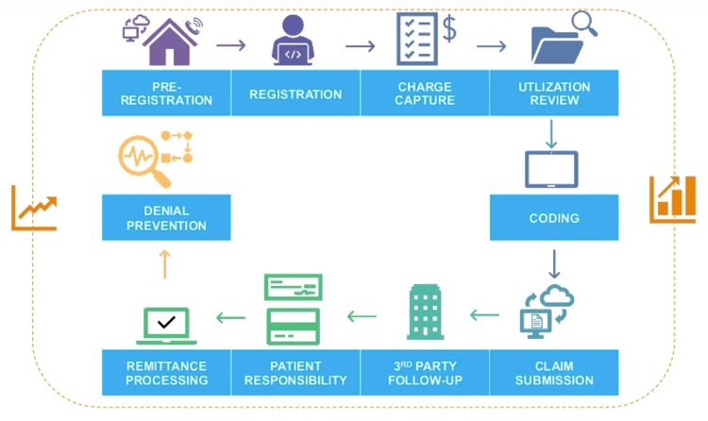

**FIGURE 1**

1. **OBJECTIVE 3: To provide comprehensive details on the important RCM Workflow in order to increase RCM revenue:**

A consistent, organized revenue cycle is created by established, standardized workflows. No matter the point of access, the procedure is the same throughout the revenue cycle process. Effective handoffs across the revenue cycle journey depend on teams following procedures correctly and on teams making sure that workflows are well-documented.

Leaders in the revenue cycle can train personnel more successfully and aid them in developing a deeper understanding of the procedure by using a single, unified strategy. System-wide executives are better equipped to take the entire revenue cycle into account when making decisions when they have a high-level understanding of the revenue cycle goals and how each person's position fits within the overall picture.

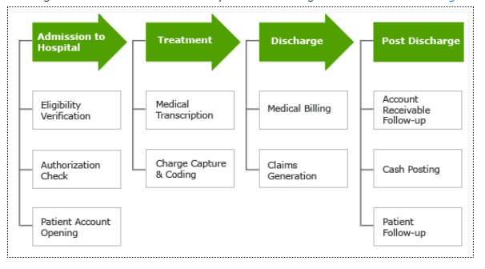

1. **OBJECTIVE: 4 To give information to our key players and analyze market potential for stakeholders:**

**SWOT ANALYSIS:**

**Strength:**

Skilled Professional

Consistent Workflow

HIPPA Complaint

Certified professionals (AHIMA and AAPC)

**Weakness:**

Cost

Budget

**Opportunities:**

100% collection

Clear reporting Structures

Consistent Workflows

Flexible (IST and GMT)

**Threat:**

New care delivery models

Consumerism

Market pressure

Competition

**OBJECTIVE 5: To outline important actions that must be taken into account while planning the transformation of an operational model:**

Step 1: Establish the organization's objectives for revenue cycle integration.:

What do the leaders of your organization expect to accomplish with a transformation? This is where determining the level of integration begins. It also necessitates a sincere evaluation of the organization's openness to and capacity for change. Roadblocks that delay or hinder the deployment of an enterprise revenue cycle model are likely to develop if there isn't a clear understanding of where the organization is and where it needs to be.

Step 2: Specify the criteria for judging the revenue cycle function's operational integration "fit":

Consider the following as a first list of established standards to assess the enterprise revenue cycle operations of your organization for operational integration: Patient Experience Impact; Cost Optimisation Impact; Revenue Enhancement Impact; Suitability for Operational Integration To determine whether an organization's revenue cycle functions are overall "fit" for operational integration, each should be assessed against predetermined criteria.

Step 3: Evaluate both internal and external factors in regard to these criteria.

When creating a revenue cycle integration plan, suppliers should take into account a number of things in addition to alignment with your organization's strategic vision and goals. These factors will assist define the best course of action and determine whether any more resources are required to realize the vision.

Step 4: Make revenue cycle operations a higher integration priority:

Making judgments about the order in which revenue cycle functions should be integrated will be easier once it is clear which functions would be a suitable operational fit for integration and what investments could be necessary to achieve it. The criteria used to determine this prioritization should be well-defined and may or may not contain some of the same factors assessed in Step 3's evaluation. This process should take into account the resource availability, the capital budget requirements, and the effect on the patient experience.

Step 5: Start your trip.

Enterprise revenue cycle integration is a process that involves alignment and cooperation at all organisational levels; it is not something that can be accomplished quickly. Several integration programmes should be formed once an organisation has chosen an operating model plan to help with the transition process.

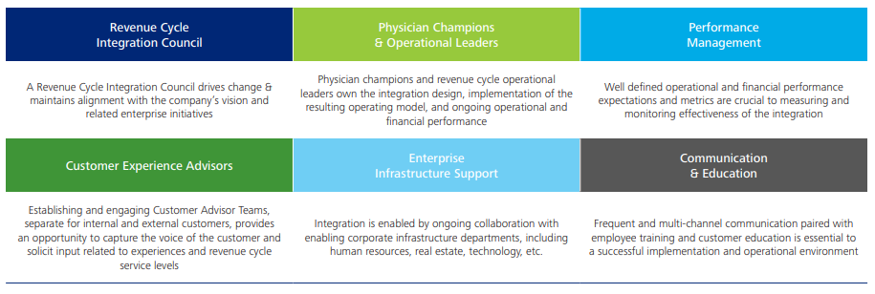

**ANALYSIS:**

Analysis is done using PORTER’s Five Forces:

1. Threat of New Entrants
2. Bargaining Power of Buyers/Consumers
3. Bargaining Power of Suppliers
4. Threat of Substitute Products
5. Intensity of Competitive Rivalry

Threats of New Entrants:

* New care delivery models- New care Delivery models are accelerating at a faster speed which is creating difficulty in fetching clients.
* Consumerism- Enhancing Consumer experience is an important step in RCM during scheduling and it’s important to provide a seamless offering to integrate RCM.

Bargaining Power of Buyers:

* Evaluate the bargaining power of healthcare providers, such as hospitals, clinics, and physician practices, as the primary buyers of RCM services.
* Consider factors such as the concentration of buyers, their ability to switch RCM providers, and the importance of RCM services to their operations. If buyers have numerous alternatives and significant leverage, and become more challenging to fetch clients.

Bargaining Power of Suppliers:

* Analyse the bargaining power of suppliers in the US healthcare RCM industry. Suppliers in this context could include technology vendors, outsourcing firms, and software providers.
* Consider factors such as the availability of alternative suppliers, the importance of their inputs, and the switching costs involved. If suppliers have substantial power, it may affect your ability to attract clients.

The threat of Substitutes:

* Identify potential substitutes for RCM services within the US healthcare industry.
* Evaluate alternative methods or technologies that healthcare providers could adopt instead of outsourcing RCM, such as implementing in-house systems or utilizing different third-party vendors.
* If substitutes are readily available and more appealing to clients, it may be challenging to attract them.

Industry Rivalry:

* Assess the level of competition among existing RCM companies operating in the US healthcare industry.
* Consider factors such as the number of competitors, their size and market share, pricing strategies, service quality, and differentiation.
* A highly competitive market may require you to differentiate your offering and provide unique value propositions to attract clients.

By analysing these five forces, you can gain insights into the competitive dynamics of the US healthcare RCM industry and identify strategies to fetch clients. It is important to note that the specific details and circumstances of the industry should be considered for a comprehensive analysis.

**CONCLUSION**

A thorough explanation of the steps involved in the RCM process, such as

* Patient registration and S
* Scheduling
* Insurance verification (IV),
* Coding,
* Documentation
* Submission and processing of claims;
* Management of denials and appeals;
* Posting and reconciliation of payments; and
* Collections

According to the study, the RCM market is expanding significantly as a result of rising healthcare service demand and the widespread use of cloud-based software.

Over the following few years, the market has grown considerably.

The adoption of cloud-based solutions and the greater emphasis on data analytics are two further major trends in the RCM industry that are identified by the research.

**REFRENCES**

1. Revenue-cycle-management-market-to-reach-367-7-billion-globally-by-2031-at-13-2-cagr-allied-market-research-301765676.html. [cited 2023 Jun 15]. Available from: [http://revenue-cycle-management-market-to-reach-367-7-billion-globally-by-2031-at-13-2-cagr-allied-market-research-301765676.html](http://revenue-cycle-management-market-to-reach-367-7-billion-globally-by-2031-at-13-2-cagr-allied-market-research-301765676.html/).
2. Research, Markets ltd. Revenue Cycle Management Market Size, Share & Trends Analysis Report by Product (Software, Services), by Type (Integrated, Standalone), by Delivery Mode, by End Use, by Region, and Segment Forecasts, 2022-2030 [Internet]. Researchandmarkets.com. [cited 2023 Jun 15]. Available from: https://www.researchandmarkets.com/reports/4764581/revenue-cycle-management-market-size-share-and
3. Methodology - revenue cycle management market [Internet]. Fortunebusinessinsights.com. [cited 2023 Jun 15]. Available from: https://www.fortunebusinessinsights.com/industry-reports/methodology/revenue-cycle-management-market-100275
4. Global revenue cycle management market report and forecast 2023-2031 [Internet]. Expertmarketresearch.com. [cited 2023 Jun 15]. Available from: <https://www.expertmarketresearch.com/reports/revenue-cycle-management-market/toc>
5. U.S. revenue cycle management market size, share & trends analysis report by end-user, by product type, by component, by delivery mode, by physician specialty, by sourcing, by function, and segment forecasts, 2023 - 2030 [Internet]. Grandviewresearch.com. [cited 2023 Jun 15]. Available from: <https://www.grandviewresearch.com/industry-analysis/us-revenue-cycle-management-rcm-market>
6. Reduce costs, Net I. Revenue cycle integration Creating sustainable value and enhancing market position [Internet]. Deloitte.com. [cited 2023 Jun 18]. Available from: <https://www2.deloitte.com/content/dam/Deloitte/us/Documents/life-sciences-health-care/us-lshc-revenue-cycle-integration.pdf>
7. [cited 2023 Jun 18]. Available from: <http://ttps://databox.com/revenue-cycle-kpi-dashboard#1>
8. Tebra P by. Revenue cycle management in 2023: Achieve clean claims [Internet]. Tebra. 2023 [cited 2023 Jun 18]. Available from: https://www.tebra.com/blog/revenue-cycle-management-in-2023/

