**“Functioning of a hospital run by SEARCH, an NGO in rural and tribal Gadchiroli”**

**A dissertation submitted in partial fulfillment of the requirements**

**for the award of**

**Post Graduate Diploma in Health and Hospital Management**

**by**

**Pragya Singh**

**Roll No. PG/ 10/ 088**



**International Institute of Health Management Research**

**New Delhi-110075**

**May, 2012**

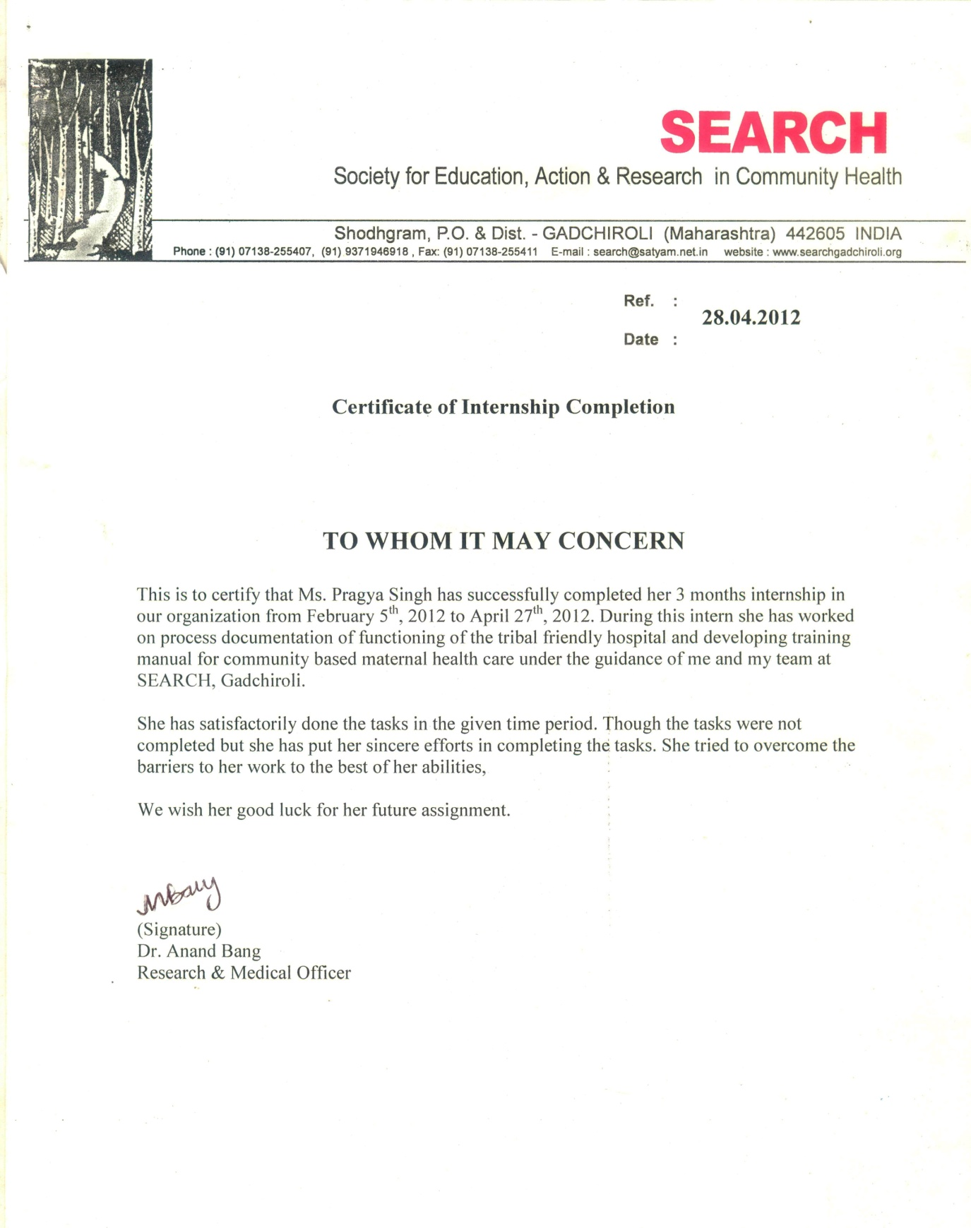

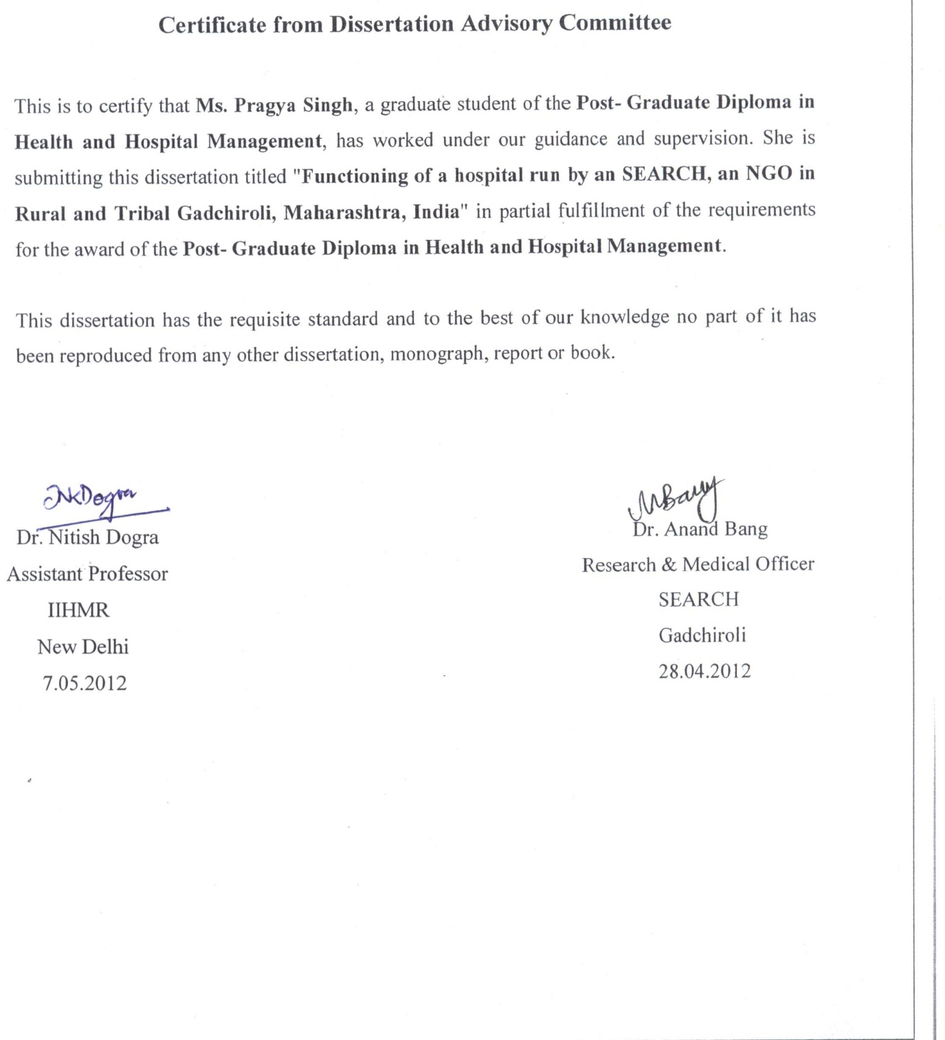

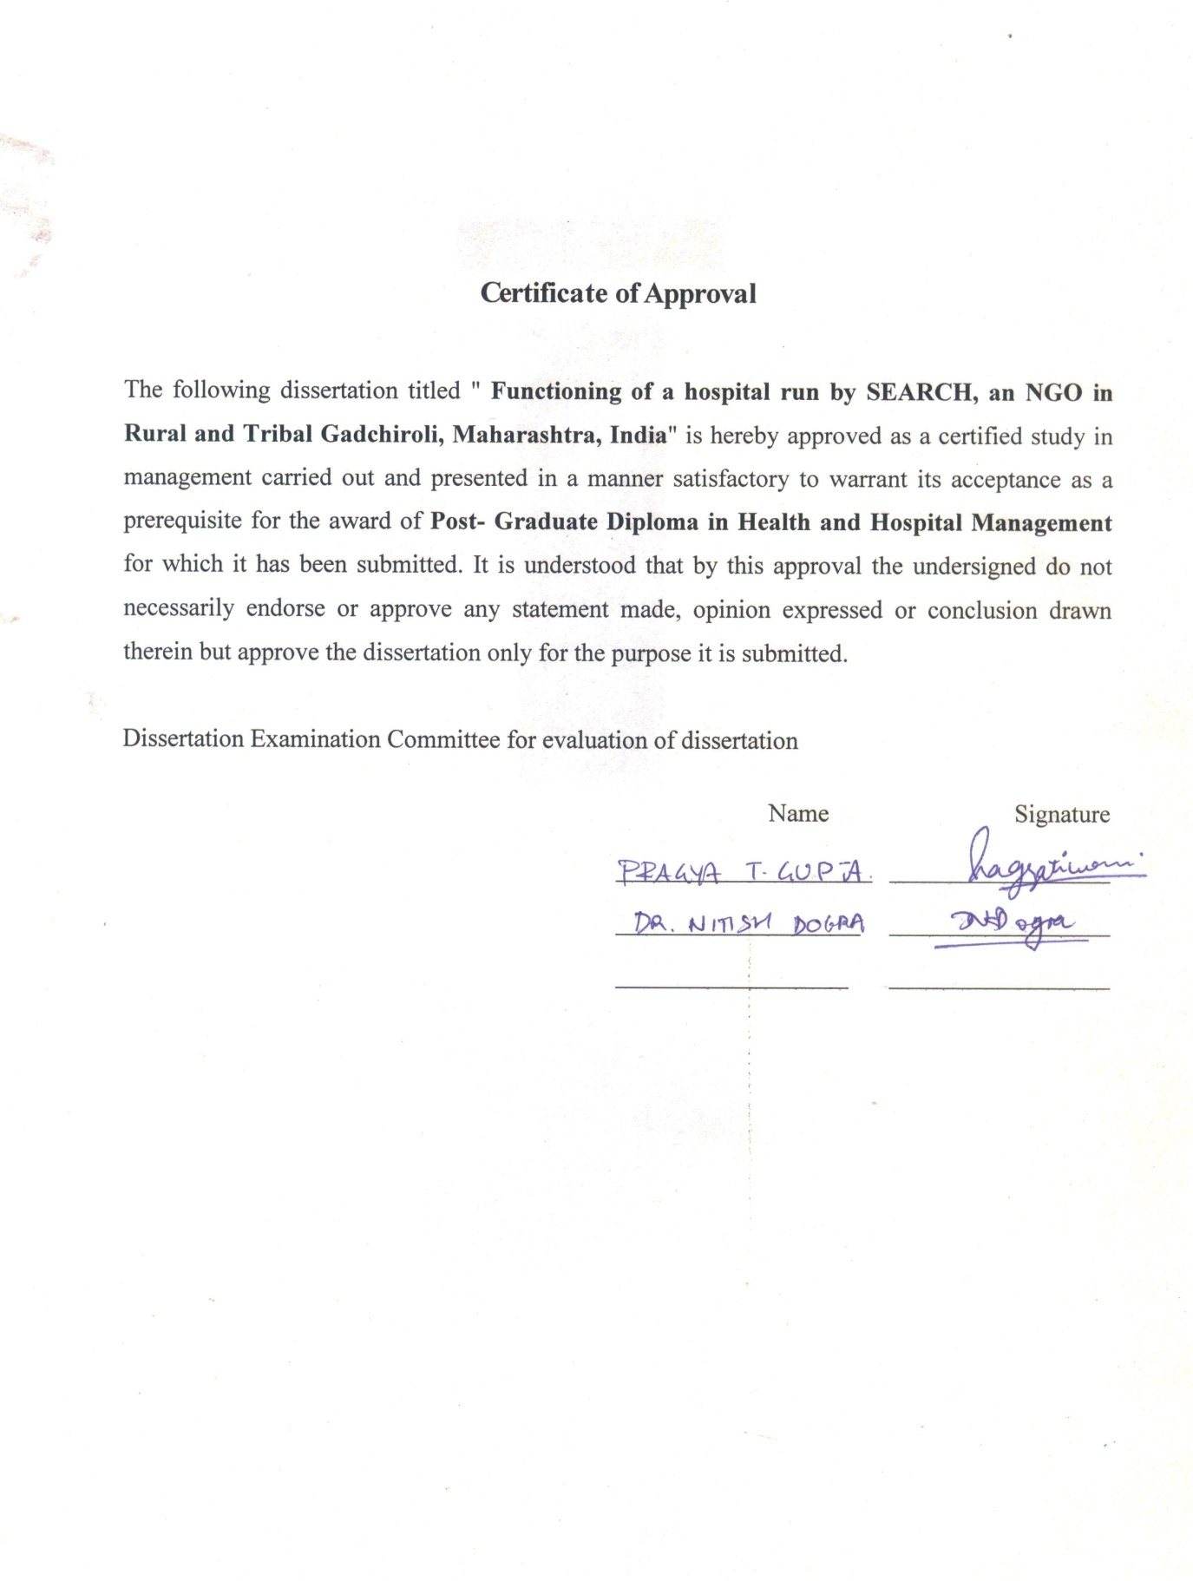

**Abstract**

**“Functioning of a hospital run by SEARCH, an NGO in rural and tribal Gadchiroli”**

by

Pragya Singh

The lack of health facilities and health workforce is a global health challenge not only in India but globally. This scarcity is evident everywhere in developing world. Most of the health workforce is concentrated in developed region. This skewness has adversely affected the provision of providing healthcare in developing and underdeveloped regions. The consequence of non availability of healthcare providers is more evident in rural areas also. In one such rural area there is a hospital trying to decrease the gap. This is the Maa Danteshwari Dawakhana in rural and tribal district of Gadchiroli, Maharashtra. This hospital has been working since 1993. To get a feel of how hospital is functioning indicators like patient attendance, bed occupancy ratio and patient satisfaction are utilized. For this retrospective cross sectional methodology was adopted. Patient attendance at OPD and IPD and bed occupancy ratio was calculated from data of last 5 years. Patient satisfaction study was done on 49 patients. Convenient sampling was done to select respondents and response was collected using structured questionnaire. Finally data was analysed using MS Office excel.

The major findings of the study

1. The patient attendance at OPD increased enormously for the year 2011-12 to 91 from average of 71 for last 5 years.
2. But the patient attendance at IPD for the last 5 years did not notice any change. It was just 4 patients except for one year.
3. The bed occupancy ratio for the last 5 years fluctuated around 50 % which is certainly low for the hospital.
4. In patient satisfaction study it was observed that almost all patients who utilized hospital services seemed satisfied from approximately all the services.

Overall it was observed that hospital was functioning well. The indicators that were taken into account except for IPD showed good performance.

Hence this was recommended to improve facilities at IPD. The scope of services at IPD should be increased.

When this hospital was compared to a CHC, Dhanora it was observed that at few places MDD outperformed CHC because this hospital provide those services that is demanded by the people. This is the uniqueness of the hospital. The health sector in rural area envisions seeing many more hospitals like this.

**ACKNOWLEDGEMENT**

I owe my deep sense of gratitude to Dr. Abhay Bang, Director, SEARCH, for having permitted me to carry out this project work and giving me the opportunity to learn various aspects of the study.

My special thanks to Dr. Anand Bang, Research & Medical Officer, SEARCH, for his valuable guidance and support. I also want to thank Ms Bhagyashri Pijdurkar, Medical Officer, SEARCH for their involvement and encouragement. They left no stone unturned in updating me about the subject. It is needless to mention SEARCH Team for their kind assistance throughout the study.

I wish to express my deep sense of gratitude to my Professor, Dr. Nitish Dogra for his indispensable and unstained cooperation throughout the study. I am grateful in receiving his exemplary supervision.

My sincere thanks to Dr. L.P. Singh, Director, Dr. Rajesh Bhalla, Dean and Dr. Dharmesh Lal, Associate Dean, International Institute of Health Management Research, New Delhi, who always have been a source of motivation and inspiration.

Finally, yet importantly, I would like to express my heartfelt thanks to my beloved parents for their blessings, my friends /classmates for their help and wishes for the successful completion of this project.

Thank You.

Pragya Singh

IIHMR

PGDHHM (PG/10/088)

**Table of Contents Page**

Acknowledgement 3

Abstract 1-2

Table of Contents 4-5

List of Figures 6

List of Tables 7

List of Appendices 8

List of Abbreviations 9

1. Introduction 17-24

1.1 The public sector 17

1.2 The private sector 18

1.3 About the Maa Danteshwari Hospital 19

1.3.1 OPD 20

1.3.2 IPD 20

1.3.3 Surgery camps 21

1.3.4 Outreach clinics in villages 22

1.3.5 Physiotherapy 22

1.3.6 Ambulance services 22

1.3.7 Educational center 22

1.3.8 Referral care 23

1.3.9 Hospital- based research 23

1.3.10 Investigative facilities 24

2. Review of literature 25

3. Objectives 26

4. Methodology 27-29

5. Results 30-35

6. Discussion 36-40

7. Conclusion and recommendations 40-41

8. References 42-43

**List of Tables**

Table 1. Calculation of IPD days 27

Table 2. Patient attendance at OPD (for last five years) 30

Table 3. Patient attendance at IPD (For last five years) 30

Table 4. BOR for last five years 31

Table 5. Comparison of infrastructure 35-36

Table 6. Comparison of staff 37-38

Table 7. Comparison of investigative facilities 38

Table 8. Comparison of equipments 38

Table 9. Comparison of services 39

**List of Figures**

Fig. 1 Pie chart of Doctor’s consultation 31

Fig. 2 Pie chart of behavior of nurses 32

Fig. 3 Chart of different charges 33

**Appendices**

Questionnaire 44-45

Photographs 46-48

**Abbreviations**

ASHA Accredited Social Health Activist

BOR Bed Occupancy Ratio

CHC Community Health Center

HBNC Home Based Neonatal Care

IPD In Patient Department

MDD Maa Danteshwari Dawakhana

OPD Out Patient Department

OT Operation Theater

PHC Primary Health Center

SC Sub Center

VHW Village Health Worker

**Internship report**

**Organization profile**

SEARCH (Society for Education, Action and Research in Community Health) is a non-government organization registered as a public trust and charitable society in India (Reg. No: MH 35- 85- GAD, F-224- GAD).

It was founded in 1985 by a doctor couple, Abhay Bang and Rani Bang. Inspired by the life and philosophy of Mahatma Gandhi, trained respectively as a physician and a gynecologist, and after studying at the Johns Hopkins University USA, for their Master of Public Health, Drs. Bang returned to India. Their dream was to develop an institution of community health which provided health care to the local population, and generated knowledge for the global community by way of research. “Think globally, act locally!”

**Philosophy**

SEARCH believes that Research is the best way to identify problems of people and to provide new and appropriate solutions. Their philosophy can be better captured in the following lines-

A Better Way—The Peoples’ WaY

*go to the people,*

*live among them,*

*love them,*

*listen to them,*

*learn from them,*

*begin with what they know,*

*build upon what they have****.***

**Mission**

The mission of SEARCH is to work with marginalized communities to identify their health needs, develop community empowering models of health care to meet these health needs, to test these models by way of research studies, and then to make this knowledge available to others by way of training and publications. Thus the mission of SEARCH includes community health care, research and training.

**Vision**

The organization started with the vision ‘Arogya Swaraj’, meaning “freedom in health,” that is to put people’s health in their own hands by educating and empowering individuals and communities to achieve freedom from disease and freedom from dependence on the medical community for their needs.

**Activities**

The work of SEARCH is broadly divided into research and program. The different programs run by SEARCH in rural and tribal Gadchiroli is

* Women’s health

Diagnosis and prevention of gynecological problems, providing antenatal care, assistance in delivery and neonatal care.

* Child and neonatal health

Care is provided to neonates by way of HBNC through VHWs, treatment of diarrhoea, pneumonia and sepsis along with health education.

* Alcohol prevention and deaddiction

Under this to educate masses awareness camps are held, prevention through campaigns and treatment of addicts is done.

* Adolescent education

Reproductive health education for adolescents through formal and informal educational methods.

* Tribal health and education

Under this various programs like malaria prevention, diagnosis and treatment, econo,ic empowerment, cultural rejuvenation, children’s development and youth organization through Danteshwari sewaks.

* Hospital services

Various clinical services provided through OPDs, IPDs, surgery camps, specialist OPDs, diagnostics, ambulatory services and pharmacy.

Following projects were given by organization

1. Developing training manual for the Home based maternal care program

To address the problems to mother during pregnancy and post delivery that can lead to complications if not treated in early phase. This is basically early diagnosis and prevention. This included general problems during ANC like nausea & vomiting, GERD, High BP, UTI, fever and danger signs. The PNC part included fever, UTI, High BP, vaginal infection, Caesar wounds, secondary PPH, uterine infection, breast abnormalities and danger signs.

Following tasks were done

1. Reading HBNC training manual

To understand how a training manual

1. Collation of material

The available training aids and manual was collated disease wise. The training aids were added in the specific locations.

1. Eliminating lacunas

Wherever there were mistakes, it was eliminated. The mistakes like grammatical mistakes, spelling mistakes and other were taken care of.

1. Translation

The training aids were in Marathi. It was translated into English. The nausea and vomiting part is almost 80 % completed. The BP and fever part was completed by 50 %. The ANC and PNC forms were completely translated. Few other treatment forms like UTI, sec. PPH and vaginal infection.

1. Addition of material

Wherever there was any lack of training material then appropriate training aids were added there.

1. Format of manual

Lastly all the editing was done to give it a proper format of manual.

1. Process documentation of hospital
2. Reading case studies

To get a feel what are the different activities offered by hospital. For how long hospital been in existence.

1. Collecting data

Data was collected from the OPD, IPD, OT registers, budget and diagnostic department.

OPD- From OPD data like

Number of patients yearly

Male, female and children below 5 years of age

New and old patients

Number of patients disease wise for which the frequency is very high

IPD-

Number of patients yearly

Cumulative IPD days of patient care

Number of patients disease wise for which the frequency is high

OT

Number of surgery camps every year

Month in which different surgery camps were held

Number of various surgeries

Diagnostics

Number of different tests performed yearly. For this data was collected from the monthly statement and added upon for the complete year.

1. Photographs of hospital

Photographs of the complete infrastructure

Photographs of different processes

Photographs of each hospital staff individually with name and their designation

Photographs of different equipments in OT, Lab and Physiotherapy center and then making its collage

1. Budget

The study of income deficit for the last 5-6 years.

1. Taking interviews of hospital staff

The insights from hospital staff helped in understanding the hospital better.

1. Milestones of HBNC
2. Reading reports

Different reports on HBNC were thoroughly studied and points important for HBNC were marked and then added in the final document.

1. CD of articles on HBNC
2. The list of articles on HBNC was checked for the comprehensiveness.
3. Designed a CD cover

Collected the necessary photographs for the CD and then designed it in the Photoshop.

1. Budget of HBNC

The yearly budget for HBNC was translated and minor mistakes were sorted.

1. Goals for the year HBNC-2012

The above document was translated into English from Marathi. This document covered the goals, objectives, steps to accomplish that and its expected outcomes.

Learning

HBNC

1. The internship at SEARCH has definitely enhanced my understanding of public health. The work has definitely added some more knowledge in the subject matter like clinical knowledge, research and training.
2. My major work was in field of maternal and child health. In this I read about what all care is given to child under HBNC. Under Maternal care program I came to know about the care given to mother during pregnancy and child birth.
3. I worked in the training and documentation part. As far as training is considered I learned to develop training manual. I came to know about the different type of aids used to provide training like case studies, role plays, case idea, case presentations, etc. By reading the manual and by making it I became aware how step by step training is provided to ASHAs.
4. This is perfect example of how cost effective measures like HBNC can affect health outcomes to a great extent.
5. This is also a perfect example of how big changes can be made in rural society through training and empowering women with less education.
6. This is also perfect example of people’s health in people’s hands. This type of approach teaches us that developmental process should be sustainable and replicable.
7. This has happened because of effective training to trainers, supervisors and VHWs.
8. This has also helped me in learning one more Indian language, Marathi.

Maa Danteshwari Hospital

1. This was the first time when I closely observed a hospital. This hospital at SEARCH is indeed very different. It is a tribal friendly hospital in its structure and culture. It is a hospital where every facility and service is geared to meet the demands of patients. For example as patient come from far off areas, so

Diagnostic department is supposed to give all the reports of tests by 4 O’ clock so that patients can take doctor’s advice and medicines and can go back to their places in time.

1. I observed hospital during camp time how arrangements are made to meet the high number of patients with their relatives.
2. I learned about the various departments of hospital, their coordination and how each department’s work affect the work of other.
3. The yearly budget gave me knowledge which all items and services consume how much of the total budget.
4. In the process documentation of hospital I came to know about what are the major health problems felt by the community.
5. The difficulty that hospital staff come across in dealing with the patients in day to day activities of hospital.

**INTRODUCTION**

The health workforce crisis is a global problem both in terms of shortages and uneven distribution. There is crisis of human resources in health system and situation is worse for the developing countries. It is quoted in a report that there is shortage of about 4 million health workers globally. The number of health care providers per 1000 population for different regions of the world calculated in 2006 is 2.9/1000 in Africa; 5.8/1000 in Southeast Asia; 14.9/1000 in the Americas (North and South) and 40.3/1000 in Europe.

India with area of 32, 87, 240 sq.km holds 17.5 % of the world’s population. With 31 % urbanization rate country’s rural area decreased by 5.9 %. But still majority of India lives in its villages. India is a developing country and has 6.41 villages. 833.1 million population resides in rural areas. It constitutes 68.84 % of total population. The task to provide health care for all is indeed a herculean task.

Health is a state subject under the Indian Constitution and the State is responsible for the delivery of health services. India’s health care system is characterized by a mixed ownership pattern practicing different systems of medicine. There are two major groups in the provision of health care services in the country. These are the public health sector and the private health sector. Recent national surveys have shown that in both rural and urban areas, dependence on private sector for outpatient and inpatient services has substantially increased over the last decade. The private health sector is the dominant sector in the health care system of the country.

**The public sector**

The public health sector consists of the central government, state government, municipal & locallevel bodies. There is an elaborate structure of the public health care system. There are two wings in the administrative structure of the Ministry of health and family welfare, the secretariat/ administrative wing and the technical wing that are staffed by civil servants and medical doctors respectively. The former is under the Secretary of health and the latter under the Director General. Both of them report to the health minister but the directorate is subordinate to the secretariat. This administrative structure is more or less repeated at the level of each state government. At the district level there is a District medical superintendent in charge of a district hospital / hospital functions and a Chief Medical Officer / District Health officer in charge of rural non hospital functions.

The large cities, depending on their population have a few state run hospitals (including teaching hospitals). They also have local body run hospitals and dispensaries. At the district level on an average there is a 150 bedded civil general hospital in the main district town and a few smaller hospitals and dispensaries spread over other towns in the district and sometimes in larger villages. In the rural areas of the district under the primary health care delivery system there are Community Health Centers (CHC), Primary Health Centers (PHCs) and Sub Centers (SCs) that provide various health services and outreach services.

**The private sector**

The private health sector consists of the ‘not-for-profit’ and the ‘for-profit’ health sectors. The not for-profit health sector includes various health services provided by Non Governmental Organizations (NGO’s), charitable institutions, missions, trusts, etc. Health care in the for profit health sector consists of various types of practitioners and institutions.

The real activities to provide health for all started with establishment of health infrastructure in the rural parts of the country. This is how SCs, PHCs and CHCs were established all over the country. At present there are 147069 SCs, 23673 PHCs and 4535 CHCs. There is a huge gap between the actual and expected number of health facilities. With population of 121 crores the no. of health facilities are less. More and more number of infrastructures is added to cover the gap. This is the scenario in case of infrastructure but the case of manpower is even more discerning. The lack of health care providers especially doctors in the entire country is far more disheartening. There has been an increase in the manpower but the scenario is very depressing. For SCs the shortfall for manpower was 8.8 %. In case of PHCs too there is shortfall of 10.3 % of allopathic doctors as compared to total requirement. The situation is worse when it comes to availability of specialists at CHCs. The shortfalls of 62.6 % of specialists make the health system even poorer.

The situation in urban area is also not promising. There is only one doctor available for a population of 1700 whereas WHO recommends to have one doctor for population of every 1000. The bed population ratio according to CII & Meckinsey it is 1.5:1000 against standard 4.3:1000.

This was the case of shortage of workforce in health industry but the skewness of workforce in the urban parts make the health system in rural areas poorer. The sharp contrast between availability of doctors in urban and rural area is well described in the WHO report on health workforce India. It says that the ratio of rural doctors to the total rural population is far less than the ratio of total doctors to total population. The median stands at 1 doctor per 17230 population. The major Indian states of Madhya Pradesh and West Bengal have high ratios of 1 doctor for about 40,000 rural population.

The national statistics looks a bit better. But the progress made so far is uneven. The areas like hilly regions, forested areas, desert or any other kind of difficult terrains have poor status either infrastructure or manpower. Mostly such areas are inhabited by tribal people. Though tribal constitute 8 percent of total population of India, they account to above quarter of the health problems. The health problems faced by tribal include high maternal and child mortality, area specific issues like malaria, IDD, etc.

The need arises to provide adequate health services to them. For this it is extremely important to keep in mind need of tribal. We should not be providing the services, the way we think is the best for them but what they assume suitable for them. Taking all the concerns of tribal people Maa Danteshwari hospital was built in the year 1993. Since then it has continued to serve tribal and rural people in the district of Gadchiroli, Maharashtra.

Gadchiroli has 376 SCs, 45 PHCs, 9 CHCs, 3 SDHs and 1 District Hospital to implement the public health programme at various levels. Private health facilities are very few. But the one that holds distinguished status is SEARCH’s Maa Danteshwari Hospital.

This hospital has been working there for 20 years. The hospital in complete rural setup addressing needs of rural people where typically there is lack of resources at every front works. The hospital taking up all challenges has worked this long. It is a perfect example of providing health care to the underserved in rural India. This hospital is addressing the problems like lack of health facilities and workforce in a big way. So how this hospital has maintained its performance this far can be seen through the study.

**About the Maa Danteshwari Hospital**

In 1991, as SEARCH made a permanent move to Chatgaon to live and work closer to the tribal villages. It was here that SEARCH’s headquarters, Shodhgram, was constructed from 1991 to 1993. Around this time, the concept of a hospital at Shodhgram evolved. The plan was to build a tribal friendly hospital as the area is dominated by tribal. A number of meetings were held with the tribal people from 45 villages, and they raised the issues they had with the modern hospitals.

Some issues that were raised were very obvious and are universal problems. The concerns like lack of money to pay for the fees and treatment. Not leaving the cost of travelling and opportunity cost. The confusing structure of modern hospitals, its culture, and language spoken by staff are other set of factors that forbid them accessing services.

The last, but not the least absence of God in the campus makes them even more skeptical about the treatment because Gods and Goddesses are important aspect in tribal healing tradition.

For these reasons, tribal often preferred to stay at home and risk worsening of their health or even death, than to seeking care in the hospitals of the area.

Knowing these major tribal concerns helped SEARCH to move ahead in constructing a “tribal friendly” hospital at Shodhgram. Every minute detail was incorporated thoughtfully in building the hospital.

Activities of the Hospital

1) OPD

•  The following services are provided Monday through Saturday by the full-time doctors at SEARCH: general internal medicine, obstetrics & gynecology, infertility and sexually transmitted diseases and neurologist.

• The services in the OPD are provided at very nominal rates. For rural patients services are provided at 10 to 25% of the charges found elsewhere. For tribal patients, services are often provided free.

2) IPD:

• 30 in-patient beds are available in the main IPD building; however, during surgery camps and epidemics, the hospital functions overcapacity and accommodates up to 150 or more patients.

• 10 huts make up for additional in-patient rooms and allow family members to stay and cook for their loved ones.

• The IPD wing opposite the wards contains two surgical suites, each with two operating tables. An adjacent room is equipped with a labor and delivery bed used for childbirth.

• Evidence-based institutional care is provided at nominal fees, or again, free if patients cannot pay.

• Emergency medical services are available around the clock.

• Commonly seen diseases requiring care in the IPD include: obstetrics & gynecology patients, antenatal and prenatal care, childbirth, MTP (Medical Termination of Pregnancy), pediatrics, general internal medicine, infectious diseases such as tuberculosis, malaria, typhoid, pneumonia, and urinary tract infections, respiratory diseases such as bronchitis and asthma, minor traumas, snake bites, and a variety of other

3) Surgery Camps

• SEARCH organizes 12-14 surgical camps for rural and tribal patients each year. • 479 patients were operated on in 2008-2009. These patients often cannot afford surgical care at the local hospitals due to financial reasons.

• Surgical specialists represented over the course of a year include urologic, gynecologic, general, pediatric, and spine surgeons. Surgeons and anesthetists come from Mumbai, Chandrapur, Nagpur, Sangli, Kolhapur and Akola.

• Surgeries are performed for the following indications: appendicitis, hydroceles, hernias, varicoceles, renal/ureteric/bladder calculi (stones), benign tumors, goiters, burn contractures, polydactaly, and cleft lip/palate, congenital hernias and hysterectomies for uterine fibroids/menorrhagia.

• Before the surgical camps, patients are educated on the need to donate blood at the local civil hospital from where units of blood are acquired, prior to major surgeries.

• While patients are recovering from their surgeries, regular health educational sessions are provided to the patients and their relatives, in order to couple preventive health measures with the surgical interventions. These include nutrition, HIV/AIDS, filariasis, alcohol, tobacco, organic farming, and the National Rural Employment Guarantee Scheme (NREGS).

4) Outreach Clinics in Villages

* SEARCH conducts 5 to 10 outreach clinics in villages each year. These clinics are held as per the demand of the village.

• Frequent diseases treated in such clinics are endemic Malaria (the most common type being Malaria falciparum, the subtype of malaria which often proves lethal within 24 hours); scabies and other skin infections; conjunctivitis; hypertension; infertility; Hydrocele and musculoskeletal pain.

• If patients require more in-depth diagnostic testing, treatment, or follow-up, they are referred to Maa Danteshwari Dawakhana in order to maximize continuity of care.

• De-addiction programs began at Maa Danteshwari Dawakhana as 12-day institution-based courses. Due to increasing demand from people from other districts, these have been converted to 5-day village-based courses.

5) Physiotherapy

• A physiotherapist is available to see patients regularly in the OPD, provide follow-up care, and assist in rehabilitating inpatients and post-operative patients.

• The physiotherapy building underwent major renovations in late 2009 and is now fully operational.

• Pulley systems, parallel bars, electrostimulation equipment, a traction bed, mats, and a treadmill are all available for patient rehabilitation regimens.

6) Ambulance Services

• SEARCH provides Ambulance services to 50 tribal and 40 rural villages at a subsidized rate of 1 Rupee/km. For many remote villages, this is the only life-line when illness strikes. On an average, the ambulance travels 24,000 km per year.

7) Educational Center

• Volunteers, both medical and non-medical, from all across Maharashtra, other Indian states, the UK and the U.S., travel to SEARCH to work at Maa Danteshwari Dawakhana.

• For them, this hospital serves as an educational center for understanding the grassroot level health problems of India, various contributing social factors the belief system of people, and the best methods of communicating with the locals.

• 20 to 25 such volunteers come to SEARCH yearly, gaining real life experiences outside of the typical school setting.

• The de-addiction center counsels patients on tobacco and alcohol abuse.

• Patients are also educated one-on-one on common pathologies such as hypertension, diabetes, malaria, diarrheal diseases, scabies, infertility, and many more.

• Youth-based sexual and reproductive health camps are run in the villages. Attendees learn everything from anatomy and physiology, to social and cultural norms and myths, to prevention of sexually transmitted diseases and family planning.

8) Referral Care

• Acute surgical cases and serious medical problems sometimes require more intensive care than what can be offered at SEARCH. These patients are referred to Government Medical Centers (GMCs) in Gadchiroli, Chandrapur, and Nagpur for diagnostic tests such as CT (computed tomography) and MRI (magnetic resonance imaging) scans.

• Cases are also referred to private hospitals in Chandrapur and Nagpur.

• Care at these referral sites is provided to these patients at very subsidized rates due to the respect these institutions have for the work of SEARCH.

9) Hospital-Based Research

• Harnessing the good follow-up rate, relatively captive patient population, variety of diseases seen in the hospital, and great communication and research skills of the staff at SEARCH, various studies have been conducted in the hospital.

10) Investigation Facilities

* Laboratory services include basic blood and urine Investigations, tuberculosis, malaria, filaria and leprosytesting, cytology and pap-screening. Radiological services include X-ray and gynecological ultrasound facilities.

**Review of Literature**

The high patient attendance shows the dedication of hospital towards the patients. A good patient attendance exhibits hospital being patient centric (Angela et al. 2006). Hospitals employ different strategies to improve patient attendance like special clinics, camps, etc. To reduce non attendance at outpatient clinics reminder calls are given to patients and efficient follow up system is also used. A good patient attendance is very important as non attendance kills professional time and resources of hospital (Farid and Alapont, 1993). Similar view has also been given in another study by going deeper by studying what is the profile of patients cancelling appointments (Rusius, 1995). The good patient attendance at OPD reflects that hospital is functioning well to attract more and more patients to the hospital.

The patient attendance at IPD, i.e. total admissions in a year exhibits the care provided at IPD. The wide scope of services at IPD is able to serve increased number of patients at IPD.

A study done in Sindh province of Pakistan reveals that strengthening of rural health facilities is very important for the appropriate use of public health institutions (Ahmed and Shaikh, 2010).

The American health care system even has differences in rural and urban quality of healthcare. A study done by United Health states that quality scores for urban and suburban areas are higher than those for rural areas in 75 percent of the hospital referral regions (HRRs). A study related to health workforce availability in Thailand it was found that out of all doctors posted in rural areas only few doctors found it appealing. Nurses seemed to be more optimistic about working in rural areas than their doctor counterparts. The study revealed that the primary health services especially performance of duty by the doctors and supply of medicines were very poor while immunization program was found excellent in a study done in rural area of Peshawar, Pakistan ( Mujibur Rahman, 2007). A qualitative study conducted in Ghana about the expectations of healthcare providers in rural areas it was found that salary is important, it is career development priorities that are keeping doctors in urban centers. Short-term service in rural areas would be more appealing if it were linked to special mentoring and/or training, and led to career advancement (Snow et.al, 2011). Improving rural health requires innovative, creative and integrative strategies that address both individual health related behaviours and many social determinants of health (Shabana and Khursheed, 2012).

**Objectives**

To study functioning of a rural and tribal friendly hospital run by an NGO in a tribal area.

**Specific objectives**

To determine patient attendance and BOR of the hospital for the last five years.

To determine satisfaction among patients towards the hospital services.

**METHODOLOGY**

The study is performed on a hospital situated in a rural area of tribal district Gadchiroli of Maharashtra. The hospital is located 17 km away from Gadchiroli Headquarters at SEARCH campus. The campus of SEARCH is located at the junction of tribal and rural area.

The nature of the study is retrospective cross sectional study. The data for the last five years of hospital is analyzed. The data from the year 2007-08 to 2011-12 is used. The fiscal year of hospital starts in the month of April every year to the month of March.

The data from the records of OPD, IPD and OT for the last five years were collected. The number of patients in the respective years from April to March was taken. The necessary indicators were then calculated to determine how good the hospital is functioning.

The IPD is open for approximately 337 days a year. It is closed only during the summer and Diwali vacations. The summer vacations are for 16 days and Diwali vacations for 8 days. IPD is also closed during the major surgery camps that are held twice in a year, one in the month of September and other in the month of March. It is usually closed for two days during the surgery camp, hence for 4 days in a year. Hence total IPD days finally come as 337 days.

|  |  |  |
| --- | --- | --- |
| **Months** | **Total days in months - vacations** | **Total days** |
| **April to July** | 30 + 31 + 30 + 31- 16 | 106 |
| **Aug to Nov** | 31 + 30 + 31 + 30- 8- 2 | 112 |
| **Dec to March** | 31 + 31 + 28 + 31- 2 | 119 |
|  |  | **337** |

*Calculation of IPD days.*

The OPD is open for 6 days a week from 9 to 5. It is closed during vacations, during surgery camps and on Sundays. The OPD days comes round to 279 days. Normal OPD days were chosen for collecting the data as it was assumed that on specialist OPD days the situation can be bit different from normal days.

**Indicators**

1. Patient attendance

An outpatient attendance is the occasion of a patient attending a consultant or other medical clinic or meeting with a consultant or senior member of his team in a clinic session.

If the patient is a new outpatient then the attendance is a new outpatient attendance, otherwise it is a follow-up (return) outpatient attendance. Similarly, there is patient attendance for IPD.

It can be calculated for a month and even for a day.

1. Bed occupancy ratio

The number of hospital beds occupied by patients expressed as a percentage of the total beds available in the ward, specialty, hospital, area, or region. It is used to assess the demands for hospital beds and hence to gauge an appropriate balance between demands for health care and number of beds.

It is calculated by the following formula

BOR(%)= IP days of care x100

Bed days available

To calculate bed days available all the surgery camps were segregated from normal days and bed days calculated. Based on the observation it takes 10 days in a camp. It include days involved in preoperative care, operation and post operative care. The no. of surgeries have been taken 30 even if there were more than 30 surgeries performed.

For the normal IPD days the complete year is divided into 3 quarters of 4 months and in a quarter one month is selected. The cumulative inpatient days of care is calculated for that particular month and extrapolated for rest of the months. If any surgery camp is held in that month then those days are left and calculated separately.

To conduct the study on patient satisfaction a small sample size of 50 was taken because of language barrier and time constraint. The sample for study was taken from patients coming to hospital for utilizing OPD services. IPD patients were not taken into consideration because they are too few in number, just 4 patients at a time. The convenient sampling method was followed as whosoever patients came to hospital were interviewed. The patients coming for the first time in the hospital were excluded from the study. The language formed the criteria for selection of respondents. Those patients were selected who can converse in Hindi.

The tool used for collection of data was a schedule of some 12 closed ended questions and 2 open ended questions. The questions included feedback of patients for services and facilities available at the hospital.

The data finally collected was analyzed using MS office Excel.

**Results**

1. **Patient Attendance**
2. **OPD attendance**

|  |  |  |  |  |
| --- | --- | --- | --- | --- |
| **Year** | **Total patients OPD** | **OPD days** | **Total OPD attendance** | **Patient Attendance OPD (approx.)** |
| 2007-08 | 19500 | 279 | 69.89247312 | 70 |
| 2008-09 | 20561 | 279 | 73.6953405 | 74 |
| 2009-10 | 18984 | 279 | 68.04301075 | 68 |
| 2010-11 | 19796 | 279 | 70.95340502 | 71 |
| 2011-12 | 25443 | 279 | 91.19354839 | 91 |

*Patient Attendance at OPD for last five years.*

The patient attendancecalculated above gives the average number of patients visiting OPD in a day for a particular year. It can be observed that it varied from 68 patients in OPD in a day to 74 patients in OPD in a day. In the last year it rose enormously from 71 to 91 patients.

1. **IPD attendance**

|  |  |  |  |  |
| --- | --- | --- | --- | --- |
| Year | Total patients IPD | Total IPD days | Patient attendance IPD | Patient Attendance IPD (approx) |
| 2007-08 | 1340 | 337 | 3.976261128 | 4 |
| 2008-09 | 1370 | 337 | 4.065281899 | 4 |
| 2009-10 | 1180 | 337 | 3.50148368 | 4 |
| 2010-11 | 1516 | 337 | 4.49851632 | 5 |
| 2011-12 | 1250 | 337 | 3.709198813 | 4 |

*Patient Attendance at IPD for last five years.*

The patient attendance in IPD varies from 4 to 5 patients. It means there are not more than 5 patients in IPD in a day. For the last 5 years it has not shown much change.

The patient attendance in IPD varied between 3.93 and 5.05. On an average there were 4.5 patients in IPD daily over the 5 years.

1. **Bed Occupancy Ratio**

|  |  |
| --- | --- |
| **Year** | **BOR (in %)** |
| 2007-08 | 54.31 |
| 2008-09 | 49.31 |
| 2009-10 | 47.76 |
| 2010-11 | 51.55 |
| 2011-12 | 48.57 |

*BOR for last five years.*

The BOR for the last 5 years fluctuated around 50 % with increment or decrement of 3-4 %.

1. **Patient satisfaction**

The female patients outnumbered the male patients and there were 11 patients from outside Gadchiroli.

As far as services and facilities are concerned more than 3/ 4th of patients were satisfied with the facilities and services available in the hospital. Almost 100 % of the patients preferred to come back to the hospital.

**Doctors’ Consultation**

*Rating of Doctor’s consultation as perceived by patients.*

Out of 49 patients around 75 % of the patients rated doctors’ consultation as good and very few patients seemed unsatisfied.

**Behavior of doctors**

Nobody rated doctors’ behavior as unsatisfactory. 94 % of the patients seemed satisfied with the behavior of doctors.

**Services by nurses**

45 patients in the study rated services of nurses as good and 3 as fair, so overall the services provided by nurses seemed well.

**Behavior of nurses**

*Behavior of nurses as perceived by patients.*

In all 71 % of the patients said that behavior of nurses was good and 22 % of them rated it as fair, so around 93 % of patients seemed satisfied with behavior of nurses.

**Availability of medicines**

Out of 49 patients 41 patients said that medicines at pharmacy are always available.

**Services at canteen**

This service was also rated as good by patients who used it ever. There were 16 respondents who never visited canteen.

**Drinking water facility**

Every respondent seemed satisfied with this facility.

**Charges**

The graph below shows the perception of charges for different services at the hospital by the patients. None of the respondent said charges for different services at the hospital was more. This graph shows that the hospital services are available at subsidized rates depending on the patient it caters to.

*Different charges as perceived by patients.*

From patients’ feedback it was observed that they are not having any kind of dissatisfaction from the services and facilities available at the hospital. Hence it shows that hospital’s services are geared to satisfy patients’ needs.

**Reasons for choosing the hospital**

When patients were asked about the most important consideration that made them to choose this hospital, the responses that were received were like

* Near from their residence place

For most of the patients coming to the hospital the distance from their home to hospital was the main criteria for choosing the hospital.

* Facilities and services are good

Majority of patients felt that facilities provided at the hospital are of good quality. The facilities are in accordance to people’s demands.

* Good doctors

The doctors serve the patients with compassion and dedication. The doctors try to alleviate problems of patients in the available resources in best possible way.

* Inexpensiveness

The quality care when available at highly subsidized rates is boon for the underserved. This is the aim of public health to provide health services at affordable prices.

* Cleanliness

The cleanliness both at IPD and OPD is good. The general cleanliness and the cleanliness in toilet at the hospital is certainly very good.

* 24*7 availability of services

The medical facility is available round the clock at IPD.

* Specialists OPD

The OPD conducted by hospital when specialists from various parts of Maharashtra come to this hospital for giving their expert services.

In the above quoted reasons availability of good doctors and appropriate facilities and services in the hospital were the most recurring reasons. These are the main pulling factor among the patients. Dr. Rani Bang working as the gynecologist in the hospital has attracted lot of patients with problem of infertility and gynac disorders.

The various services and facilities available at the hospital when combined with the subsidized rates formed another major pulling factor among patients.

Only 20 % of the patients in the study said that nearness is the deciding factor.

**Suggestions**

The following suggestions were given by around 15 patients out of 49.

* Need of other specialists OPD

Patients who were interviewed, few of them said to have more of specialists OPD.

* BPL concession

Few patients who came very often to the hospital at IPD said there should be some concession to such patients along with BPL concession.

* Departments like oncology should be opened

Few respondents said to have specialist OPD of Oncologist like other OPDs.

* Pharmacy should open earlier

Few of the patients felt that timing of opening of pharmacy should be few hours earlier.

* Need of new equipments for investigation

To enhance the number and quality of investigative services new equipments must be used.

* Need of doctors like Dr. Rani Bang

People very clearly had an understanding of importance of gynecologist at the hospital, so they said to have more doctors like Dr. Rani Bang.

* Coverage by ambulance services should be increased

Presently tribal villages are covered under the ambulance services. So some people felt that more number of villages should be covered by it.

* Advertisement of hospital and its services

To increase the catchment area of hospital and its services there is a need to press for the advertisement of hospital through different mediums.

**Discussion**

The hospital is compared to a CHC working nearby in a tribal block Dhanora. The bed capacity of this hospital is same as that of CHC. The hospital is compared to CHC on different fronts like infrastructure, manpower , services, etc.

|  |  |  |
| --- | --- | --- |
| **Coverage and availability of infrastructure** | **SEARCH Hospital** | **CHC, Dhanora** |
| Population served | >20, 780 | 20, 780 |
| Distance |  |  |
| District Hospital | 17 kms | 36 kms |
| Number of beds available | 30 | 30 |
| **Availability of infrastructure** |  |  |
| Status of building |  |  |
| Own Building | 1 | 1 |
| Rented premises |  |  |
| Other rent free building |  |  |
| Electricity in all parts: |  |  |
| No regular electric supply |  |  |
| Regular electricity supply in all parts | 1 | 1 |
| 30 or more beds |  | 1 |
| Generator | 1 | 1 |
| Telephone | 1 | 1 |
| Computer | 1 | 1 |
| Internet |  | 1 |
| Running vehicke/ ambulance | 1 | 1 |
| Laboratory | 1 | 1 |
| Investigative facilities |  |  |
| ECG | 1 |  |
| X-Ray | 1 | 1 |
| Ultrasound | 1 |  |
| OT | 1 |  |
| OT used for Gynaecology |  | 1 |
| Labour room | 1 | 1 |
| Separate areas for septic and aseptic deliveries |  | 1 |
| New born Care Corner |  | 1 |
| Pharmacy for drug dispensing and drug storage | 1 | 1 |
| Counter near entrance of CHC to obtain contaceptives, ORS packets, Vitamin A medicines |  | 1 |
| Separate public utilities (toilets) for males and females | 1 | 1 |
| Suggestion/ complaint box |  | 1 |
| OPD rooms/ cubicles | 1 | 1 |
| Waiting room for patients | 1 | 1 |
| Waiting room have adequate sitting place | 1 | 1 |
| Drinking water available in the waiting area | 1 | 1 |
| Emergency room/ casualty |  |  |
| Separate wards for males and females | 1 | 1 |
|  |  |  |
|  |  |  |
| **Type of sewarage system** |  |  |
| Soak pit |  | 1 |
| Open drain |  |  |
| Connected to Municipal sewerage |  |  |
| Other |  |  |
| **Waste disposal** |  |  |
| Buried in a pit |  | 1 |
| Collected by an agency |  |  |
| Incineration | 1 |  |
| Thrown in open |  |  |
| Status of Cleanliness of OPD reported good or fair | Good | 1 |
| Status of Cleanliness of compound/ premises reported good or fair | Good | 1 |
| Status of Cleanliness of room/ wards reported good or fair | Good | 1 |
| Prominent display boards regarding service availability in local language | 1 | 1 |
| Names of JSY beneficiaries maintained in record | 1 | 1 |

*Comparison of infrastructure.*

|  |  |  |
| --- | --- | --- |
| **Position of Medical Staff (Clinical)** | **SEARCH Hospital** | **CHC, Dhanora** |
| General Surgeon |  |  |
| Physician | 4 |  |
| Obstetrician/ Gynaecologist | 1 |  |
| Medical officer trained with short term obstetrics course |  | 1 |
| Paediatrician |  | 1 |
| Anaesthetist |  |  |
| Medical officer trained with short term anaesthetist course |  | 1 |
| General Duty Medical officer | 2 |  |
| Eye Surgeon |  |  |
| Public Health Nurse |  |  |
| **Position of Paramedical & Support Staff** |  |  |
| Lady Health Visitor |  |  |
| Block Extension Educator |  |  |
| ANM |  |  |
| Staff Nurse | 5 | 6 |
| Dresser |  |  |
| Pharmacist/ Compounder | 1 | 1 |
| Lab. Technician | 3 | 2 |
| Radiographer | 1 | 1 |
| Ophthalmic Assistant |  | 1 |
| Statistical Assistant/ Data Entry Operator | 1 | 1 |
| OT Attendant | 1 |  |
| Ambulance Driver | 1 | 1 |
| Registration Clerk | 1 | 1 |

*Comparison of staff.*

|  |  |  |
| --- | --- | --- |
| **Laboratory Testing** | **SEARCH Hospital** | **CHC, Dhanora** |
| Hb | 1 | 1 |
| Urine RE | 1 | 1 |
| Blood Sugar | 1 | 1 |
| Blood Grouping | 1 | 1 |
| Blood smear | 1 | 1 |
| Bleeding time, clotting time | 0 | 0 |
| Diagnosis of RTI/ STIs with wet mounting, grams stain etc | 0 | 0 |
| Blood smear examination for malaria parasite | 1 | 1 |
| Rapid test for pregnancy | 0 | 1 |
| RPR test for Syphilis | 0 | 1 |
| Rapid test for HIV | 1 | 1 |

*Comparison of investigative facilities(above) and equipments(below)*

|  |  |  |
| --- | --- | --- |
| **Equipments available/ working** | **SEARCH Hospital** | **CHC, Dhanora** |
| Boyles apparatus |  | 1 |
| ECG Machine | 1 | 0 |
| Cardiac Monitor for OT | 1 | 0 |
| Defibrillator for OT | 1 | 0 |
| Ventilator for OT |  | 0 |
| Horizontal high pressure Sterilizer |  | 0 |
| Vertical High pressure Sterilizer 2/ 3 drum capacity |  | 1 |
| OT care Fumigation Apparatus | 1 | 1 |
| Gloves and Dusting Machines |  | 0 |
| Oxygen Cylinder | 1 | 1 |
| Hydraulic Operation Table | 1 | 0 |
| Resuscitation trolley |  | 1 |
| Phototherapy Unit |  | 1 |
| MVA Syringe |  | 1 |
| Baby incubator |  | 1 |

*Comparison of services.*

|  |  |  |
| --- | --- | --- |
| **Type of Service** | **SEARCH Hospital** | **CHC, Dhanora** |
| Medicine | 1 | 0 |
| Surgery | 1 | 0 |
| Obstetric & Gynaecology | 1 | 0 |
| Pediatrics |  | 1 |
| DOTS |  | 1 |
| Cataract Surgery |  | 1 |
| Leprosy Diagnosis management and referral services | 1 | 1 |
| Emergency Services (24 hrs) | 1 | 1 |
| Mobile Medical Unit | 1 | 0 |
| Separate Neo-natal Care Unit |  | 1 |
| Emergency care for sick children |  | 1 |
| Full range of family planning services including Laproscopic ligation |  | 1 |
| Safe abortion services | 1 | 1 |
| Treatment of STI/ RTI |  | 1 |
| Blood storage facility |  | 0 |
| Counseling facility on HIV/ AIDs/ STD etc |  | 1 |
| Voluntary Counselling and Testing center (VCTC) |  | 1 |
| AYUSH facility |  | 0 |
| Primary management of wounds | 1 | 1 |
| Primary management fracture | 1 | 1 |
| Primary management of cases of poisoning/ snake, insect, scorpion bite | 1 | 1 |
| Primary management of dog bite | 1 | 1 |
| Primary management of burns | 1 | 1 |
| Management of RTI/ STI |  | 1 |

The comparison of hospital to a CHC shows that hospital is no less in any kind of infrastructure and services. At most of the places hospital is doing good than CHC as hospital is able to perform many kind of surgeries at multiple times. Hospital do lack facility of ICU but it is hoped that hospital will have it in the future if need arises.

The patient attendance at OPD for the last five years is good. On an average 75 patients were seen at OPD on each day of the year. It varied from minimum of 68 patients to maximum of 91 patients this year. The reason that can be attributed to the increase no. of patients at OPD this year is enhancement of facilities and reaching masses through news. There has been no epidemic or disaster observed that increased the no. of patients immensely.

As far as patient attendance at IPD is observed it has remain around 4 for last 5 years. No major change has been observed. The same scenario can be observed in case of BOR. It has fluctuated from 48 % to 54 %. In other words it can be said that it moved around 50%. But

50 % occupancy in a CHC level hospital is good, but if we see the varied services provided by the hospital BOR seems low.

This is the hospital figures but if we see the patients’ side they seem to be satisfied with what they are getting. There is unavailability of good health facility in the district of Gadchiroli. Even the DH is in bad shapes with unavailability of good gynecologist. For others this hospital is the only health facility but a good one. For people coming from far off places it shows that it is facility that provides quality patient care which attracts patients from nearby districts like Gondia, Bhandara, Chandrapur, Rajnandgaon, etc.

The major barrier in the study was the language barrier. The limitation of people understanding any language other than Marathi reflected the effects on the study.

The collection of data from the hospital records was also a big task because documentation in the hospital before 4 years was not sound. It has evolved from that time and is at good position today. The inconsistency in data made the data collection even tougher.

Also the time when data was collected Dr. Rani Bang was not well so this could be one of the reasons why people suggested having doctors like her. One more thing in those days due to some reason pharmacy opened late than its usual timing so this could be the reason why people asked to change the timing of the pharmacy.

**Conclusion and recommendations**

The conclusion that can be drawn is that hospital is functioning well with its present services and infrastructure. The patients also seem satisfied with not any major suggestions. Also the suggestions for improvements given are not common concern of majority. The hospital is not taking undue advantage of being the only good health facility in the region. It is providing its services with same passion today also. But the BOR and patient attendance at IPD do not show good numbers. So efforts of the hospital team should be to increase the occupancy at IPD otherwise though the hospital is not profit making one the difference between budget and income will increase higher.

Lastly it is recommended that hospital should increase percentage of beds occupied. This can be done by enhancing services at IPD. The ICU department can be started in the IPD.

Special unit dedicated for neonatal care should be opened up. The scope of services at diagnostic can also be improved.

**References**

1. Provisional report Census 2011.Office of Registrar General. Government of India.
2. Rural health statistics 2010. Ministry of rural development. Government of India.
3. Bringing health services for tribal in Karnataka, Rajasthan and Tamil Nadu. Volume 10/ No.3. World Bank. India. November 2011.
4. Zulfiqar A. Bhutta, Zohra S. Lassi, George Pariyo and Luis Huicho. Global Experience of Community Health Workers for Delivery of Health Related Millennium Development Goals: A Systematic Review, Country Case Studies, and Recommendations for Integration into National Health Systems. WHO. Global health workforce alliance.
5. Workforce Resources for Health in Developing Countries. Shrikant I. Bangdiwala; Sharon Fonn; Osegbeaghe Okoye; Stephen Tollman MMed, MA, MPH, PhD4. Public Health Reviews, Vol. 32, No 1, 296-318.
6. World Health Organization. Working together for health: the world health report 2006, Geneva: World Health Organization; 2006
7. Increased performance and better patient attendance in an hospital with the use of smart agendas. [Ângelo Costa](http://jigpal.oxfordjournals.org/search?author1=%C3%82ngelo+Costa&sortspec=date&submit=Submit); [Paulo Novais](http://jigpal.oxfordjournals.org/search?author1=Paulo+Novais&sortspec=date&submit=Submit); [Juan M. Corchado](http://jigpal.oxfordjournals.org/search?author1=Juan+M.+Corchado&sortspec=date&submit=Submit); [José Neves](http://jigpal.oxfordjournals.org/search?author1=Jos%C3%A9+Neves&sortspec=date&submit=Submit). Oxford journals. November, 2010.
8. Improving out-patient attendance using postal appointment reminders. Psychiatric Bulletin 1995, 19:291-292.C.W. Rusius
9. The state of affairs at primary health care facilities in Pakistan: where is the State’s stewardship? Vol. 17 No. 7. 2011EasternMediterraneanHealth Journal. J. Ahmed & B.T. Shaikh.
10. Modernizing Rural health care: Coverage, quality and innovation. Working paper 6. United Health- Center for Health Reform & Modernization. July, 2011.
11. Health workers’ preferences and policy interventions to improve retention in rural areas in Thailand. International Health Policy Program Ministry of Public Health

Thailand. June, 2011. Pagaiya N et.al.

1. Availability and utilization of primary health care services in the rural areas of district Peshawar – a case study. Sarhad J. Agric. Vol. 23, No. 4. 2007. Mujib-ur-Rehman, Naushad Khan and Muhammad Abbas.
2. Key factors leading to reduced recruitment and retention of health professionals in remote areas of Ghana: a qualitative study and proposed policy solutions. Human Resources for Health. 9:13. 2011. Snow et al.

**Questionnaire**

**Patient Satisfaction form**

**A.**

1. **Name**

1. **Age**

1)21-30 2)31-40 3)41-60 4)61-80 5)other

1. **Sex**

1)Male 2) Female

1. **Occupation**
2. **Education**

1)Illiterate 2)Till 5th 3)Till 12th 4)Graduate 5)PG

1. **Village**

1. **District**

1)Gadchiroli 2)other

**B.**

1. **How will you rate the consultation given by doctor?**

1)Good 2)Fair 3)Unsatisfactory 4)NA

1. **How is the behavior of doctors?**

1)Good 2)Fair 3)Unsatisfactory 4)NA

1. **How is the services given by nurses?**

1)Good 2)Fair 3)Unsatisfactory 4)NA

1. **How is the behavior of nurses?**

1)Good 2)Fair 3)Unsatisfactory 4)NA

1. **Availability of medicines at pharmacy?**

1)Always 2)Sometimes 3) Rare 4)Never 5) NA

1. **How is the services given at canteen?**

1)Good 2)Fair 3)Unsatisfactory 4)NA

1. **Drinking water facility?**

1)Good 2)Fair 3)Unsatisfactory 4)NA

**C.**

1. **Is the fees charged for different services like**
2. Registration 1) less 2) fair 3)more 4)NA
3. Investigation 1)less 2)fair 3) more 4)NA
4. Medicines 1)less 2)fair 3)more 4)NA

**D.**

1. **Do you think time taken is appropriate for complete process?**

1) Yes 2)No

1. **If no, where is more time consumed?**

1)In registration 2)In consultation 3)In investigation 4)In purchasing medicines

5)NA

**E.**

1. **Cleanliness in the hospital?**

1)Good 2)Fair 3)Unsatisfactory 4)NA

**F.**

1. What is the most important consideration in your decision for choosing this hospital?

____________________________________________________________________

____________________________________________________________________

1. **If you have any health related problem would you like to come to this hospital again?**

1)Yes 2) No

1. **Would you like to give any suggestion for improvement?**

____________________________________________________________________

____________________________________________________________________

**Photographs of the hospital**

1. Maa Danteshwari Temple(at the SEARCH’s main gate)

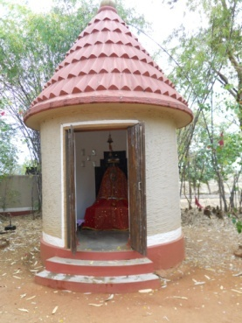

1. The entrance to the OPD

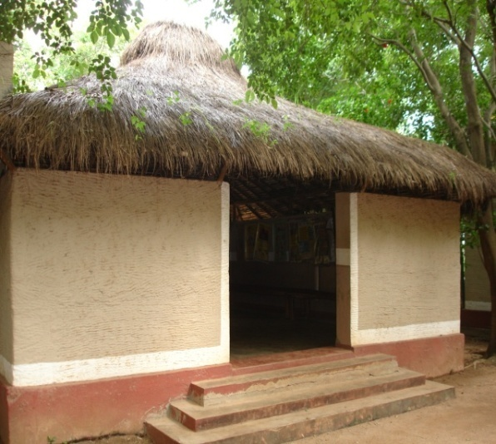

1. Registration Counter

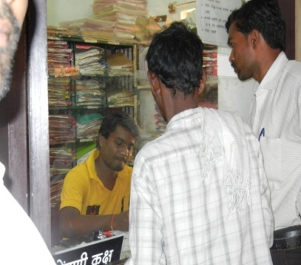

1. Waiting area

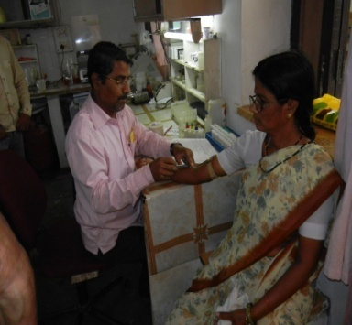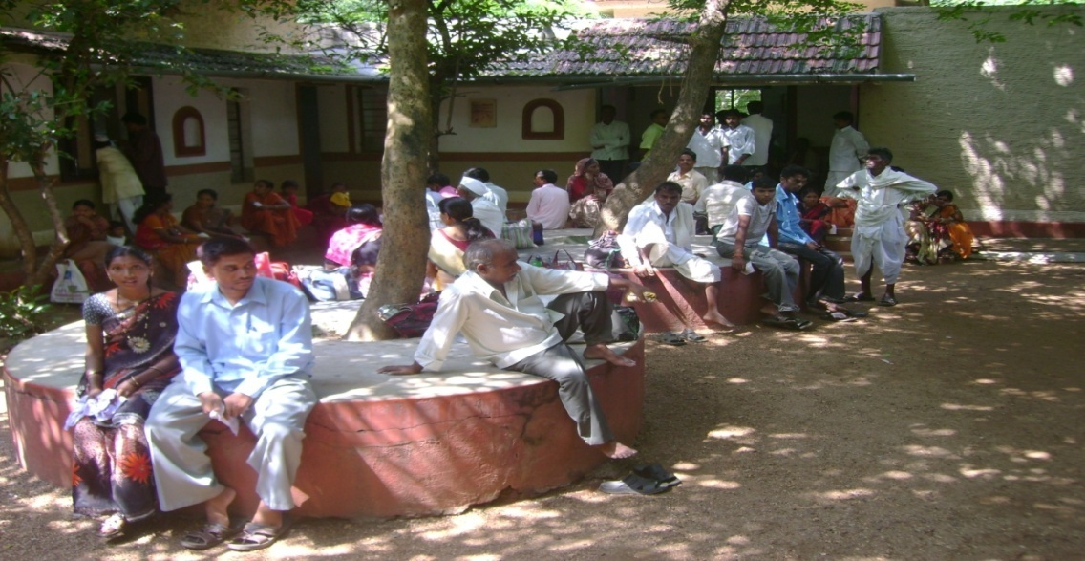

1. 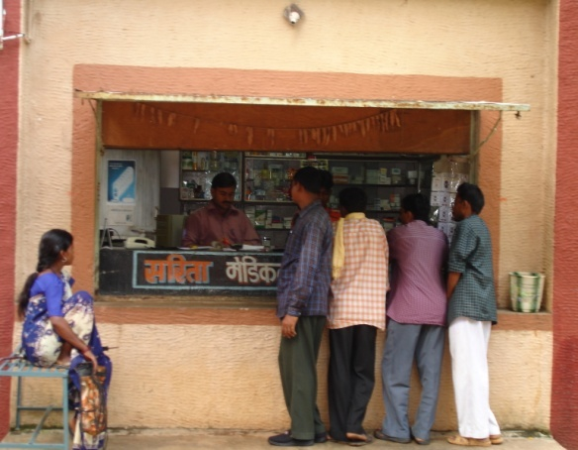Laboratory
2. Pharmacy
3. Ambulance services

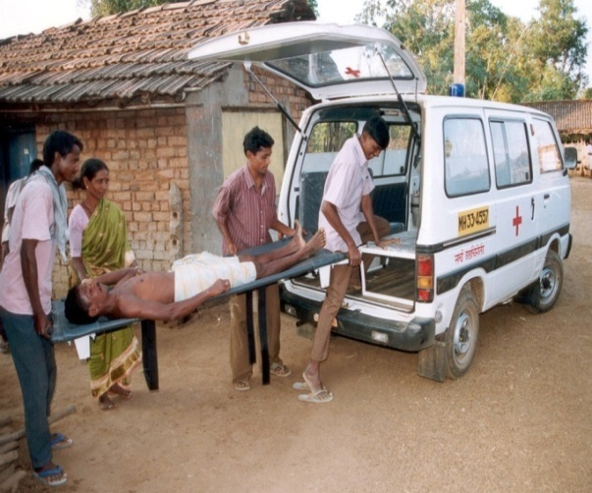

1. Special ward for tribal- Kuti

